**MINISTRY OF EDUCATION**

**AND TRAINING**

**FPT UNIVERSITY**

Capstone Project Document

Distribution Management System in Pharmaceutical

|  |  |
| --- | --- |
| Distribution Management System in Pharmaceutical | |
| Group Members | Trương Võ Thiên Vũ – Team Leader – SE60626  Tạ Đức Tùng – Team Member – 60416  Nguyễn Trọng Việt – Team Member – SE02406 |
| Supervisor | Nguyễn Văn Sang |
| Capstone Project code | DMS |

- Ha Noi, 12/2015 -

Contents

1.1. Introduction 5

1.1.1. Purpose 5

1.1.2. Acronyms and definitions 5

1.2. Abstract 5

1.3. Literature review 6

1.4. Proposal 6

1.4.1. Initial idea of the DMS 6

1.4.2. Objectives 6

1.4.3. System features 7

1.5. Benefit from project 7

1.5.1. For our group 7

1.5.2. For Distrisbutor and Drugstore 7

1.6. Critical assumption and constraints 8

1.7. Potential risks 8

2.1. Problem Definition 8

2.1.1. Name of this Capstone Project 8

2.1.2. Problem Abstract 8

2.1.3. Project Overview 9

2.2. Project Organization 10

2.2.1. System Process Model 10

2.2.2. Roles Responsibilities 12

2.2.3. Tools and Techniques 13

2.3. Schedule 14

2.4. Convention Rules 16

3.1. User Requirement Specification 16

3.1.1. Functional Requirements 16

3.2. System Requirement Specification 17

3.2.1. External Interfaces 17

3.2.2. Functional Requirement 18

3.2.3. Non-functional Requirements 83

3.3. Entity Relationship Diagram 84

4.1. Architectured Design 85

4.1.1. Choice of Architecture Design 85

4.1.2. Component Design 86

4.2. Detail Description of Components 88

4.2.1. Entities Classes 88

4.2.2. Generic Repository Class 89

4.2.3. Screen Design 92

4.2.4. Sequence Diagram 110

4.3. Database Design 120

4.3.1. Physical Database Design 120

4.4. Algorithms 128

4.4.1. Nearest Neighbor Algorithms 128

5.1. Introduction 129

5.1.1. System Overview 129

5.1.2. Test Approach 129

5.2. Test Plan 129

5.2.1. Scope of testing 129

5.2.2. Requirement for testing 129

5.2.3. Test Strategy 131

5.3. Test Cases 136

5.3.1. Account Control 136

5.3.2. Manage Order 138

5.3.3. Mange Drug Store 139

5.3.4. Manage Drug 139

5.3.5. Manage Category 140

5.3.6. Manage Schedule 140

5.3.7. Manage Salesman 141

5.3.8. Manage Account 141

5.4. Checklists 141

5.4.1. Checklist of Validation 141

5.4.2. Checklist of User Interface 142

5.4.3. Checklist for Document 143

5.5. Test logs 145

5.5.1. Defect Logs 145

5.5.2. Test Report 146

6.1. Software User’s Manual 148

6.1.1. Installation Guide 148

6.1.2. User’s Guide 152

Appendix 186

Reference 186

## Introduction

### Purpose

This part is the introduction for Distribution Management System in phamarceutical (DMS) Project – our Capstone Project in FPT University. It is included the overview of existing system, the initial idea of this project.

The propose system will eliminate all the existing system limitations with its new features:

* Drugstores can easily make orders on website with registed account or view drug brand information. That helps Drugstore no longer solely depended on salesmen.
* Staffs manage Drugstore, Drugstore’s order, Salesman, Deliverymen and drug brands. All management functions are in one system.
* Salesmans are able to create order for drugstore in their areas.
* Administrator manage all user belong to system.
* System create shortest path between Drugstore for Deliveryman.

The new system will help the supplier save money, protect ustomer and reduce unnessary work for Staff.

### Acronyms and definitions

|  |  |  |
| --- | --- | --- |
| **Acronym & Abbreviation** | **Definition** | **Note** |
| DMS | Distribution Management System in phamarceutical |  |

**Table 1-1 :Acronyms and definitions**

## Abstract

The existing pharmaceutical supplier website only provides drug brands information. If drugstore want to order, they have to contact with Distributor….

The managements of Drugstore’s orders, Salesmen and Deliverymen are done separately, so the effort for an order to reach the drugstore is multiple. Since, Salesmen have to inform the Staff, and Staff will use the program to create an order then prepare that order’s products. After the preparation is finished, the staff will have to calculate by themselves which orders go together for a more efficient route. This calculation can be incorrect and sometimes the Staff just skips it when it seems too difficult which causes the supplier to lose money.

## Literature review

Indico International Distribution (<http://www.indico.vn>) .

* + - **Advantages:**
      * User interface clearly and easy to use.
      * Quick response for user’s action.
      * There are more Drug’s information.
      * There are more different kind of Drugs.
      * Feedback function.
* **Disadvantages:**
  + - * There are no price with each product.
      * System does not support register new account.
      * Cannot search Drug with Textbox.
      * Paging limit minimum 75 elements, hard to view and scroll.

## Proposal

### Initial idea of the DMS

The initial idea is to make the management of a pharmaceutical supplier’s distribution system more efficient and easy. By providing an online system that has these features:

* Drugstores can easily make orders on website with a registered account or view drug brand information.
* Staffs can manage drugstores, drugstore’s orders, salesmen, deliverymen and drug brands.
* Salesmen are able to create orders for drugstores in their areas.
* The system can automatically arrange drugstore’s orders for deliverymen to create the shortest path between drugstores and it can also automatically create and assign drugstore group for salesmen based on their addresses.
* The administrator can manage staffs, salesmen, deliverymen, drugstore’s accounts.
* The system also manages drugstore payments and debts.

### Objectives

This project is the Capstone Project for all team members. Firstly, we do this project to fulfill the requirements from FPT University studying program. During the time do this, we can learn how to develop a project, how to communicate with other team members, how to control time, how to do teamwork effectively. Therefore, after finishing this project, we can practice what we have learnt in University and learn so many new things. It’s very necessary for our future work after graduating from FPT University.

Secondly, we want to create a website for Distributor that help Drugstore and Distributor can work more effective, faster, easier and simpler.

### System features

The expected system will eliminate all the existing system limitations with its new features:

**Manage components below:**

* *Drugstores* can easily make orders on website with a registered account or view drug brand information. This helps the drugstores no longer solely depended on salesmen.
* *Staff* can manage Drugstore, Drugstore’s order, salesman, deliveryman and drug brand. All managements are done on one system.
* *Administrator* can manage staffs, salesman, deliveryman, drugstore’s accounts.
* *System* can automatically create the shortest path between drugstores. System can manages drugstore payments and debts.
* *Salesman* are able to create orders for drugstores in their area. Reduce work for staff.

## Benefit from project

If this application will be developed and implemented successfully, our group and Distributor will get some benefits from it.

### For our group

After developing and implementing this project, our group will get some benefits:

* We have more experiences of managing a software project: how to manage plan, time, and risk. These experiences help us a lot in our future work.
* Know how to communicate with other team members and how to do teamwork efficiently
* If this application is developed, we will get a good mark in Capstone Project. It makes our grade better.

### For Distrisbutor and Drugstore

After developing and sending to Distributor, Staff and Drugstore will work in only one website.

* Drugstore users can order Drug easier, faster. They can find out more drug information. They can view all history about order and payment.
* Staff can work efficient and easy to manage drug, salesman, deliveryman
* Deliveryman can get shortest path that help save money, time and effort.
* Salesman can view order history order and payment of each Drugstore and have new strategy for them.

## Critical assumption and constraints

There are some critical assumptions that we realize after analyzing this project. The first assumption is about team members. We assume that all the team members can work with MVC and C#. We do not know anything about it before this project, but we have to study hard for not missing any deadline of project plan. Besides, we also assume all our members do not have any health problems, so they are not absent and can do their works.

There are also some constraints of our project. Firstly, about the time and deadline, we have to finish project on time. It has no extra time for us to complete developing and deliver application to teachers. Besides, the reports need to be submitted before the deadline. Secondly, about the quality, the application must be well enough for users to do main function. Finally, about the technique, our knowledge in C# and MVC is not in the high level. Therefore, with all the expected features that we gave before, we do not know if we can solve all of those or not. However, we will try our best to make our project successfully.

## Potential risks

After analyzing this project, we may be facing some risks:

* + - With the short duration - about 3 months – we will not have enough time to do all things and miss the delivery deadline.
    - We do not have any experiences in software project management such as time management, risk management etc. So maybe we will miss the deadline or have some unknown risks.
    - It is the first time we manage big project like this, we do not have much experiences in communicating between the team. So maybe in the future, we will have conflict and argument and we will not finish all the works in time.
    - Maybe we will lose source code or device during the developed time.



## Problem Definition

### Name of this Capstone Project

English: Distribution Management System in pharmaceutical

Vietnamese: Hệ thống quản lý phân phối ngành dược phẩm

Abbreviation: DMS

### Problem Abstract

The existing pharmaceutical supplier website only provides drug brands information. If drugstores want to order, they have to do it through a salesman. But the salesman are not always consistant to the supplier, they can change product prices or switch to another supplier which causes the supplier to loose customer.

The manager of drugstore’s orders, salesman and deliverymans are done separately, so the effort for an order to reach the drugstore is mutilpled. Since the salesman have to inform the staff, and the staff will use the program to create an order then prepare that order’s products. After the preparation is finished, the staff will have to calculate by themselves which orders go together for a more efficient route. This calculation can be incorrect and sometimes the staff just skips it when it seems too difficult which causes the supplier to loose money.

### Project Overview

#### The Current System

The existing pharmaceutical supplier website only provides Drug brand information

The management of drugstore’s orders is done by using a program which has no function other than managing Drug brand, Drugstore and orders

* Advantages:
  + User interface clearly and easy to use.
  + Quick response for user’s action.
  + There are more Drug’s information.
  + There are more different kind of Drugs.
  + Feedback function.
* Disadvantages:
  + There are no price with each product.
  + System does not support register new account.
  + Cannot search Drug with Textbox.
  + Paging limit minimum 75 elements, hard to view and scroll.

#### The Proposed System

The new system will have belows components:

* Salesman: Manage Drugstore, View Order, Create Order, Edit Discout, View history
* Staff: Manage Salesman, assign Drugstore to Salesman, Confirm Order, View Order, View history.
* Administrator: Manage all account.
* Drug Store: Create Order, View history.

Advantages over the old system:

* More stable.
* Easy upgrade, manage and maintance
* Manage multiple data.

Can be used for many types of Distributor.

#### Boundaries of the System

* The system is designed for all Pharmaceutical Distributor.
* The language of the system support Vietnamese.
* The system does not include Warehouse management.

#### Development Environment

#### Hardware Requirement

**For Server**

|  |  |  |
| --- | --- | --- |
| Windows | Minimum Requirements | Recommended |
| Internet Connection | Cable, Wi-Fi (4 Mbps) | Cable, Wi-Fi (8 Mbps) |
| Operating System | Window Server 2008 | Window Server 2008 |
| Computer Processor | Intel® Xeon ® 1.4GHz | Intel® Xeon ® Quad Core  (12M Cache, 2.50 GHz) |
| Computer Memory | 1GB RAM | 2GB RAM or more |

**Table 2-1: Hardware Requirement**

#### Software Requirement

* Handle Products and sprints backlog: MS Excel 2013.
* Implement Website and service: Visual Studio 2013.
* Create and manage database for system: SQL Server 2008.
* Source control: Github.
* Create models and diagrams: Software Ideas Modeler.
* Communicate and meeting: Skype 7.0, Facebook, Mobile Phone and Google mail.
* System and platform development: Window 7.

## Project Organization

### System Process Model

With the schedule of weekly reports and a huge of information every week, the software will be developed by using Rational Unified Process model which is very simple and easy for a new group want to make a big project. With RUP model, developing process will include four main phases:

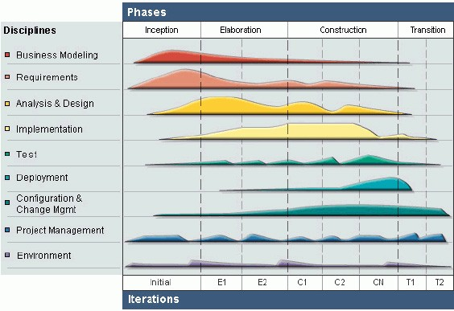

**Figure 2-1: Rational Unified Process Process Model**

* **Inception Phase**: This is the first phase of process. In this startup phase, we should provide business case of the system and determine the scope of project. Besides, we have to create the project management plan that has project schedule, effort estimation and risk management etc. At the end of this phase, we should check the objectives of project and decide whether to continue development or not. Hence, Inception phase must be properly planned and done. Based activities of this phase:
  + Study business case and feasibility study of project.
  + Complete draft ERD of system.
  + Complete draft screen prototypes.
  + Complete draft requirements.
  + Determine project scopes.
  + Complete project management plan.
* **Elaboration Phase**: The objectives of this phase are to determine appropriate architectural and construction plan for the project. The architectural decision needs to be made for the entire system, and to describe most of the requirements of system. At the end of this phase, we must examine the objectives and scopes, the choice of architecture and decide whether to proceed to the next phase. Based activities of this phases:
* Complete user requirement specification.
* Complete ERD, final prototypes.
* Complete Software Requirement Specification.
* Complete database model.
* Complete System Architecture Design.
* **Construction Phase**: Construction is the third phase of RUP lifecycle. In this phase, we must have done all the coding and testing work. After coding, developers will do unit test themselves, then test team will do functional test and regression test when finishing all. Based activities of this phase:

- Complete coding and unit test.

- Complete functional and regression test.

- Complete user manual.

* **Transition Phase**: Transition is the final phase of the RUP lifecycle. In this phase, project team has to deploy the application and give it to users. The next step is receiving feedback from users to identify the problems and then complete the system. Based activities of this phase:

- Deploy the system.

- Deliver source code.

- Complete all reports and documents.

### Roles Responsibilities

|  |  |  |  |
| --- | --- | --- | --- |
| # | Name | Role | Responsibilities |
| 1 | Nguyễn Văn Sang | Supervisor | Support business and solution  Tracking and review project |
| 2 | Trương Võ Thiên Vũ | Project Manager  SRS Analysis  Developer Leader  QA Leader | - PM has responsibilities to develop the project plan and manage project stakeholders, project team, project risk, project schedule, project budget, project conflicts.  - Analyze business.  - Ensure that the Project Team completes the project.  - Provide suitable technology solutions, tools for project development process.  - Create coding guidelines, coding convention and standards.  - Review document, product, and reports.  - Support other team members. |
| 3 | Tạ Đức Tùng | Member  SRS Analysis  Tester Leader | - Analyze business. Understand business related to project topic.  - Present and explain business information to other members.  - Create and review SRS, SAD and SDD documents.  - Writing report.  - Create test data for all functions.  - Design User Interface  - Create test cases for the system.  - Execute test to ensure all functions fulfill requirements and make test report.  - Cooperate with Developer to create software specification requirement (SRS), architectural design (SAD) and software detailed design (SDD). |
| 4 | Nguyễn Trọng Việt | Member  Developer  Tester | - Develop a plan to draw and control architectural design.  - Coding function  - Execute test to ensure all functions fulfill requirements and make test report.  - Create test cases for the system, both in document and script.  - Support other team members. |

**Table 2-2: Role and Responsibilities**

### Tools and Techniques

#### Tools

* Microsoft Visual Studio 2013: Integrated Development Environment (IDE)
* Microsoft SQL Server 2008: Database Management System (DBMS)
* Microsoft Office: Create documents and reports
* Software Ideas Modeler: Draw diagrams
* GitHub: Subversion repository for controlling source code
* Firefox, Chrome: Environment to use and testing project.

#### Techniques

* Front-end technologies:
  + CSS3, Javascript, jQuery, AJAX, Google API, Bootstrap
* Back-end technologies:
  + Website: MVC5.NET
  + Framework: Entities Frame Work 6
* Webserver: localhost

## Schedule

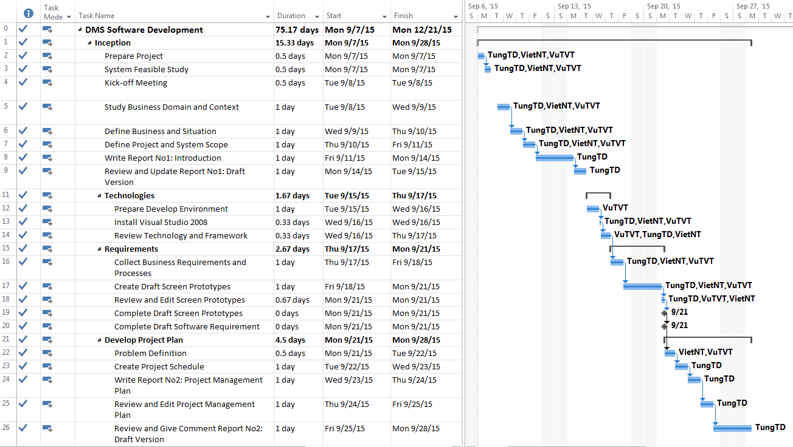

**Figure 2-2: DMS Project Management Plan part 1**

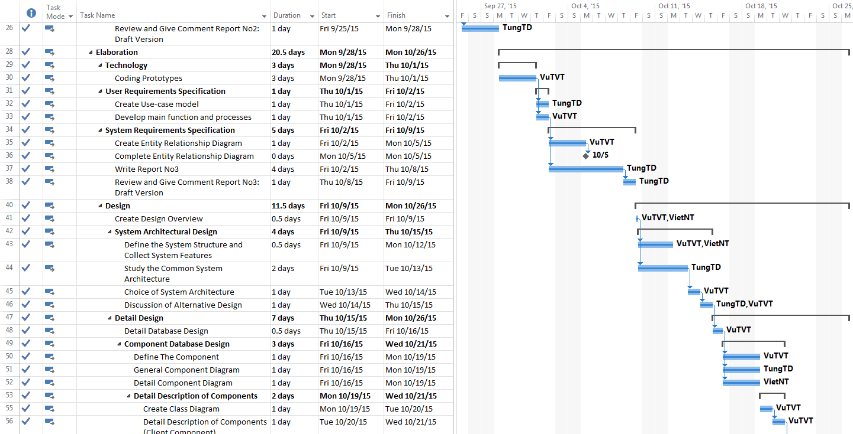

**Figure 2-3: DMS Project Management Plan part 2**

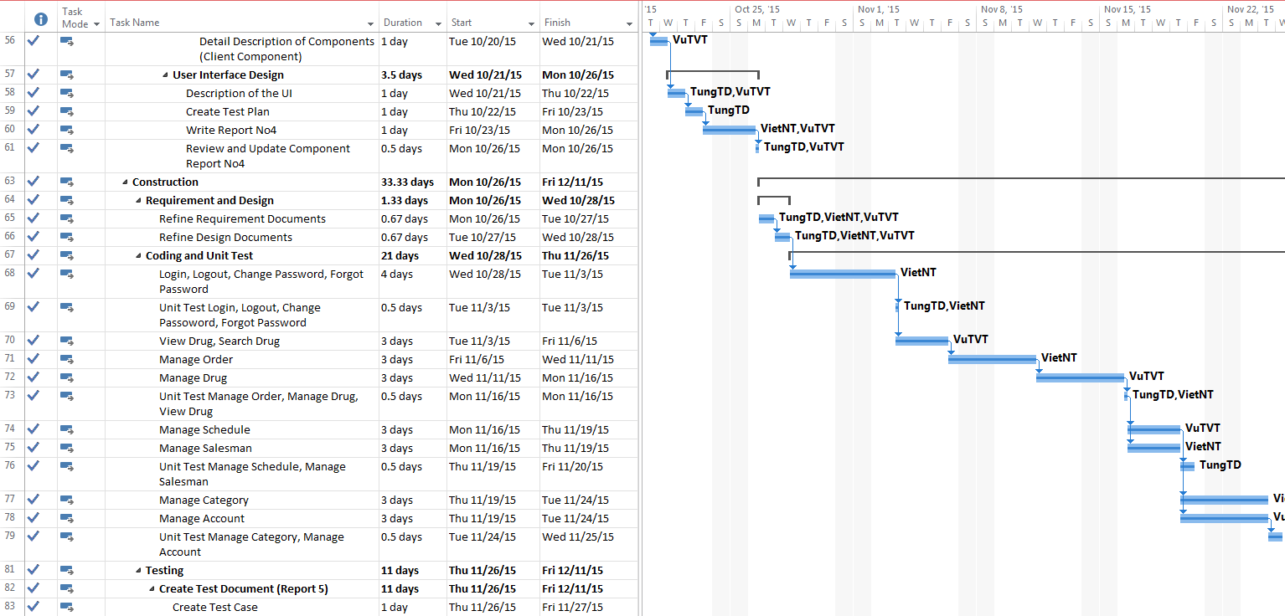

**Figure 2-4: DMS Project Management Plan part 3**

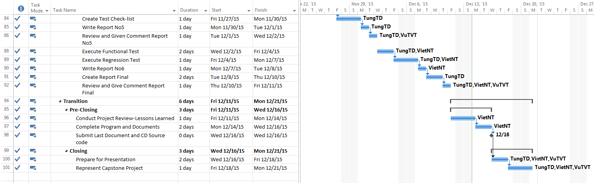

**Figure 2-5: DMS Project Management Plan part 4**

## Convention Rules

Summary:

* Naming Convention.
* Indentation.
* Declaration.
* Code Examples.

Follow “Code Conventions for the C# Programming Language, by Microsoft:

<http://msdn.microsoft.com/en-us/library/ff926074.aspx>



## User Requirement Specification

### Functional Requirements

#### Guest Requirement

**Guest is an unauthorized user of website. Guest have to:**

* Login with thier authorized account.
* Register new account.
* View, search drug.
* View details drug.

#### Authorized User Requirement

**An Authorized user can:**

* Log out.
* Change their password.
* View and update their account details.
* View, search drugs.
* View drug detail.

#### Drugstore Requirement

**Customer is a logged user and has all function of a logged user. In addition, they have all function of Guest except Login and Register function. Customer also has their own function**

* Create drugs orders.
* Search and view details drugs.
* View history payment of orders.
* View history orders.

#### Staff Requirement

**Staff is a logged user and have all function of logged user. In addition, a system Staff also has their function:**

* Manage all order: approve, reject online orders.
* Manage schedule: create and detele schedules.
* Manage drus: create, edit, delete drugs.
* Manage drugstores: create, edit, delete drugs, import drugstore from excel files, assign Drugstore to Salesman.

#### Salesman Requirement

**Salesman is a logged user and have all function of a logged user. In addition, a system Salesman also has their function:**

* Create order for Drugstore managed by themselves.
* Verify Drugstores.
* View all orders of Drugstores.

#### Administrator Requirement

**Administrator is a logged user and have all function of logged user. In addition, Administrator have their function:**

Manage all user: Deactivate and Activate user, edit user details, delete account.

## System Requirement Specification

### External Interfaces

#### User Interfaces

The DMS website should adopt an attractive and user-friendly interface so that the users of the system can get a good experience browsing the site.

The page should be well linked together to promote seamless navigation between them. The instructions should be specific and suggestive, so that the users will not be confused about what to do next

Client postbacks should be limited wherever possible, in oder to perfomance and easy of use.

Vietnamese should be the official language of website as its target customer are mainly Vietnamese market. Vietnam Dong should be officical currency. Moreover, all other localizable information, such as date and time, shoud be Vietnamese-styled.

Time New Roman font with size 12 is the main format font of Website with Black color. Background with White color and Blue color for nomal button.

#### Software Interface

### Functional Requirement

#### Function List

##### List of User

|  |  |
| --- | --- |
| Term | Description |
| Guest | Who not logged in System |
| Authorized User | Who logged in System |
| Drug Store | Who logged in System with Drug Store roll |
| Staff | Who logged in System with Staff roll |
| Administrator | Who logged in Sytem with Admin roll |

**Table 3-1: List of User in System**

#### Overview Use-Case Diagram

**Figure 3-1: Overview Use Case Diagram**

#### Use-Case list

|  |  |  |  |
| --- | --- | --- | --- |
| Use-Case ID | Actor | Use-Case | Description |
| UC0001 | Guest | Register | Guest register new account in System. |
| UC0002 | Guest | Login | Guest login with an Authenticated User. |
| UC0003 | Guest | Forgot Password | Support User get a new Password. |
| UC0004 | Guest | Search Drug | Support User search Drug in System. |
| UC0005 | Guest | View Drug Detail | Support User view Drug’s information. |
| UC0006 | Guest | View all Drug | Support User view all Drug in System. |
| UC0007 | Authorized User | Search Drug | Support User search Drug in System. |
| UC0008 | Authorized User | View all Drug | Support User view all Drug in System. |
| UC0009 | Authorized User | Update profile | Support User update their information. |
| UC0010 | Authorized User | Change Password | Support User changer their password. |
| UC0011 | Authorized User | Logout | Support User logout of System. |
| UC0012 | Drug Store | Create Order | Support Drugstore Create Order. |
| UC0013 | Drug Store | View Order history | Support Drugstore view their history order. |
| UC0014 | Drug Store | View Payment history | Support Drugstore view their history payment. |
| UC0015 | Drug Store | Cancel Order | Support Drugstore cancel their Order. |
| UC0016 | Salesman | Verify Drugstore | Salesman verify what kind of Drugstore. |
| UC0017 | Salesman | Create Order | Salesman Create Order for Drugstore. |
| UC0018 | Salesman | View Order | View all Order from Drugstore. |
| UC0019 | Salesman | View Order Detail | View Detail of an Order. |
| UC0020 | Salesman | Set Discount Rate | Salesman set Discount rate for Drugstore. |
| UC0021 | Staff | Approve Order | Confirm Order request from Drugstore. |
| UC0022 | Staff | Add New Drug | Staff add new Drug to System. |
| UC0023 | Staff | Delete Drug | Staff delete a Drug from System. |
| UC0024 | Staff | Edit Drug | Staff Edit detail of Drug (price, status…) |
| UC0025 | Staff | Assign Salesman | Assign salesman to their group they manage. |
| UC0026 | Staff | Create Category | Staff can Create a new category of Drug. |
| UC0027 | Staff | Delete Category | Staff can Delete a category of Drug. |
| UC0028 | Staff | Edit Category | Staff can Edit a category of Drug. |
| UC0029 | Staff | Create Delivery Schedule | Staff create Delivery schedule for Deliveryman. |
| UC0030 | Staff | Update Delivery Status | Staff update Delivery status to System. |
| UC0031 | Administrator | Create new account | Admin can create new account for Manager, Staff, Salesman. |
| UC0032 | Administrator | Deactivate account | Admin can deactivate all active account in System. |
| UC0033 | Administrator | Activate account | Admin can activate all deactivate account in System. |

**Table 3-2: Use Case List**

#### UC0001 <Guest> Register

##### Use-Case Diagram

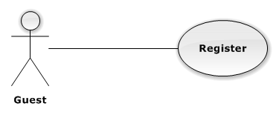

**Figure 3-2: Register Use-Case Diagram**

##### Use-Case Specification

|  |  |  |  |
| --- | --- | --- | --- |
| USE CASE SPECIFICATION | | | |
| Use-case No. | UC0001 | Use-case Version | 1.0 |
| Use-case Name | Register | | |
| Author | Tạ Đức Tùng | | |
| Date | 1/10/2015 | Priority | Normal |
| Actor:  Guest.  Summary:  This Use Case help Guest to create an account in the system.  **Goal:**  Help Guest can have an account in the system. Guest can use this account to login the system and post their request.  Triggers:  Guest go to [Trang chủ] and click on “Tạo tài khoản” link.  Preconditions:  Guest does not have an account in system.  Post Conditions:  User [Trang chủ] display.  Main Success Scenario:   |  |  |  | | --- | --- | --- | | Step | Actor | Action | | 1 | User | Guest go to [Trang chủ] and clicks on [Đăng Kí] button. | | 2 | System | Display [Đăng ký] screen with text box for guest input all necessary to create new account. | | 3 | User | Input all required field. | | 4 | System | Validate all input date. Send error message (if have invalid data). | | 5 | User | Guest click on [Đồng ý] button (Correct all invalid fields if have any invalid data). | | 6 | System | System creates new account for guest. | | 7 | System | Redirect to [Trang chủ]. |   Alternative Scenario:   |  |  |  | | --- | --- | --- | | # | Actor | Action | | 1 | User | Click on [Hủy] button | | System | System redirect to [Trang chủ] |   Exceptions:   |  |  |  | | --- | --- | --- | | # | User | System | | 1 | User | Not input enough information required | | System | Display message error: “Vui lòng điền thông tin vào những ô bắt buộc” |   Relationships:  “Login” use case.  Business Rules:   |  |  | | --- | --- | | # | Business Rule Description | | 1 | Guest must be enter all required fields before submitting. | | 2 | Each register, guest can create one account in the system | | 3 | Each Drugstore’s info, there is only one account. | | 4 | Each account in the system is distinguished by e-mail address. | | 5 | When e-mail fields of the new account are the same as the existing ones, system will show invalid message. | | | | |

#### UC0002 <Guest> Login

##### Use-Case Diagram

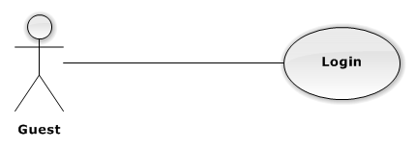

**Figure 3-3: Login Use-Case Diagram**

##### Use-Case Specification

|  |  |  |  |
| --- | --- | --- | --- |
| USE CASE SPECIFICATION | | | |
| Use-case No. | UC0002 | Use-case Version | 1.0 |
| Use-case Name | Login | | |
| Author | Tạ Đức Tùng | | |
| Date | 1/10/2015 | Priority | Normal |
| Actor:  Guest.  Summary:  This use case allows authorized user login to the system.  **Goal:**  Authenticate user.  Triggers:  User access website area that is Authorized User.  Preconditions:  User has an account and has not logged in yet.  Post Conditions:  ***On Success****:* User logged in. System redirects user to [Trang chủ].  ***On Failure****:* System redirects to [Đăng nhập] page.  Main Success Scenario:   |  |  |  | | --- | --- | --- | | Step | Actor | Action | | 1 | User | User go to website page press [Đăng nhập] button. | | 2 | System | Website display [Đăng nhập] page. | | 3 | User | User input information into username field and password field | | 4 | User | Presses [Đăng nhập] button or click [Enter] key. | | 5 | System | Check username and password. | | 6 | System | Redirect to [Trang chủ]. |   Alternative Scenario:  N/A  Exceptions:   |  |  |  | | --- | --- | --- | | # | Actor | Action | | 1 | User | Presses [Đăng nhập] button. If invalid username or password. | | 2 | System | System redirect to [Đăng nhập] page and display error message “Tên đăng nhập hoặc mật khẩu không đúng!” | | 3 | User | Presses [Đăng nhập] button. If have error when connect database | | 4 | System | System redirect to [Đăng nhập] page and display error message “Lỗi kết nối đến máy chủ!” |   Relationships:  N/A  Business Rules:   |  |  | | --- | --- | | # | Business Rule Description | | 1 | Needed Internet Connection. | | | | |

#### UC0003 <Guest> Forgot Password

##### Use-Case Diagram

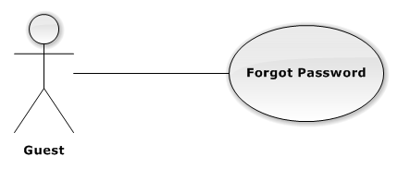

**Figure 3-4: Forgot Password Use-Case Diagram**

##### Use-Case Specification

|  |  |  |  |
| --- | --- | --- | --- |
| USE CASE SPECIFICATION | | | |
| Use-case No. | UC0003 | Use-case Version | 1.0 |
| Use-case Name | Forgot Password | | |
| Author | Tạ Đức Tùng | | |
| Date | 1/10/2015 | Priority | Normal |
| Actor:  Guest.  Summary:  This use case allow authenticate user get new password.  **Goal:**  Support Authenticate User get new Password.  Triggers:  User click on “Quên mật khẩu” link on [Đăng nhập] Page.  Preconditions:  User has an account in System.  Post Conditions:  ***On Success:*** Redirect to login screen.  ***On Failure:*** An error message will display.  Main Success Scenario:   |  |  |  | | --- | --- | --- | | Step | Actor | Action | | 1 | User | User click [Xác Nhận] button on [Quên mật khẩu] Page | | 2 | System | Display Successful message and redirect to [Đăng nhập] Page. |   Alternative Scenario:  N/A  Exceptions:  N/A  Relationships:  N/A  Business Rules:   |  |  | | --- | --- | | # | Business Rule Description | | 1 | Needed Internet Connection. | | | | |

#### UC0004 <Guest> Search Drug

##### Use-Case Diagram

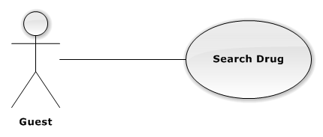

**Figure 3-5: Search Drug Use-Case Diagram**

##### Use-Case Specification

|  |  |  |  |
| --- | --- | --- | --- |
| USE CASE SPECIFICATION | | | |
| Use-case No. | UC0004 | Use-case Version | 1.0 |
| Use-case Name | Search Drug | | |
| Author | Tạ Đức Tùng | | |
| Date | 1/10/2015 | Priority | Normal |
| Actor:  Guest, Authorized User.  Summary:  This Use Case help Guest to Find Drug in System.  **Goal:**  Help User can find a Drug that they know the name easier.  Triggers:  Guest go to Homepage and Input name of Drug in [SearchTextbox].  Preconditions:  User is in System.  Post Conditions:  Drug display on Search Screen.  Main Success Scenario:   |  |  |  | | --- | --- | --- | | Step | Actor | Action | | 1 | User | Fill Drug name in [SearchTextbox] and press [Tìm kiếm] button | | 2 | System | Show Drug if exists in database. |   Alternative Scenario:  N/A  Exceptions:   |  |  |  | | --- | --- | --- | | Step | Actor | Action | | 1 | User | Fill Drug name in textbox and press [Tìm kiếm] button | | 2 | System | Display message “Không có loại thuốc nào”. |   Relationships:  N/A  Business Rules:   |  |  | | --- | --- | | # | Business Rule Description | | 1 | Needed Internet Connection. | | | | |

#### UC0005 <Guest> View Drug Detail

##### Use-Case Diagram

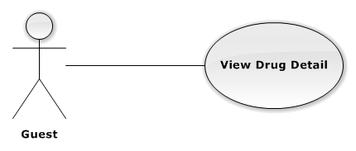

**Figure 3-6: View Drug Detail Use-Case Diagram**

##### Use-Case Specification

|  |  |  |  |
| --- | --- | --- | --- |
| USE CASE SPECIFICATION | | | |
| Use-case No. | UC0005 | Use-case Version | 1.0 |
| Use-case Name | View Drug Detail | | |
| Author | Tạ Đức Tùng | | |
| Date | 1/10/2015 | Priority | Normal |
| Actor:  Authorized User, Guest  Summary:  This Use Case help User view Detail of each Drug.  **Goal:**  Help User know detail of Drug, price, status, effect.  Triggers:  Guest go to Homepage and click on Drug’s image.  Preconditions:  User were in Homepage.  Post Conditions:  Drug’s Detail page Display.  Main Success Scenario:   |  |  |  | | --- | --- | --- | | Step | Actor | Action | | 1 | User | Guest go to [Trang chủ] and clicks on any [Drug] Product. | | 2 | System | Display [Thông tin thuốc] screen. |   Alternative Scenario:  N/A  Exceptions:  N/A  Relationships:    Business Rules:   |  |  | | --- | --- | | # | Business Rule Description | | 1 | Needed Internet Connection. | | | | |

#### UC0006 <Guest> View All Drug

##### Use-Case Diagram

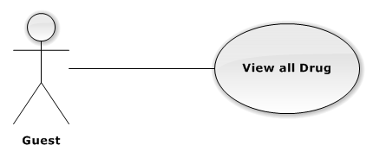

**Figure 3-7: View all Drug Use-Case Diagram**

##### Use-Case Specification

|  |  |  |  |
| --- | --- | --- | --- |
| USE CASE SPECIFICATION | | | |
| Use-case No. | UC0006 | Use-case Version | 1.0 |
| Use-case Name | View all Drug | | |
| Author | Tạ Đức Tùng | | |
| Date | 1/10/2015 | Priority | Normal |
| Actor:  Guest. Authorized User  Summary:  This Use Case help user can view all Drug in system.  **Goal:**  Help user can view all Drug of company.  Triggers:  Guest go to Homepage and Press [Xem toàn bộ thuốc] button.  Preconditions:  User in [Trang chủ].  Post Conditions:  ***On Success:*** Display list all Drug Product.  Main Success Scenario:   |  |  |  | | --- | --- | --- | | Step | Actor | Action | | 1 | User | Press on [Xem toàn bộ] button | | 2 | System | Show All Drug exists in database. |   Alternative Scenario:  N/A  Exceptions:  N/A  Relationships:  N/A.  Business Rules:   |  |  | | --- | --- | | # | Business Rule Description | | 1 | Needed Internet Connection. | | | | |

#### UC0007 <Authorized User> Search Drug

##### Use-Case Diagram

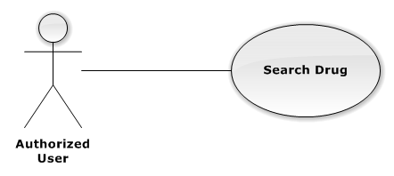

**Figure 3-8: Search Drug Use-Case Diagram**

##### Use-Case Specification

|  |  |  |  |
| --- | --- | --- | --- |
| USE CASE SPECIFICATION | | | |
| Use-case No. | UC0007 | Use-case Version | 1.0 |
| Use-case Name | Search Drug | | |
| Author | Tạ Đức Tùng | | |
| Date | 1/10/2015 | Priority | Normal |
| Actor:  Guest, Authorized User.  Summary:  This Use Case help Guest to Find Drug in System.  **Goal:**  Help User can find a Drug that they know the name easier.  Triggers:  Guest go to Homepage and Input name of Drug in textbox.  Preconditions:  User is in System.  Post Conditions:  Drug display on Search Screen.  Main Success Scenario:   |  |  |  | | --- | --- | --- | | Step | Actor | Action | | 1 | User | Fill Drug name in [SearchTextbox]and press [Tìm kiếm] button | | 2 | System | Show Drug if exists in database. |   Alternative Scenario:  N/A  Exceptions:   |  |  |  | | --- | --- | --- | | Step | Actor | Action | | 1 | User | Fill Drug name in [SearchTextbox] and press [Tìm kiếm] button | | 2 | System | Display message “Không có loại thuốc nào”. |   Relationships:  N/A  Business Rules:   |  |  | | --- | --- | | # | Business Rule Description | | 1 | Needed Internet Connection. | | | | |

#### UC0008 <Authorized User> View All Drug

##### Use-Case Diagram

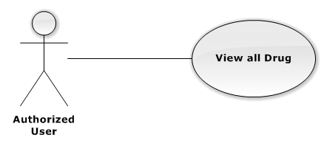

**Figure 3-9: View all Drug Use-Case Diagram**

##### Use-Case Specification

|  |  |  |  |
| --- | --- | --- | --- |
| USE CASE SPECIFICATION | | | |
| Use-case No. | UC0008 | Use-case Version | 1.0 |
| Use-case Name | View all Drug | | |
| Author | Tạ Đức Tùng | | |
| Date | 1/10/2015 | Priority | Normal |
| Actor:  Guest. Authorized User  Summary:  This Use Case help user can view all Drug in system.  **Goal:**  Help user can view all Drug of company.  Triggers:  Guest go to Homepage and Press [Xem toàn bộ thuốc] button.  Preconditions:  User in [Trang chủ].  Post Conditions:  Display list all Drug Product.  Main Success Scenario:   |  |  |  | | --- | --- | --- | | Step | Actor | Action | | 1 | User | Press on [Xem toàn bộ] button | | 2 | System | Show All Drug exists in database. |   Alternative Scenario:  N/A  Exceptions:  N/A  Relationships:  N/A.  Business Rules:   |  |  | | --- | --- | | # | Business Rule Description | | 1 | Needed Internet Connection. | | | | |

#### UC0009 <Authorized User> Update Profile

##### Use-Case Diagram

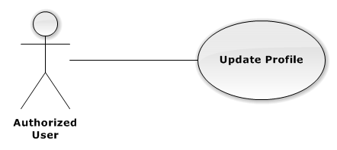

**Figure 3-10: Update Profile Use-Case Diagram**

##### Use-Case Specification

|  |  |  |  |
| --- | --- | --- | --- |
| USE CASE SPECIFICATION | | | |
| Use-case No. | UC0009 | Use-case Version | 1.0 |
| Use-case Name | Register | | |
| Author | Tạ Đức Tùng | | |
| Date | 1/10/2015 | Priority | Normal |
| Actor:  Guest.  Summary:  This Use Case help Guest to create an account in the system.  **Goal:**  Help Guest can have an account in the system. Guest can use this account to login the system and post their request.  Triggers:  Guest go to Homepage and click on “Tạo tài khoản” link.  Preconditions:  Guest does not have an account in system.  Post Conditions:  User Homepage display.  Main Success Scenario:   |  |  |  | | --- | --- | --- | | Step | Actor | Action | | 1 | User | Guest go to [Trang chủ] page and clicks on “Đăng Kí” link. | | 2 | System | Display [Đăng ký] screen with text box for guest input all necessary to create new account. | | 3 | User | Input all required field. | | 4 | System | Validate all input date. Send invalid message (if have invalid data). | | 5 | User | Guest click on [Đồng ý] button (Correct all invalid fields if have any invalid data). | | 6 | System | System creates new account for guest. | | 7 | System | Redirect to User Homepage. |   Alternative Scenario:   |  |  |  | | --- | --- | --- | | # | Actor | Action | | 1 | User | Click on [Hủy] button. | | System | System redirect to [Trang chủ]. |   Exceptions:   |  |  |  | | --- | --- | --- | | # | User | System | | 1 | User | Not input enough information required. | | System | Display message error: “Vui lòng điền thông tin vào những ô bắt buộc”. |   Relationships:  “Login” use case.  Business Rules:   |  |  | | --- | --- | | # | Business Rule Description | | 1 | Guest must be enter all required fields before submitting. | | 2 | Each register, guest can create one account in the system | | 3 | Each Drugstore’s info, there is only one account. | | 4 | Each account in the system is distinguished by e-mail address. | | 5 | When e-mail fields of the new account are the same as the existing ones, system will show invalid message. | | | | |

#### UC0010 <Authorized User> Change Password

##### Use-Case Diagram

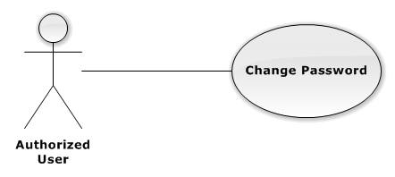

**Figure 3-11: Change Password Use-Case Diagram**

##### Use-Case Specification

|  |  |  |  |
| --- | --- | --- | --- |
| USE CASE SPECIFICATION | | | |
| Use-case No. | UC0010 | Use-case Version | 1.0 |
| Use-case Name | Change Password | | |
| Author | Tạ Đức Tùng | | |
| Date | 09/10/2015 | Priority | Normal |
| Actor:  Authorized User.  Summary:  This use case allows authorized user can change password of them.  **Goal:**  Change password.  Triggers:  User access website area and click on “Đổi mật khẩu” link on User Control Panel.  Preconditions:  User has logged in.  Post Conditions:  ***On Success****:* The password is changed and display message “Cập nhật mật khẩu thành công!”  ***On Failure****:* Password is not changed. Display error message.  Main Success Scenario:   |  |  |  | | --- | --- | --- | | Step | Actor | Action | | 1 | User | Press on “Thay đổi mật khẩu” in User Control Panel. | | 2 | System | Display Change Password Screen. | | 3 | User | Input all required field. | | 4 | System | Check all required field. | | 5 | User | Press on [Xác nhận] button. | | 6 | System | Display successful message “Thay đổi mật khẩu thành công” |   Alternative Scenario:   |  |  |  | | --- | --- | --- | | *#* | Actor | Action | | 1 | User | Click on [Hủy] button. | | 2 | System | Redirect to [Trang chủ]. |   Exceptions:   |  |  |  | | --- | --- | --- | | *#* | Actor | Action | |  | User | Field “Mật khẩu cũ” are blank. | | System | Shows error message “Hãy nhập lại mật khẩu cũ”. | | User | Field “Mật khẩu mới”, are blank. | | System | Shows error message “Hãy nhập mật khẩu mới” | | User | Field “Lặp lại mật khẩu mới” are blank. | | System | Shows error message “Hãy nhập lại mật khẩu mới” | | User | Input to field “Mật khẩu cũ”, “Mật khẩu mới” and field “Lặp lại mật khẩu mới” regular expression. | | System | Shows error message “Mật khẩu không được có kí tự đặc biệt”. | | User | Input to field “Mật khẩu mới” and field “Lặp lại mật khẩu mới” not enough 6 character. | | System | Shows error message “Mật khẩu mới phải có ít nhất 6 kí tự” | | User | Input to field “Mật khẩu mới” and field “Lặp lại mật khẩu mới” are different. | | System | Shows error message “Mật khẩu 2 không trùng khớp” | | User | Input to field “Mật khẩu cũ” not the same with database. | | System | Shows error message “Mật khẩu cũ không đúng!”. |   Relationships:  N/A  Business Rules:   |  |  | | --- | --- | | # | Business Rule Description | | 1 | Needed Internet Connection. | | | | |

#### UC0011 <Authorized User> Logout

##### Use-Case Diagram

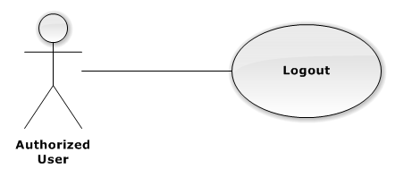

**Figure 3-12: Logout Use-Case Diagram**

##### Use-Case Specification

|  |  |  |  |
| --- | --- | --- | --- |
| USE CASE SPECIFICATION | | | |
| Use-case No. | UC0011 | Use-case Version | 1.0 |
| Use-case Name | Logout | | |
| Author | Tạ Đức Tùng | | |
| Date | 1/10/2015 | Priority | Normal |
| Actor:  Authorized User.  Summary:  This Use Case help Authorized User log out of system.  **Goal:**  Help Authorized User can log out of system.  Triggers:  Authorized User Press “Đăng xuất” on User Control Panel.  Preconditions:  User has logged in the System.  Post Conditions:  Redirect to [Trang chủ].  Main Success Scenario:   |  |  |  | | --- | --- | --- | | Step | Actor | Action | | 1 | User | Press “Đăng xuất” on User Control Panel | | 2 | System | End session of User and redirect to [Trang chủ] |   Alternative Scenario:  N/A  Exceptions:  N/A  Relationships:  N/A  Business Rules:   |  |  | | --- | --- | | # | Business Rule Description | | 1 | User must be logged in System. | | 2 | Needed Internet Access. | | | | |

#### UC0012 <Drugstore> Create Order

##### Use-Case Diagram

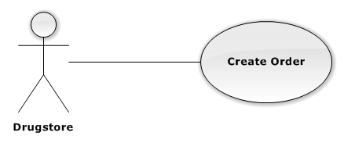

**Figure 3-13: Create Order Use-Case Diagram**

##### Use-Case Specification

|  |  |  |  |
| --- | --- | --- | --- |
| USE CASE SPECIFICATION | | | |
| Use-case No. | UC0012 | Use-case Version | 1.0 |
| Use-case Name | Create Order | | |
| Author | Tạ Đức Tùng | | |
| Date | 1/10/2015 | Priority | Normal |
| Actor:  Drugstore.  Summary:  This Use Case allow Drugstore make order to Company.  **Goal:**  Drug can make Order.  Triggers:  Drugstore want to make Order.  Drugstore click on “Tạo đơn hàng” or Cart icon.  Preconditions:  User has logged in with Drugstore role.  Account has been approve in System.  Post Conditions:  ***On Success:*** Order will be marked, pending for Confirm.  ***On Failure:*** Show error message, required to do again.  Main Success Scenario:   |  |  |  | | --- | --- | --- | | Step | Actor | Action | | 1 | User | Guest login with Drugstore role. | | 2 | System | Redirect to [Trang chủ] page. | | 3 | User | Click on “Tạo đơn hàng” link. | | 4 | System | Display “Show Cart” screen with a textbox for customer to enter drugstore name. A table content all drugs’s information will be order. | | 5 | User | Choose Drug want to order. | | 6 | System | Valid all input data. | | 7 | User | Click on [Đặt hàng] button. | | 8 | System | Create new pending Order. |   Alternative Scenario:   |  |  |  | | --- | --- | --- | | # | Actor | Action | | 1 | User | Click on [Hủy] button | | System | System redirect to [Trang chủ] |   Exceptions:   |  |  |  | | --- | --- | --- | | # | User | System | | 1 | User | Not input enough information required | | System | Display message error: “Vui lòng điền thông tin vào những ô bắt buộc” |   Relationships:  “Login” use case.  Business Rules:   |  |  | | --- | --- | | # | Business Rule Description | | 1 | Drugstore must be enter all required fields before submitting. | | 2 | Needed Interned Access. | | | | |

#### UC0013 <Drugstore> View Order history

##### Use-Case Diagram

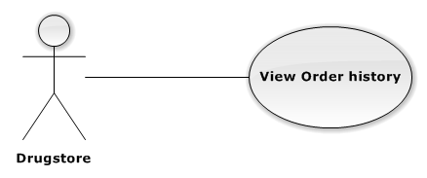

**Figure 3-14: View Order history Use-Case Diagram**

##### Use-Case Specification

|  |  |  |  |
| --- | --- | --- | --- |
| USE CASE SPECIFICATION | | | |
| Use-case No. | UC0013 | Use-case Version | 1.0 |
| Use-case Name | Register | | |
| Author | Tạ Đức Tùng | | |
| Date | 1/10/2015 | Priority | Normal |
| Actor:  Drugstore.  Summary:  This Use Case help Drugstore view their history Order.  **Goal:**  Drugstore can view all history Order.  Triggers:  Drugstore click on “Lịch sử đơn hàng” on User Control Panel.  Preconditions:  User has logged in with Drugstore role.  Post Conditions:  Show all history Order.  Main Success Scenario:   |  |  |  | | --- | --- | --- | | Step | Actor | Action | | 1 | User | Click on “Lịch sử đơn hàng” on User Control Panel | | 2 | System | Display all Order history |   Alternative Scenario:  N/A  Exceptions:  N/A  Relationships:  N/A  Business Rules:   |  |  | | --- | --- | | # | Business Rule Description | | 1 | User has logged in with Drugstore role. | | 2 | Needed Internet Access. | | | | |

#### UC0014 <Drugstore> View Payment history

##### Use-Case Diagram

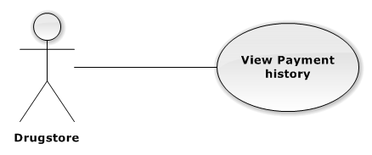

**Figure 3-15: View Payment history Use-Case Diagram**

##### Use-Case Specification

|  |  |  |  |
| --- | --- | --- | --- |
| USE CASE SPECIFICATION | | | |
| Use-case No. | UC0014 | Use-case Version | 1.0 |
| Use-case Name | View Payment history | | |
| Author | Tạ Đức Tùng | | |
| Date | 1/10/2015 | Priority | Normal |
| Actor:  Drugstore.  Summary:  This Use Case help Drugstore view their history Payment.  **Goal:**  Drugstore can view all history Payment.  Triggers:  Drugstore click on “Lịch sử thanh toán” on User Control Panel.  Preconditions:  User has logged in with Drugstore role.  Post Conditions:  Show all history Payment.  Main Success Scenario:   |  |  |  | | --- | --- | --- | | Step | Actor | Action | | 1 | User | Click on “Lịch sử thanh toán” on User Control Panel | | 2 | System | Display all Payment history |   Alternative Scenario:  N/A  Exceptions:  N/A  Relationships:  N/A  Business Rules:   |  |  | | --- | --- | | # | Business Rule Description | | 1 | User has logged in with Drugstore role. | | 2 | Needed Internet Access. | | | | |

#### UC0015 <Drugstore> Cancel Order

##### Use-Case Diagram

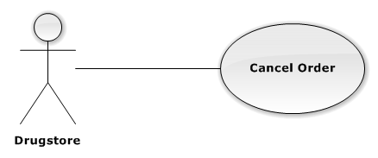

**Figure 3-16: Cancel Order Use-Case Diagram**

##### Use-Case Specification

|  |  |  |  |
| --- | --- | --- | --- |
| USE CASE SPECIFICATION | | | |
| Use-case No. | UC0015 | Use-case Version | 1.0 |
| Use-case Name | Cancel Order | | |
| Author | Tạ Đức Tùng | | |
| Date | 1/10/2015 | Priority | Normal |
| Actor:  Drugstore.  Summary:  This Use Case help Drugstore Cancel their Order.  **Goal:**  Help Drugstore can cancel Order with any reasons.  Triggers:  User go to Order History Page.  Preconditions:  User logged in with Drugstore role.  Drugstore has at least 1 pending Order.  Post Conditions:  ***On Success:***Cancel Order Successful.  ***On Failure:*** Cancel fail because Order be Confirmed.  Main Success Scenario:   |  |  |  | | --- | --- | --- | | Step | Actor | Action | | 1 | User | Click on “Lịch sử hàng” link. | | 2 | System | Display Order history Screen. | | 3 | User | Click on [Hủy] button at right side of Order. | | 4 | System | Cancel Order and Change Status |   Alternative Scenario:  N/A  Exceptions:   |  |  |  | | --- | --- | --- | | # | User | System | | 1 | User | Click on “Hủy đơn hàng” | | System | Display message error: “Đơn hàng này đã được xác nhận nên không thể hủy” |   Relationships:  N/A  Business Rules:   |  |  | | --- | --- | | # | Business Rule Description | | 1 | User has logged in with Drugstore role. | | 2 | Needed Internet Access. | | 3 | There are least 1 Pending Order. | | | | |

#### UC0016 <Salesman> Verify Drugstore

##### Use-Case Diagram

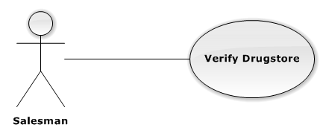

**Figure 3-17: Verify Drugstore Use-Case Diagram**

##### Use-Case Specification

|  |  |  |  |
| --- | --- | --- | --- |
| USE CASE SPECIFICATION | | | |
| Use-case No. | UC0016 | Use-case Version | 1.0 |
| Use-case Name | Verify Drugstore | | |
| Author | Tạ Đức Tùng | | |
| Date | 1/10/2015 | Priority | Normal |
| Actor:  Salesman.  Summary:  This Use Case help Guest to create an account in the system.  **Goal:**  Help Guest can have an account in the system. Guest can use this account to login the system and post their request.  Triggers:  Guest go to Homepage and click on “Tạo tài khoản” link.  Preconditions:  Guest does not have an account in system.  Post Conditions:  User Homepage display.  Main Success Scenario:   |  |  |  | | --- | --- | --- | | Step | Actor | Action | | 1 | User | Guest go to [Trang chủ] page and clicks on [Đăng Kí] | | 2 | System | Display [Đăng kí] screen with text box for guest input all necessary to create new account | | 3 | User | Input all required field | | 4 | System | Validate all input date. Send invalid message (if have invalid data) | | 5 | User | Guest click on [Đồng ý] button (Correct all invalid fields if have any invalid data) | | 6 | System | System creates new account for guest | | 7 | System | Redirect to [Trang chủ] page |   Alternative Scenario:   |  |  |  | | --- | --- | --- | | # | Actor | Action | | 1 | User | Click on [Hủy] button | | System | System redirect to Homepage |   Exceptions:   |  |  |  | | --- | --- | --- | | # | User | System | | 1 | User | Not input enough information required | | System | Display message error: “Vui lòng điền thông tin vào những ô bắt buộc” |   Relationships:  “Login” use case.  Business Rules:   |  |  | | --- | --- | | # | Business Rule Description | | 1 | Guest must be enter all required fields before submitting. | | 2 | Each register, guest can create one account in the system | | 3 | Each Drugstore’s info, there is only one account. | | 4 | Each account in the system is distinguished by e-mail address. | | 5 | When e-mail fields of the new account are the same as the existing ones, system will show invalid message. | | | | |

#### UC0017 <Salesman> Create Order

##### Use-Case Diagram

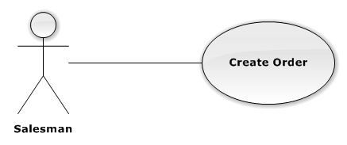

**Figure 3-18: Create Order Use-Case Diagram**

##### Use-Case Specification

|  |  |  |  |
| --- | --- | --- | --- |
| USE CASE SPECIFICATION | | | |
| Use-case No. | UC0017 | Use-case Version | 1.0 |
| Use-case Name | Create Order | | |
| Author | Tạ Đức Tùng | | |
| Date | 1/10/2015 | Priority | Normal |
| Actor:  Drugstore.  Summary:  This Use Case allow Drugstore make order to Company.  **Goal:**  Drug can make Order.  Triggers:  Drugstore want to make Order.  Drugstore click on “Tạo đơn hàng” or Cart icon.  Preconditions:  User has logged in with Drugstore role.  Account has been approve in System.  Post Conditions:  ***On Success:*** Order will be marked, pending for Confirm.  ***On Failure:*** Show error message, required to do again.  Main Success Scenario:   |  |  |  | | --- | --- | --- | | Step | Actor | Action | | 1 | User | Guest login with Drugstore role. | | 2 | System | Redirect to [Trang chủ] page. | | 3 | User | Click on “Tạo đơn hàng” link. | | 4 | System | Display “Show Cart” screen with a textbox for customer to enter drugstore name. A table content all drug’s information will be order. | | 5 | User | Choose Drug want to order. | | 6 | System | Valid all input data. | | 7 | User | Click on [Đặt hàng] button. | | 8 | System | Create new pending Order. |   Alternative Scenario:   |  |  |  | | --- | --- | --- | | # | Actor | Action | | 1 | User | Click on [Hủy] button | | System | System redirect to [Trang chủ] |   Exceptions:   |  |  |  | | --- | --- | --- | | # | User | System | | 1 | User | Not input enough information required | | System | Display message error: “Vui lòng điền thông tin vào những ô bắt buộc” |   Relationships:  “Login” use case.  Business Rules:   |  |  | | --- | --- | | # | Business Rule Description | | 1 | Drugstore must be enter all required fields before submitting. | | 2 | Needed Interned Access. | | | | |

#### UC0018 <Salesman> View Order

##### Use-Case Diagram



**Figure 3-16: Cancel Order Use-Case Diagram**

##### Use-Case Specification

|  |  |  |  |
| --- | --- | --- | --- |
| USE CASE SPECIFICATION | | | |
| Use-case No. | UC0018 | Use-case Version | 1.0 |
| Use-case Name | Cancel Order | | |
| Author | Tạ Đức Tùng | | |
| Date | 1/10/2015 | Priority | Normal |
| Actor:  Salesman.  Summary:  This Use Case help Drugstore Cancel their Order.  **Goal:**  Help Drugstore can cancel Order with any reasons.  Triggers:  User go to Order History Page.  Preconditions:  User logged in with Drugstore role.  Drugstore has at least 1 pending Order.  Post Conditions:  ***On Success:***Cancel Order Successful.  ***On Failure:*** Cancel fail because Order be Confirmed.  Main Success Scenario:   |  |  |  | | --- | --- | --- | | Step | Actor | Action | | 1 | User | Click on “Lịch sử hàng” link. | | 2 | System | Display Order history Screen. | | 3 | User | Click on [Hủy] button at right side of Order. | | 4 | System | Cancel Order and Change Status |   Alternative Scenario:  N/A  Exceptions:   |  |  |  | | --- | --- | --- | | # | User | System | | 1 | User | Click on [Hủy đơn hàng] button | | System | Display message error: “Đơn hàng này đã được xác nhận nên không thể hủy” |   Relationships:  N/A  Business Rules:   |  |  | | --- | --- | | # | Business Rule Description | | 1 | User has logged in with Drugstore role. | | 2 | Needed Internet Access. | | 3 | There are least 1 Pending Order. | | | | |

#### UC0019 <Salesman> View Order Detail

##### Use-Case Diagram



**Figure 3-17: Verify Drugstore Use-Case Diagram**

##### Use-Case Specification

|  |  |  |  |
| --- | --- | --- | --- |
| USE CASE SPECIFICATION | | | |
| Use-case No. | UC0019 | Use-case Version | 1.0 |
| Use-case Name | View Order detail | | |
| Author | Tạ Đức Tùng | | |
| Date | 1/10/2015 | Priority | Normal |
| Actor:  Salesman.  Summary:  This Use Case help Salesman view Detail of an Order.  **Goal:**  Help Guest can view all Detail of an Order from Drugstore.  Triggers:  Guest go to [Danh sách đơn hàng] page.  Preconditions:  User has logged in with Salesman role.  View Order Page has at least 1 Order.  Post Conditions:  ***On Success:*** Show Order Detail.  Main Success Scenario:   |  |  |  | | --- | --- | --- | | Step | Actor | Action | | 1 | User | Guest go to [Danh sách đơn hàng] page and clicks on [Xem chi tiết] button. | | 2 | System | Display View Detail screen. |   Alternative Scenario:  N/A  Exceptions:  N/A  Relationships:  N/A  Business Rules:   |  |  | | --- | --- | | # | Business Rule Description | | 1 | User has logged in with Salesman role. | | 2 | Needed Internet Access. | | | | |

#### UC0020 <Salesman> Set Discount Rate

##### Use-Case Diagram

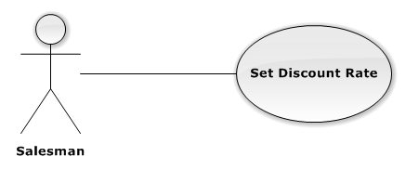

**Figure 3-21: Set Discount Rate Use-Case Diagram**

##### Use-Case Specification

|  |  |  |  |
| --- | --- | --- | --- |
| USE CASE SPECIFICATION | | | |
| Use-case No. | UC0020 | Use-case Version | 1.0 |
| Use-case Name | Set Discount Rate | | |
| Author | Tạ Đức Tùng | | |
| Date | 1/10/2015 | Priority | Normal |
| Actor:  Salesman, Staff.  Summary:  This Use Case help set Discount Rate for Drug.  **Goal:**  Help Salesman and Staff Set Discount Rate for each Drug Product.  Triggers:  User go to [Thông tin thuốc] page.  Preconditions:  User has logged in with Salesman or Staff role.  There are least 1 Drug Product in system.  Post Conditions:  Discount Rate Set successful.  Main Success Scenario:   |  |  |  | | --- | --- | --- | | Step | Actor | Action | | 1 | User | Guest go to [Thông tin thuốc] page and clicks on [Chiết khấu] button | | 2 | System | Display [Chỉnh sửa thông tin nhà thuốc] page. | | 3 | User | Choose Discount rate for Drug. | | 4 | System | Discount rate of Drug changed. |   Alternative Scenario:  N/A  Exceptions:  N/A  Relationships:  N/A  Business Rules:   |  |  | | --- | --- | | # | Business Rule Description | | 1 | User has logged in with Salesman or Staff role. | | 2 | There are least 1 Drug in System. | | | | |

#### UC0021 <Staff> Approve Order

##### Use-Case Diagram

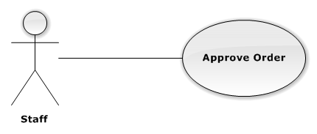

**Figure 3-22: Approve Use-Case Diagram**

##### Use-Case Specification

|  |  |  |  |
| --- | --- | --- | --- |
| USE CASE SPECIFICATION | | | |
| Use-case No. | UC0021 | Use-case Version | 1.0 |
| Use-case Name | Approve Order | | |
| Author | Tạ Đức Tùng | | |
| Date | 1/10/2015 | Priority | Normal |
| Actor:  Staff.  Summary:  This Use Case help Staff confirm Order request form Drugstore.  **Goal:**  Help Staff confirm Order from Drugstore and Delivery for them.  Triggers:  Staff go to [Xem danh sách đơn hàng] page and click on [Xác Nhận] button.  Preconditions:  There are least 1 pending Order.  Post Conditions:  Order change to Confirmed status.  Main Success Scenario:   |  |  |  | | --- | --- | --- | | Step | Actor | Action | | 1 | User | Go to [Xem danh sách đơn hàng] page and click on [Xác nhận] button. | | 2 | System | Confirm order and change status to “Đã Xác Nhận”. |   Alternative Scenario:  N/A  Exceptions:  N/A  Relationships:  N/A  Business Rules:   |  |  | | --- | --- | | # | Business Rule Description | | 1 | At least 1 Pending Order exists in System. | | 2 | Needed Internet Access. | | | | |

#### UC0022 <Staff> Add Drug

##### Use-Case Diagram

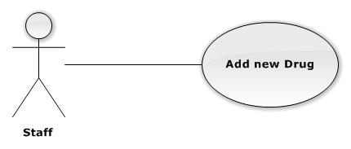

**Figure 3-23: Add new Drug Use-Case Diagram**

##### Use-Case Specification

|  |  |  |  |
| --- | --- | --- | --- |
| USE CASE SPECIFICATION | | | |
| Use-case No. | UC0022 | Use-case Version | 1.0 |
| Use-case Name | Add new Drug | | |
| Author | Tạ Đức Tùng | | |
| Date | 1/10/2015 | Priority | Normal |
| Actor:  Staff.  Summary:  This Use Case help Staff can Add new Drug.  **Goal:**  Help Staff Add new Drug to System.  Triggers:  Guest go to [Quản lý thuốc] Page and click on [Thêm mới thuốc] button.  Preconditions:  User has logged in System with Staff role.  Post Conditions:  Drug added to system successful.  Main Success Scenario:   |  |  |  | | --- | --- | --- | | Step | Actor | Action | | 1 | User | Guest go to [Quản lý thuốc] page and clicks on [Thêm mới thuốc] button. | | 2 | System | Display all required information Drug field. | | 3 | User | Input all required field. | | 4 | System | Valid all input field and Add new Drug to database. Display message “Thêm mới thuốc thành công”. |   Alternative Scenario:   |  |  |  | | --- | --- | --- | | # | Actor | Action | | 1 | User | Click on [Hủy] button | | System | Back to [Quản lý thuốc] page |   Exceptions:   |  |  |  | | --- | --- | --- | | # | User | System | | 1 | User | Not input enough information required | | System | Display message error: “Vui lòng điền thông tin vào những ô bắt buộc” |   Relationships:  “Login” use case.  Business Rules:   |  |  | | --- | --- | | # | Business Rule Description | | 1 | User has logged in with Staff role. | | 2 | Needed Internet Access. | | | | |

#### UC0023 <Staff> Delete Drug

##### Use-Case Diagram

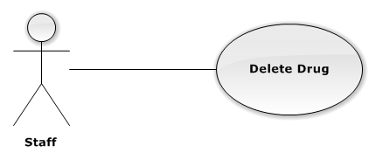

**Figure 3-24: Delete Drug Use-Case Diagram**

##### Use-Case Specification

|  |  |  |  |
| --- | --- | --- | --- |
| USE CASE SPECIFICATION | | | |
| Use-case No. | UC0023 | Use-case Version | 1.0 |
| Use-case Name | Delete Drug | | |
| Author | Tạ Đức Tùng | | |
| Date | 1/10/2015 | Priority | Normal |
| Actor:  Staff.  Summary:  This Use Case help Staff delete Drug from System.  **Goal:**  Help Staff Delete unnecessary from System.  Triggers:  Staff go to [Xem thông tin chi tiết] page or [Xem tất cả thuốc] page.  Preconditions:  At least 1 Drug product exists in system.  Post Conditions:  Drug deleted from database.  Main Success Scenario:   |  |  |  | | --- | --- | --- | | Step | Actor | Action | | 1 | User | Staff go to [Xem thông tin chi tiết] page or [Xem tất cả thuốc] page and click on [Xóa] button. | | 2 | System | Display message “Bạn muốn xóa sản phẩm này?” | | 3 | User | Click on [Xác nhận] button. | | 4 | System | Delete Drug from database and display message “Đã xóa thành công”. |   Alternative Scenario:   |  |  |  | | --- | --- | --- | | # | Actor | Action | | 1 | User | Click on [Hủy] button. | | System | System redirect to Previous page. |   Exceptions:  N/A  Relationships:  N/A  Business Rules:   |  |  | | --- | --- | | # | Business Rule Description | | 1 | At least 1 Drug product exists in System. | | 2 | Needed Internet Access. | | | | |

#### UC0024 <Staff> Edit Drug

##### Use-Case Diagram

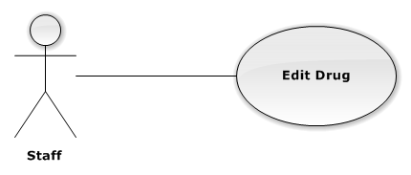

**Figure 3-25: Edit Drug Use-Case Diagram**

##### Use-Case Specification

|  |  |  |  |
| --- | --- | --- | --- |
| USE CASE SPECIFICATION | | | |
| Use-case No. | UC0024 | Use-case Version | 1.0 |
| Use-case Name | Edit Drug | | |
| Author | Tạ Đức Tùng | | |
| Date | 1/10/2015 | Priority | Normal |
| Actor:  Staff.  Summary:  This Use Case help Staff edit Drug.  **Goal:**  Help Staff can update lastest information about Drug.  Triggers:  Staff go to [Quản lý thuốc] Page.  Preconditions:  At least 1 Drug exists in System.  User has logged in with Staff role.  Post Conditions:  Update information Drug to database successful.  Main Success Scenario:   |  |  |  | | --- | --- | --- | | Step | Actor | Action | | 1 | User | Staff go to [Xem thông tin thuốc] page or [Xem tất cả thuốc] page and click on [Chỉnh sửa] button. | | 2 | System | Display all required field. | | 3 | User | Input all required field. | | 4 | System | Validate all input date. Send invalid message (if have invalid data). | | 5 | User | Guest click on [Đồng ý] button (Correct all invalid fields if have any invalid data). | | 6 | System | Update database and display message “Cập nhật thành công”. | | 7 | System | Go back to Previous page. |   Alternative Scenario:   |  |  |  | | --- | --- | --- | | # | Actor | Action | | 1 | User | Click on [Hủy] button | | System | Go back to Previous Page |   Exceptions:   |  |  |  | | --- | --- | --- | | # | User | System | | 1 | User | Not input enough information required | | System | Display message error: “Vui lòng điền thông tin vào những ô bắt buộc” |   Relationships:  N/A.  Business Rules:   |  |  | | --- | --- | | # | Business Rule Description | | 1 | At least 1 Drug exists in System. | | 2 | Needed Internet Access. | | | | |

#### UC0025 <Staff> Assign Salesman

##### Use-Case Diagram

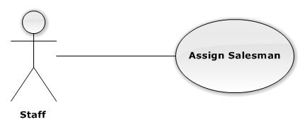

**Figure 3-26: Assign Salesman Use-Case Diagram**

##### Use-Case Specification

|  |  |  |  |
| --- | --- | --- | --- |
| USE CASE SPECIFICATION | | | |
| Use-case No. | UC0025 | Use-case Version | 1.0 |
| Use-case Name | Register | | |
| Author | Tạ Đức Tùng | | |
| Date | 1/10/2015 | Priority | Normal |
| Actor:  Staff.  Summary:  This Use Case help Staff assign Salesman to group they manage.  **Goal:**  Help Salesman manage their Drugstore easier.  Triggers:  Staff choose a Salesman and assign to group.  Preconditions:  At least 1 Salesman exists in System.  At least 1 Group exists in System.  Post Conditions:  Salesman assigned to Group.  Main Success Scenario:   |  |  |  | | --- | --- | --- | | Step | Actor | Action | | 1 | User | Choose a Salesman and assign to any Group they want. | | 2 | System | Display message “Bạn có muốn chỉ định nhân viên tiếp thị [UserName] quản lý nhóm của hàng [NameGroup]?”. | | 3 | User | Click on [Xác nhận] button. | | 4 | System | Assign Salesman to Group and Display message “Đã chỉ định thành công” |   Alternative Scenario:   |  |  |  | | --- | --- | --- | | # | Actor | Action | | 1 | User | Click on “Hủy” button | | System | System redirect to Previous Page |   Exceptions:  N/A  Relationships:  N/A  Business Rules:   |  |  | | --- | --- | | # | Business Rule Description | | 1 | At least 1 Salesman exists in System. | | 2 | At least 1 Group exist in System. | | 3 | Needed Internet Access. | | | | |

#### UC0026 <Staff> Create Category

##### Use-Case Diagram

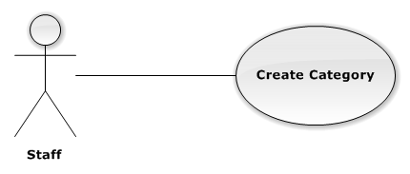

**Figure 3-27: Create Category Use-Case Diagram**

##### Use-Case Specification

|  |  |  |  |
| --- | --- | --- | --- |
| USE CASE SPECIFICATION | | | |
| Use-case No. | UC0026 | Use-case Version | 1.0 |
| Use-case Name | Create Category | | |
| Author | Tạ Đức Tùng | | |
| Date | 1/10/2015 | Priority | Normal |
| Actor:  Staff.  Summary:  This Use Case help Staff Create Category to System.  **Goal:**  Help Staff Create Category to System, easily to Group Drug.  Triggers:  Go to [Quản lý nhóm thuốc] page.  Preconditions:  User has logged in with Staff role.  Post Conditions:  Category Created.  Main Success Scenario:   |  |  |  | | --- | --- | --- | | Step | Actor | Action | | 1 | User | Staff go to [Quản lý nhóm thuốc] and click on “Tạo mới danh mục thuốc”. | | 2 | System | Display [Tạo mới nhóm thuốc] screen with text box for guest input all necessary field. | | 3 | User | Input all required field. | | 4 | System | Validate all input date. Send invalid message (if have invalid data). | | 5 | User | Guest click on [Đồng ý] button. | | 6 | System | Create new Category to database and Display message “Tạo mới thành công”. | | 7 | System | Go back to Previous Page. |   Alternative Scenario:   |  |  |  | | --- | --- | --- | | # | Actor | Action | | 1 | User | Click on [Hủy] button. | | System | System redirect to Previous Page. |   Exceptions:   |  |  |  | | --- | --- | --- | | # | User | System | | 1 | User | Not input enough information required. | | System | Display message error: “Vui lòng điền thông tin vào những ô bắt buộc”. |   Relationships:  N/A  Business Rules:   |  |  | | --- | --- | | # | Business Rule Description | | 1 | User has logged in with Staff role. | | 2 | Needed Internet Access. | | | | |

#### UC0027 <Staff> Delete Category

##### Use-Case Diagram

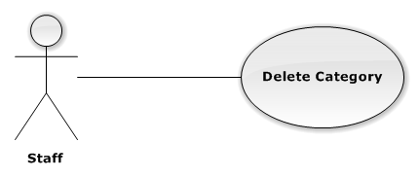

**Figure 3-28: Delete Category Use-Case Diagram**

##### Use-Case Specification

|  |  |  |  |
| --- | --- | --- | --- |
| USE CASE SPECIFICATION | | | |
| Use-case No. | UC0027 | Use-case Version | 1.0 |
| Use-case Name | Delete Category | | |
| Author | Tạ Đức Tùng | | |
| Date | 1/10/2015 | Priority | Normal |
| Actor:  Staff.  Summary:  This Use Case help Staff Delete a Category.  **Goal:**  Help Staff can Delete an unnecessary Category form system.  Triggers:  Staff go to [Quản lý nhóm thuốc] page.  Preconditions:  Guest does not have an account in system.  Post Conditions:  User Homepage display.  Main Success Scenario:   |  |  |  | | --- | --- | --- | | Step | Actor | Action | | 1 | User | Go to [Quản lý nhóm thuốc] page and click on [Xóa] button on the right side of [Nhóm thuốc]. | | 2 | System | Display message “Bạn muốn xóa danh mục này?” | | 3 | User | Click on [Xác nhận] button. | | 4 | System | Delete from database and display message “Xóa thành công”. | | 5 | System | Redirect to Previous Page. |   Alternative Scenario:   |  |  |  | | --- | --- | --- | | # | Actor | Action | | 1 | User | Click on [Hủy] button. | | System | System redirect to Previous Page. |   Exceptions:  N/A  Relationships:  N/A  Business Rules:   |  |  | | --- | --- | | # | Business Rule Description | | 1 | User has logged in with Staff role. | | 2 | At least 1 Category exists in System. | | | | |

#### UC0028 <Staff> Edit Category

##### Use-Case Diagram

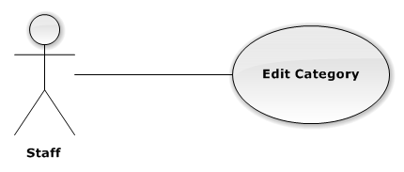

**Figure 3-29: Edit Category Use-Case Diagram**

##### Use-Case Specification

|  |  |  |  |
| --- | --- | --- | --- |
| USE CASE SPECIFICATION | | | |
| Use-case No. | UC0028 | Use-case Version | 1.0 |
| Use-case Name | Edit Category | | |
| Author | Tạ Đức Tùng | | |
| Date | 1/10/2015 | Priority | Normal |
| Actor:  Staff.  Summary:  This Use Case allow Staff edit information of Category.  **Goal:**  Help Staff update latest information about Category.  Triggers:  Staff go to [Quản lý nhóm thuốc] page.  Preconditions:  At least 1 Category exists in System.  Post Conditions:  Category information Updated.  Main Success Scenario:   |  |  |  | | --- | --- | --- | | Step | Actor | Action | | 1 | User | Go to [Quản lý nhóm thuốc] page and click on [Sửa] button on the right side of [Nhóm thuốc]. | | 2 | System | Display [Chỉnh sử nhóm thuốc] page with text box for guest input all necessary field. | | 3 | User | Input all required field | | 4 | System | Validate all input data. | | 5 | User | Guest click on [Đồng ý] button. | | 6 | System | Display message “Cập nhật thành công” | | 7 | System | Redirect to Previous page |   Alternative Scenario:   |  |  |  | | --- | --- | --- | | # | Actor | Action | | 1 | User | Click on [Hủy] button | | System | System redirect to Previous page. |   Exceptions:   |  |  |  | | --- | --- | --- | | # | User | System | | 1 | User | Not input enough information required | | System | Display message error: “Vui lòng điền thông tin vào những ô bắt buộc” |   Relationships:  N/A  Business Rules:   |  |  | | --- | --- | | # | Business Rule Description | | 1 | User has logged in with Staff role. | | 2 | At least 1 Category exists in System. | | 3 | Needed Internet Access. | | | | |

#### UC0029 <Staff> Create Delivery Schedule

##### Use-Case Diagram

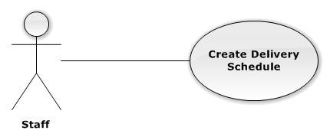

**Figure 3-30: Create Delivery Use-Case Diagram**

##### Use-Case Specification

|  |  |  |  |
| --- | --- | --- | --- |
| USE CASE SPECIFICATION | | | |
| Use-case No. | UC0029 | Use-case Version | 1.0 |
| Use-case Name | Create Delivery Schedule | | |
| Author | Tạ Đức Tùng | | |
| Date | 1/10/2015 | Priority | Normal |
| Actor:  Staff.  Summary:  This Use Case help Staff Create delivery schedule.  **Goal:**  Help Deliveryman move in shortest path and exactly address.  Triggers:  Go to [Quản lý đơn giao hàng] page.  Preconditions:  At least 1 Confirmed Order exists in system.  Post Conditions:  ***On success:***Delivery schedule created.  Main Success Scenario:   |  |  |  | | --- | --- | --- | | Step | Actor | Action | | 1 | User | Staff go to [Quản lý dơn giao hàng] click on [Tạo lịch giao hàng] button. | | 2 | System | Show all Confirm order. | | 3 | User | Choose Delivery man. | | 4 | System | Delivery Schedule created. |   Alternative Scenario:   |  |  |  | | --- | --- | --- | | # | Actor | Action | | 1 | User | Click on [Hủy] button | | System | System redirect to Previous page. |   Exceptions:  N/A  Relationships:  N/A  Business Rules:   |  |  | | --- | --- | | # | Business Rule Description | | 1 | At least 1 Confirmed exists in System. | | 2 | Needed Internet Access. | | | | |

#### UC0030 <Staff> Update Schedule Status

##### Use-Case Diagram



**Figure 3-31: Update Delivery Status Use-Case Diagram**

##### Use-Case Specification

|  |  |  |  |
| --- | --- | --- | --- |
| USE CASE SPECIFICATION | | | |
| Use-case No. | UC0030 | Use-case Version | 1.0 |
| Use-case Name | Update delivery status | | |
| Author | Tạ Đức Tùng | | |
| Date | 1/10/2015 | Priority | Normal |
| Actor:  Staff.  Summary:  This Use Case help Staff update Delivery status in system.  **Goal:**  Help Drugstore know their order status.  Triggers:  Staff go to [Quản lý đơn giao hàng] page.  Preconditions:  Guest does not have an account in system.  Post Conditions:  User Homepage display.  Main Success Scenario:   |  |  |  | | --- | --- | --- | | Step | Actor | Action | | 1 | User | Guest go to Homepage and clicks on [Hoàn thành] button. | | 2 | System | Change Order status “Hoàn thành”. |   Alternative Scenario:  N/A  Exceptions:  N/A  Relationships:  N/A  Business Rules:   |  |  | | --- | --- | | # | Business Rule Description | | 1 | Needed Internet Access. | | | | |

#### UC0031 <Administrator> Create Account

##### Use-Case Diagram

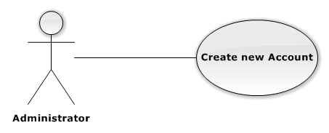

**Figure 3-35: Create New Account Use-Case Diagram**

##### Use-Case Specification

|  |  |  |  |
| --- | --- | --- | --- |
| USE CASE SPECIFICATION | | | |
| Use-case No. | UC0031 | Use-case Version | 1.0 |
| Use-case Name | Create Account | | |
| Author | Tạ Đức Tùng | | |
| Date | 1/10/2015 | Priority | Normal |
| Actor:  Administrator.  Summary:  This Use Case help Admin Create Account.  **Goal:**  Help Staff, Salesman have account in system.  Triggers:  Go to [Quản lý tài khoản] page.  Preconditions:  Admin has logged in to System.  Post Conditions:  Account Created.  Main Success Scenario:   |  |  |  | | --- | --- | --- | | Step | Actor | Action | | 1 | User | Admin go to [Quản lý tài khoản] page and click on [Tạo tài khoản] button. | | 2 | System | Display [Tạo tài khoản] screen with text box for Admin input all necessary to create new account. | | 3 | User | Input all required field | | 4 | System | Validate all input date. Send invalid message (if have invalid data) | | 5 | User | Admin click on [Xác nhận] button. | | 6 | System | System creates new account. | | 7 | System | Redirect to Previous page. |   Alternative Scenario:   |  |  |  | | --- | --- | --- | | # | Actor | Action | | 1 | User | Click on [Hủy] button | | System | System redirect to Previous Page. |   Exceptions:   |  |  |  | | --- | --- | --- | | # | User | System | | 1 | User | Not input enough information required | | System | Display message error: “Vui lòng điền thông tin vào những ô bắt buộc” |   Relationships:  N/A  Business Rules:   |  |  | | --- | --- | | # | Business Rule Description | | 1 | User has logged in system with Admin role. | | 2 | Need Internet Access. | | | | |

#### UC0032 <Administrator> Deactivate Account

##### Use-Case Diagram

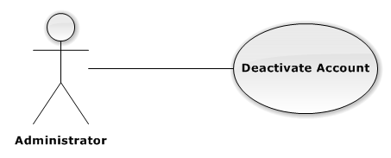

**Figure 3-36: Deactivate Account Use-Case Diagram**

##### Use-Case Specification

|  |  |  |  |
| --- | --- | --- | --- |
| USE CASE SPECIFICATION | | | |
| Use-case No. | UC0032 | Use-case Version | 1.0 |
| Use-case Name | Register | | |
| Author | Tạ Đức Tùng | | |
| Date | 1/10/2015 | Priority | Normal |
| Actor:  Administrator.  Summary:  This Use Case help Admin ban Account in system.  **Goal:**  Help Admin deactivate account in system.  Triggers:  Admin go to [Quản lý tài khoản] page.  Preconditions:  At least 1 account exists in System.  Post Conditions:  Account has Deactivated.  Main Success Scenario:   |  |  |  | | --- | --- | --- | | Step | Actor | Action | | 1 | User | Admin go to [Quản lý tài khoản] and click on [Khóa] button on the right of [AccountName]. | | 2 | System | Deactivated account and change status to “Đã Khóa” |   Alternative Scenario:  N/A  Exceptions:  N/A  Relationships:  N/A  Business Rules:   |  |  | | --- | --- | | # | Business Rule Description | | 1 | At least 1 Active Account exists in System. | | 2 | Needed Internet Access. | | | | |

#### UC0033 <Administrator> Register

##### Use-Case Diagram

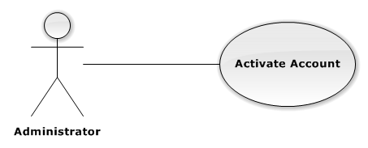

**Figure 3-37: Activate Account Use-Case Diagram**

##### Use-Case Specification

|  |  |  |  |
| --- | --- | --- | --- |
| USE CASE SPECIFICATION | | | |
| Use-case No. | UC0033 | Use-case Version | 1.0 |
| Use-case Name | Register | | |
| Author | Tạ Đức Tùng | | |
| Date | 1/10/2015 | Priority | Normal |
| Actor:  Administrator.  Summary:  This Use-Case allow Admin re-activate account.  **Goal:**  Help Deactivated account change to activate status.  Triggers:  Admin go to [Quản lý tài khoản] page.  Preconditions:  At least 1 Deactivated Account exists in System.  Post Conditions:  Activate Account.  Main Success Scenario:   |  |  |  | | --- | --- | --- | | Step | Actor | Action | | 1 | User | Admin go to [Quản lý tài khoản] page and click on [Activate] button on the right side of [Mở khóa]. | | 2 | System | Re-Active account and change status to Active. |   Alternative Scenario:  N/A  Exceptions:  N/A  Relationships:  N/A  Business Rules:   |  |  | | --- | --- | | # | Business Rule Description | | 1 | At least 1 Deactivated Account exists in System. | | 2 | Needed Internet Access. | | | | |

### Non-functional Requirements

#### Reliability

Information about drug are provided by Staff in such a way that preserves the most accurate and up-to-date data.

#### Security

Authentication is required when the user utilizes certain function in system. Password must be encrypted so the even they are unrecognizable even to System Administrator and Database Administrator. System should also require authorization when user tries to access an unauthorized function.

#### Maintainability

In the architecture design of the system, the responsibilities of all component should be clear and do not overlap each other. The communication with a web service provider should be packaged in single module independent from the rest of the system. The module should support plug-and-play, so when the web service provider change the structure of web service result, or when system work with other web service provider. Minimal changes to rest of system are required.

## Entity Relationship Diagram

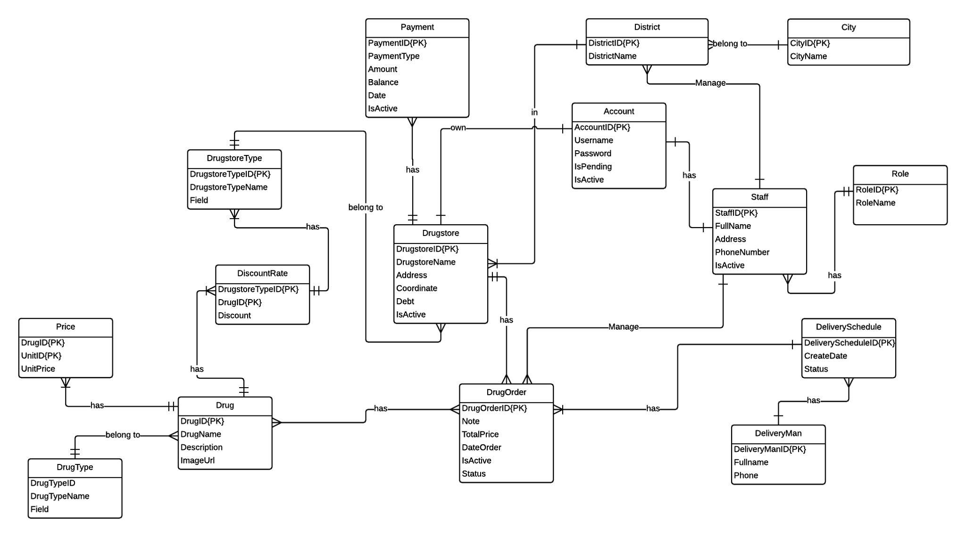

**Figure 3-38: Entities Relationship Diagram**



## Architectured Design

### Choice of Architecture Design

#### MVC Model Overview

**CONTROLLER**

* Intercepts user input;
* Coordinates the view and model;
* Handles communication between the model anddata layer.

**VIEW**

* Binds to the model;
* Renders the UIs (HTML, CSS, JavaScript);
* Allows navigating between controllers.

**MODEL**

* Communicates with data source;
* Exposes functionalities, business logics, and data validation.

Database   
Server

Application Server

1. Request

8. Response

5. Select views

7.Changes made

2. Invoke methods

6. Query states

Method invocations

Change notifications

**Figure 4-1: Model-View-Controller Model**

The components in MVC Model :

* **Model** is the part of the application that handles the logic for the application data. Often model objects retrieve data (and store data) from a database.
* **View** is the parts of the application that handles the display of the data. Most often the views are created from the model data.
* **Controller** is the part of the application that handles user interaction. Typically controllers read data from a view, control user input, and send input data to the model.

#### Advantages and Disadvantages of Layer Model

* **Advantages:**
* Easy to maintain the code and future improvements.
* Each object in mvc have distinct responsibilities.So change in one class doesn't need alternation in other classes.
* Clear separation between presentation logic and business logic.
* **Disadvantages:**
* For parallel development there is a needed multiple programmers.
* Too complex to implement and is not suitable for smaller application.

### Component Design

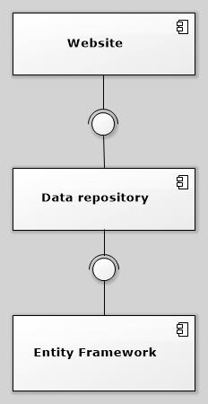

**Figure 4-2: Component Design**

The DMS system includes the following major components:

* **Entity Framework:** An object-relational mapper that enables working with relational data persistence using domain-specific objects;
* **Data Repository:** A data store that provides data access functionality, using the Entity Framework to communicates with the database;
* **Website:** A web-application that helps exposes all the functionalities to end-users.

From the point of view of the MVC-III pattern, the components Entity Framework 5.0, Data Repository all belong to the Model part. The Controller and the View parts are wrapped in the component Website.

## Detail Description of Components

### Entities Classes

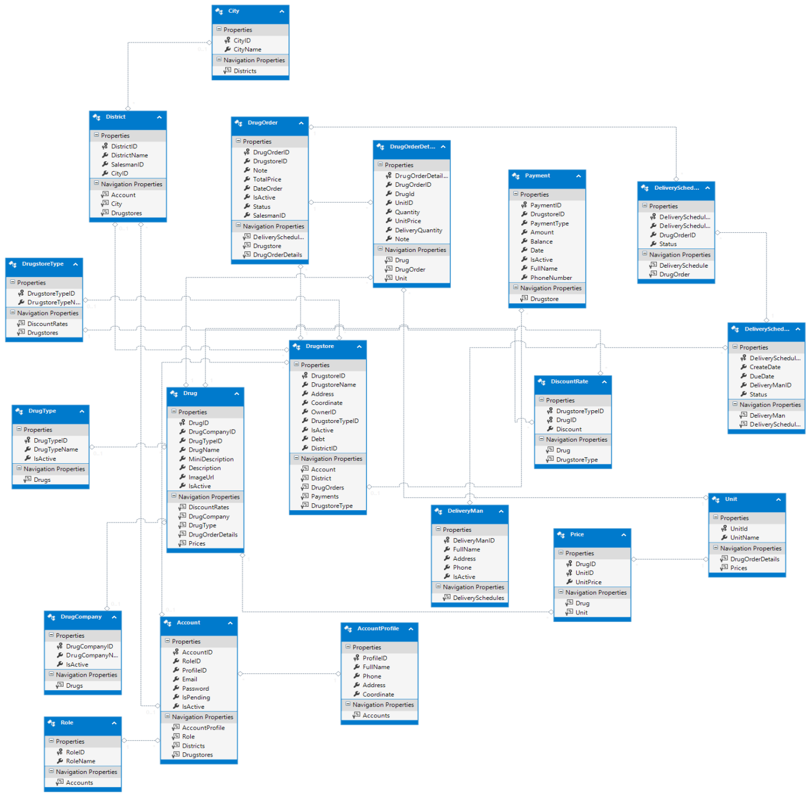

**Figure 4-3: Entities Class Diagram**

### Generic Repository Class



**Figure 4-4: Data Repository Class Diagram**

Properties:

|  |  |  |  |
| --- | --- | --- | --- |
| **Property Name** | **Type** | **Visibility** | **Description** |
| Context | DMPEntities | internal | Database context |
| bdSet | DbSet<TEntity> | internal | The entity set that the repository is instantiated for. |

Operations:

|  |  |  |
| --- | --- | --- |
| **Signature:** voidDelete(objectid)  **Description:** Delete an entity by given id. | | |
| **Parameter** | **Type** | **Description** |
| *id* | Object | ID of the entity to be deleted |

|  |  |  |
| --- | --- | --- |
| **Signature:** voidDelete(TEntity entityToDelete)  **Description:** Delete entity which was given by id | | |
| **Parameter** | **Type** | **Description** |
| entityToDelete | TEntity | Entity instance of the entity to be deleted. |

|  |  |  |
| --- | --- | --- |
| **Signature:** GenericRepository(DMPEntities context)  **Description:** The constructor accepts a database context instance and initializes the entity set variable. | | |
| **Parameter** | **Type** | **Description** |
| context | DMPEntites | Database context |

|  |  |  |
| --- | --- | --- |
| **Signature:** IEnumerable<TEntity> Get(  Expression<Func<TEntity, bool>> filter = null,  Func<IQueryable<TEntity>, IOrderedQueryable<TEntity>> orderBy = null,  string includeProperties = "")  **Description:** This method uses lambda expressions to allow the calling code to specify a filter condition and a column to order the results by, and a string parameter lets the caller provide a comma-delimited list of navigation properties for eager loading. | | |
| **Parameter** | **Type** | **Description** |
| filter | Expression<Func<TEntity, bool>> | The caller will provide a lambda expression based on the TEntity type, and this expression will return a Boolean value. |
| orderBy | Func<IQueryable<TEntity>, IOrderedQueryable<TEntity>> | The input to the expression is an IQueryable object for the TEntitytype. The expression will return an ordered version of that IQueryable object. |

|  |  |  |
| --- | --- | --- |
| **Signature:** IEnumerable<TEntity>GetAll()  **Description:** Get all entity. | | |
| **Parameter** | **Type** | **Description** |

|  |  |  |
| --- | --- | --- |
| **Signature:** voidGetByID(object id)  **Description:** Get an entity by given id. | | |
| **Parameter** | **Type** | **Description** |
| Id | Object | ID of the entity to be deleted |

|  |  |  |
| --- | --- | --- |
| **Signature:** boolInsert(TEntityentity)  **Description:** Insert an entity by given id. | | |
| **Parameter** | **Type** | **Description** |
| entity | TEntity | Entity instance of the entity to be inserted. |

|  |  |  |
| --- | --- | --- |
| **Signature:** voidSaveChanges()  **Description:** Save entity changes. | | |
| **Parameter** | **Type** | **Description** |

### Screen Design

#### Register

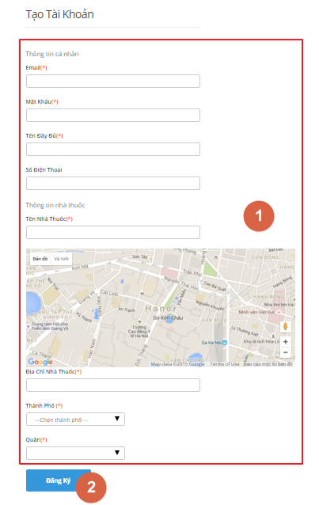

**Figure 4-5: Register Screen**

|  |  |  |  |  |
| --- | --- | --- | --- | --- |
| No | Object/Control Name | Type | Required | Description |
| 1 | Email | Textbox | Yes | Email of Drugstore |
| Mật khẩu | Textbox | Yes | Password of account |
| Tên đầy đủ | Textbox | Yes | Name of Owner |
| Số điện thoại | Textbox | Yes | Phone Number |
| Tên nhà thuốc | Textbox | Yes | Name of Drugstore |
| Địa chỉ | Textbox | Yes | Address |
| Thành phố | Dropdown List | Yes | City |
| Quận | Dropdown List | Yes | District |
| 2 | Đăng ký | Button | Yes | Click to Register |

#### Login

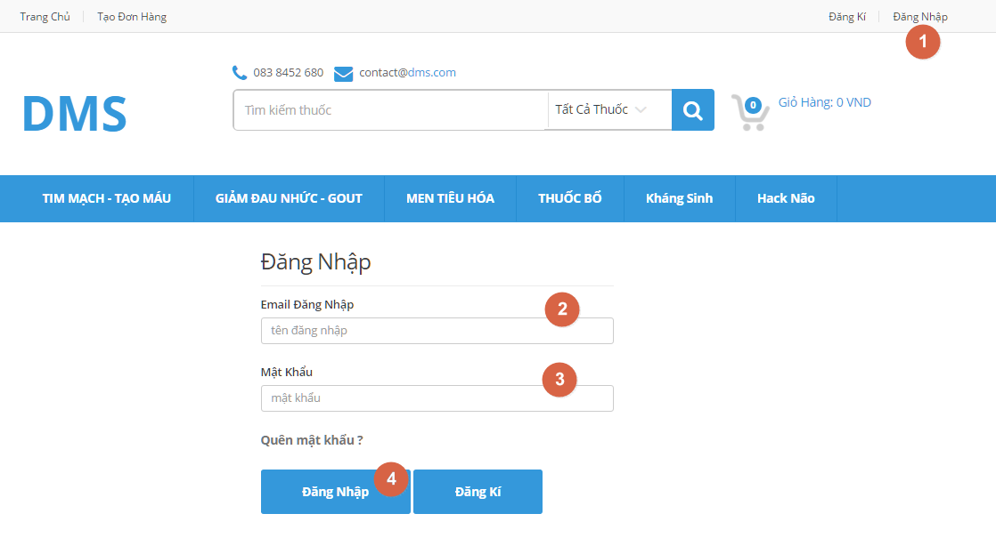

**Figure 4-6: Login Screen**

|  |  |  |  |  |
| --- | --- | --- | --- | --- |
| No | Object/Control Name | Type | Required | Description |
| 1 | Đăng nhập | Hyperlink | Yes | Click to go to [Đăng nhập] page |
| 2 | Email Đăng nhập | Textbox | Yes | Registered Email |
| 3 | Mật khẩu | Textbox | Yes | Password |
| 4 | Đăng nhập | Button | Yes | Click to Login |

#### Forgot Password

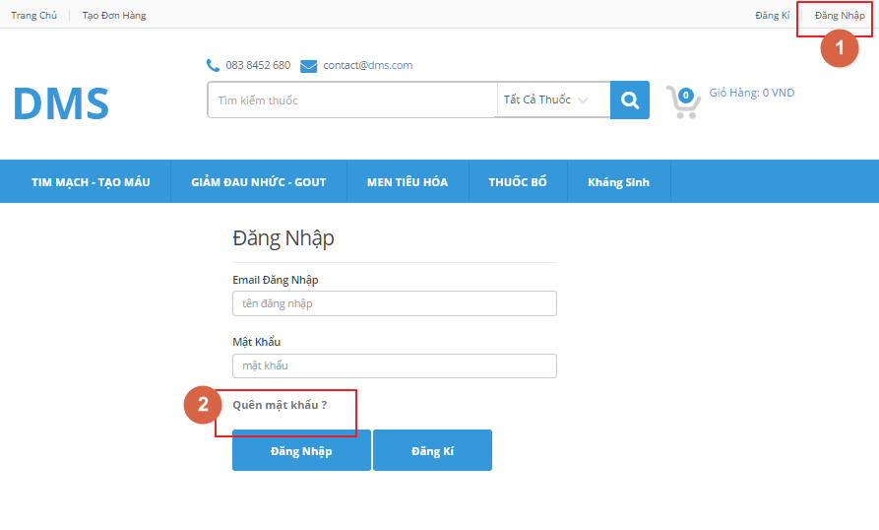

**Figure 4-7: Forgot Password Screen**

|  |  |  |  |  |
| --- | --- | --- | --- | --- |
| No | Object/Control Name | Type | Required | Description |
| 2 | Quên mật khẩu | Hyperlink | Yes | Click to go to [Quên mật khẩu] page |

#### Change Password

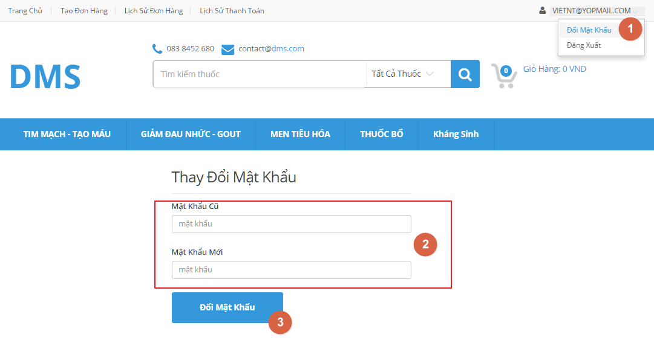

**Figure 4-8: Change Password Screen**

|  |  |  |  |  |
| --- | --- | --- | --- | --- |
| No | Object/Control Name | Type | Required | Description |
| 1 | Đổi mật khẩu | Hyperlink | Yes | Click to go to [Đổi mật khẩu] page |
| 2 | Mật khẩu cũ | Textbox | Yes | Old Password |
| 3 | Mật khẩu mới | Textbox | Yes | New Password |

#### Logout

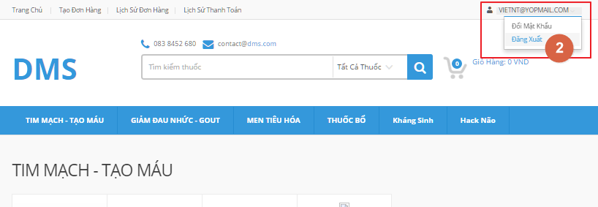

**Figure 4-9: Logout Screen**

|  |  |  |  |  |
| --- | --- | --- | --- | --- |
| No | Object/Control Name | Type | Required | Description |
| 2 | Đăng xuất | Hyperlink | Yes | Click to Logout |

#### Create Order

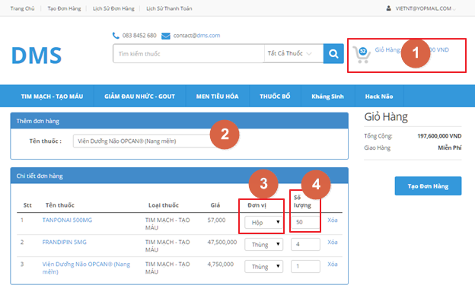

**Figure 4-10: Create Order Screen**

|  |  |  |  |  |
| --- | --- | --- | --- | --- |
| No | Object/Control Name | Type | Required | Description |
| 1 | Giỏ hang | Label | Yes | Total amount |
| 2 | Tên thuốc | Textbox | Yes | Input Drugname |
| 3 | Đơn vị | Dropdown List | Yes | Unit |
| 4 | Số lượng | Dropdown List | Yes | Quantity |

#### View Order History

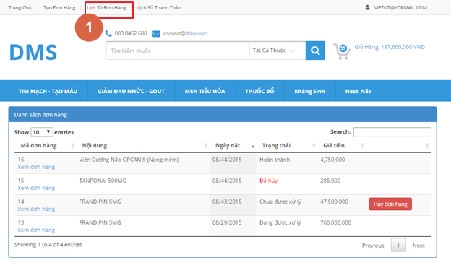

**Figure 4-11: View Order History**

|  |  |  |  |  |
| --- | --- | --- | --- | --- |
| No | Object/Control Name | Type | Required | Description |
| 1 | Lịch sử đơn hang | Hyperlink | Yes | Order History |
| 2 | Hủy đơn hang | Button | Yes | Click to Cancel Order |

#### View Payment History

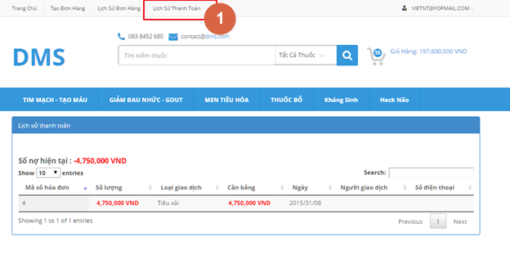

**Figure 4-12: View Payment History**

|  |  |  |  |  |
| --- | --- | --- | --- | --- |
| No | Object/Control Name | Type | Required | Description |
| 1 | Lịch sử thanh toán | Hyperlink | Yes | Click to view Order History |
| 2 | Mã số hóa đơn | Label | Yes | Receipt Number |
| 3 | Số lượng | Label | Yes | Quantity |
| 4 | Loại giao dịch | Label | Yes | Transaction kind |
| 5 | Ngày | Date/Time | Yes | Date |
| 6 | Người giao dịch | Label | Yes | People |
| 7 | Số điện thoại | Label | Yes | Phone Number |

#### Cancel Order

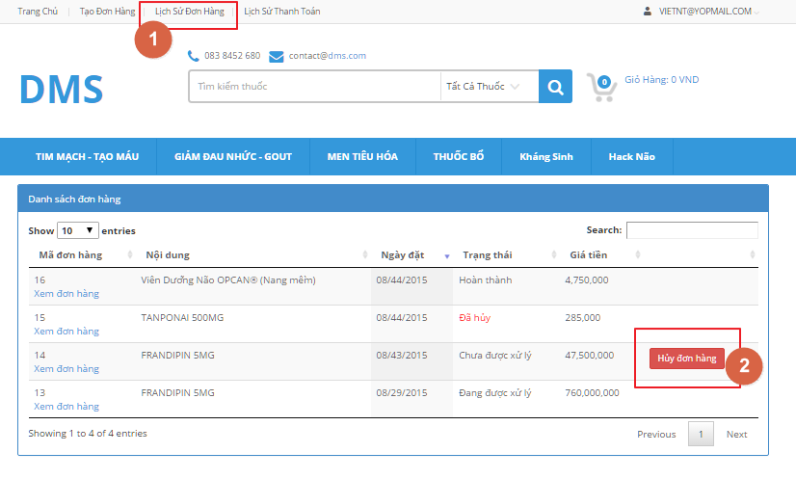

**Figure 4-12: Cancel Order Screen**

|  |  |  |  |  |
| --- | --- | --- | --- | --- |
| No | Object/Control Name | Type | Required | Description |
| 2 | Hủy đơn hang | Button | Yes | Click to Cancel Order |

#### Add Drug

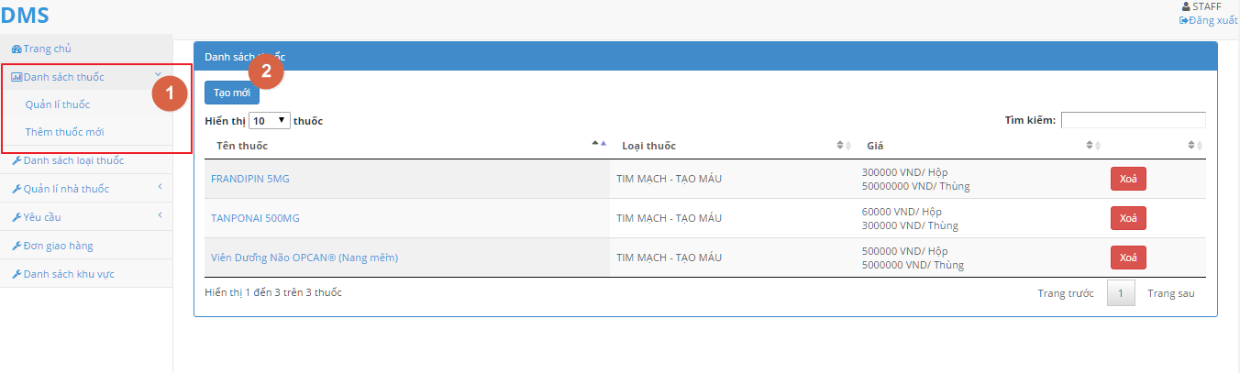

**Figure 4-13: Add Drug Screen**

|  |  |  |  |  |
| --- | --- | --- | --- | --- |
| No | Object/Control Name | Type | Required | Description |
| 1 | Quản lý thuốc | Hyperlink | Yes | Click to go to [Quản lí thuốc] |
| 2 | Tạo mới | Button | Yes | Click to Add Drug |

#### Edit Drug

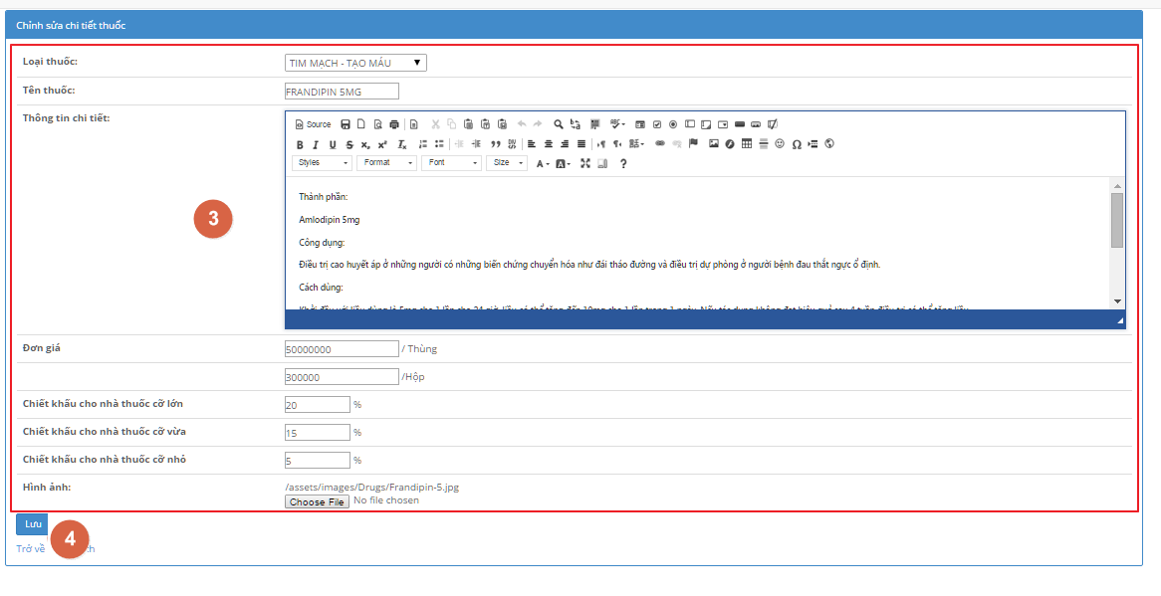

**Figure 4-14: Edit Drug Screen**

|  |  |  |  |  |
| --- | --- | --- | --- | --- |
| No | Object/Control Name | Type | Required | Description |
| 3 | Thông tin chi tiết | Editor | Yes | Input Drug Information |
| 4 | Lưu | Button | Yes | Save |

#### Delete Drug

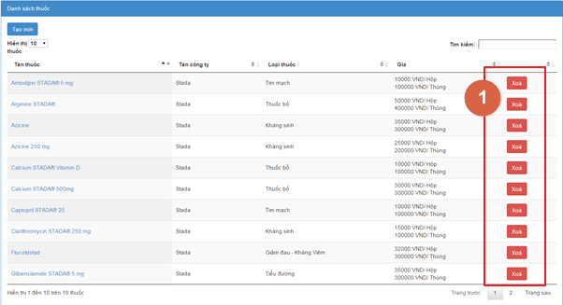

**Figure 4-15: Delete Drug Screen**

|  |  |  |  |  |
| --- | --- | --- | --- | --- |
| No | Object/Control Name | Type | Required | Description |
| 1 | Xoá | Button | Yes | Click to Delete |

#### Create Category

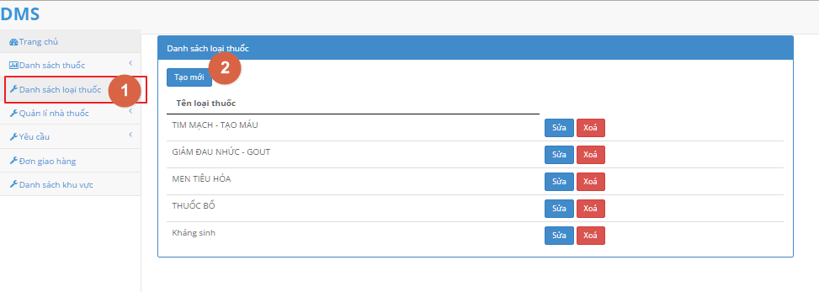

**Figure 4-16: Create Category Screen – 1**

|  |  |  |  |  |
| --- | --- | --- | --- | --- |
| No | Object/Control Name | Type | Required | Description |
| 1 | Danh sách loại thuốc | Hyperlink | Yes | Click to go to Create Category |
| 2 | Tạo mới | Button | Yes | Click to Create Category |

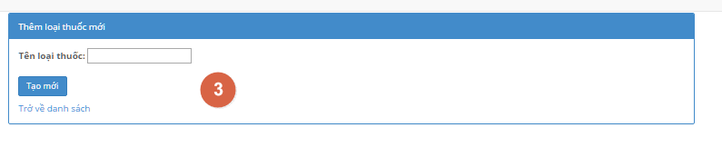

**Figure 4-17: Create Category Screen - 2**

|  |  |  |  |  |
| --- | --- | --- | --- | --- |
| No | Object/Control Name | Type | Required | Description |
| 3 | Tạo mới | Button | Yes | Click to Add Drug |

#### Edit Category

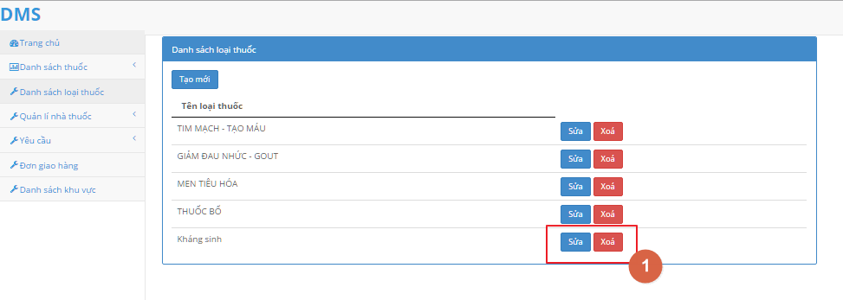

**Figure 4-18: Edit Category Screen – 1**

|  |  |  |  |  |
| --- | --- | --- | --- | --- |
| No | Object/Control Name | Type | Required | Description |
| 1 | Sửa | Button | Yes | Click to Edit |
| 1 | Xóa | Button | Yes | Click to Delete |

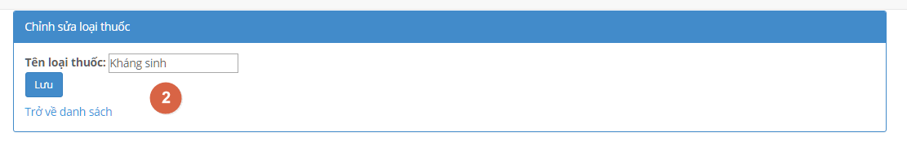

**Figure 4-19: Edit Category Screen - 2**

|  |  |  |  |  |
| --- | --- | --- | --- | --- |
| No | Object/Control Name | Type | Required | Description |
| 2 | Lưu | Button | Yes | Click to Save |

#### Approve Order

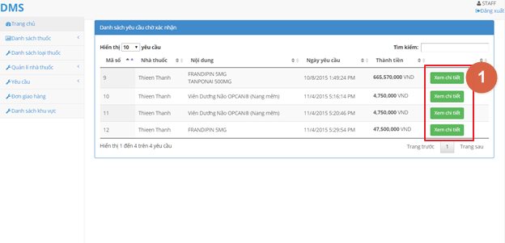

**Figure 4-20: Approve Order Screen**

|  |  |  |  |  |
| --- | --- | --- | --- | --- |
| No | Object/Control Name | Type | Required | Description |
| 1 | Xem chi tiết | Button | Yes | Click to view Order Detail |

#### Assign Salesman

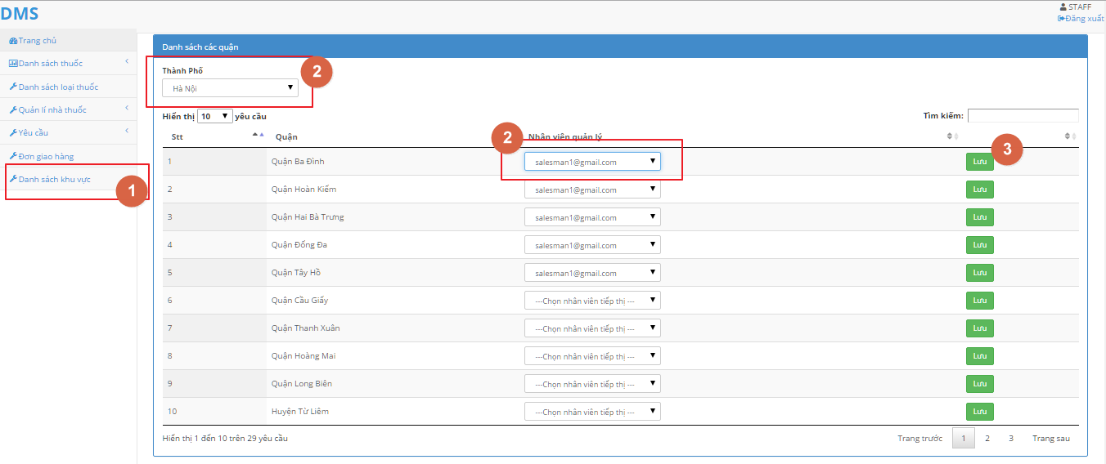

**Figure 4-21: Assign Salesman Screen**

|  |  |  |  |  |
| --- | --- | --- | --- | --- |
| No | Object/Control Name | Type | Required | Description |
| 1 | Danh sách khu vực | Hyperlink | Yes | Click to go to Assign Salesman |
| 2 | Thành Phố | Dropdown List | Yes | Click to choose city |
| 3 | Nhân viên | Dropdown List | Yes | Click to choose Salesman |
| 4 | Lưu | Button | Yes | Click to Save |

#### Create Delivery Schedule

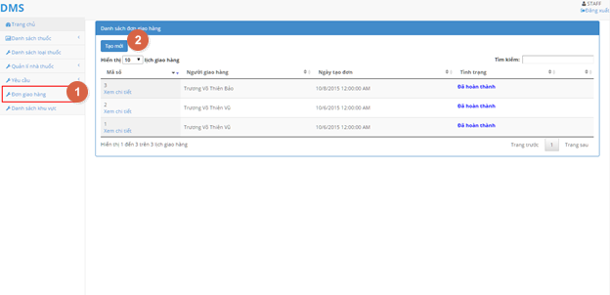

**Figure 4-22: Create Schedule Screen**

|  |  |  |  |  |
| --- | --- | --- | --- | --- |
| No | Object/Control Name | Type | Required | Description |
| 1 | Đơn giao hang | Hyperlink | Yes | Click to go to Create Schedule Page |
| 2 | Tạo mới | Button | Yes | Click to Create Schedule |

#### Update Delivery Schedule

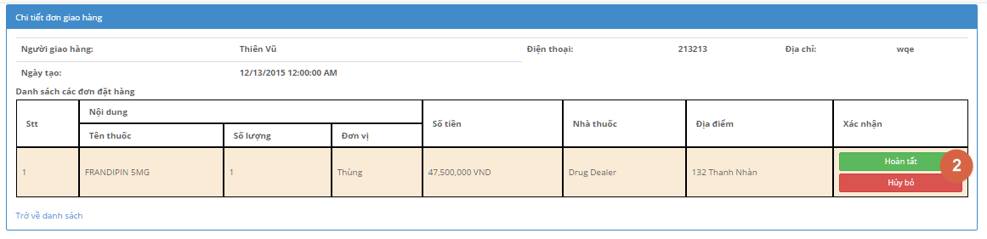

**Figure 4-23: Update Delivery Schedule Screen**

|  |  |  |  |  |
| --- | --- | --- | --- | --- |
| No | Object/Control Name | Type | Required | Description |
| 2 | Hoàn tất | Button | Yes | Click to Finish |
| 2 | Hủy Bỏ | Button | Yes | Click to Cancel |

#### Create Order for Drugstore

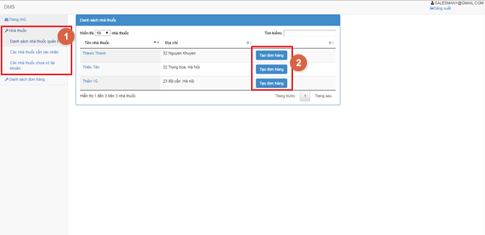

**Figure 4-24: Create Order for Drugstore Screen**

|  |  |  |  |  |
| --- | --- | --- | --- | --- |
| No | Object/Control Name | Type | Required | Description |
| 1 | Danh sách nhà thuốc | Hyperlink | Yes | Click to go to [Quản lý nhà thuốc] page |
| 2 | Tạo đơn hang | Button | Yes | Click to Create Order |

#### Verify Drugstore Account

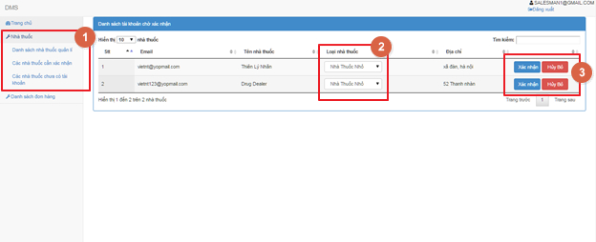

**Figure 4-25: Verify Drugstore Account**

|  |  |  |  |  |
| --- | --- | --- | --- | --- |
| No | Object/Control Name | Type | Required | Description |
| 1 | Các nhà thuốc chờ xác nhận | Hyperlink | Yes | Click to go to [Các nhà thuốc chờ xác nhận] page |
| 2 | Nhà thuốc nhỏ | Dropdown List | Yes | Choose kind of Drugstore |
| 3 | Xác nhận | Button | Yes | Click to Confirm |
| 3 | Hủy bỏ | Button | Yes | Click to Ignore |

#### View Order

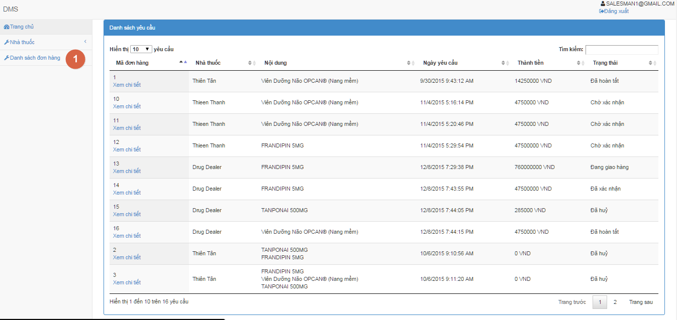

**Figure 4-26: View Order Screen**

#### View Order Detail

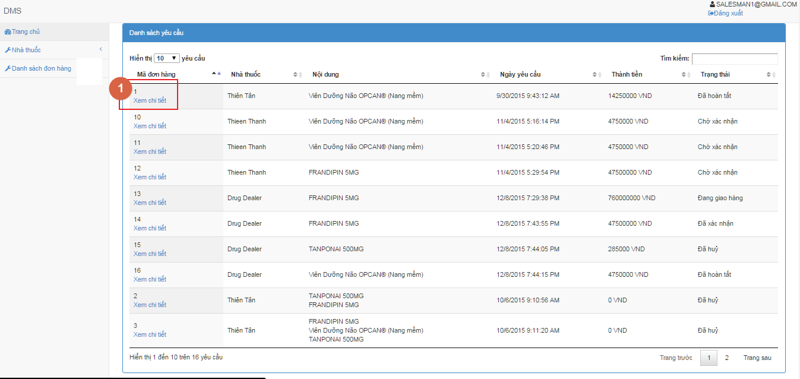

**Figure 4-27: View Order Detail Screen**

#### Manage Drugstore account

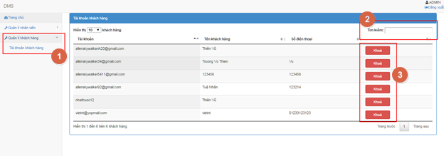

**Figure 4-28: Manage Drugstore Account**

|  |  |  |  |  |
| --- | --- | --- | --- | --- |
| No | Object/Control Name | Type | Required | Description |
| 2 | Tìm kiếm | Textbox | Yes | Input Keyword to search |
| 3 | Khóa | Button | Yes | Click to Deactivate account |

### Sequence Diagram

#### <Guest> Register

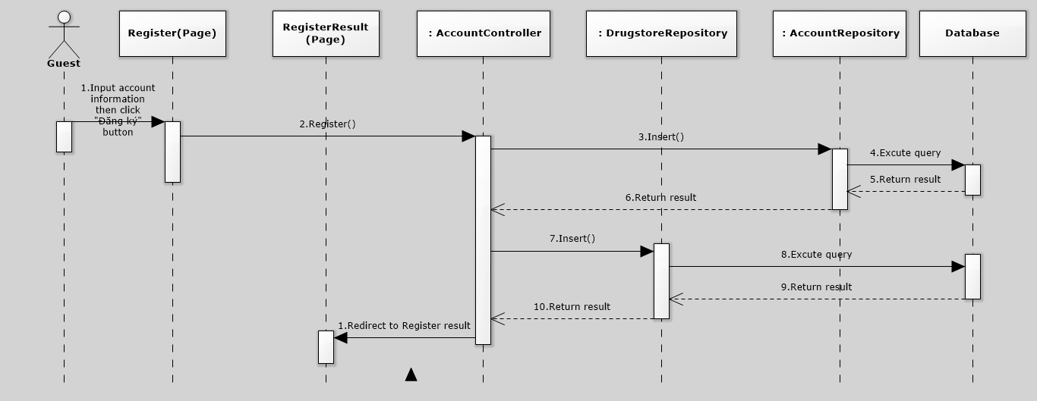

**Figure 4-29: Register Sequence Diagram**

#### <Guest> Login

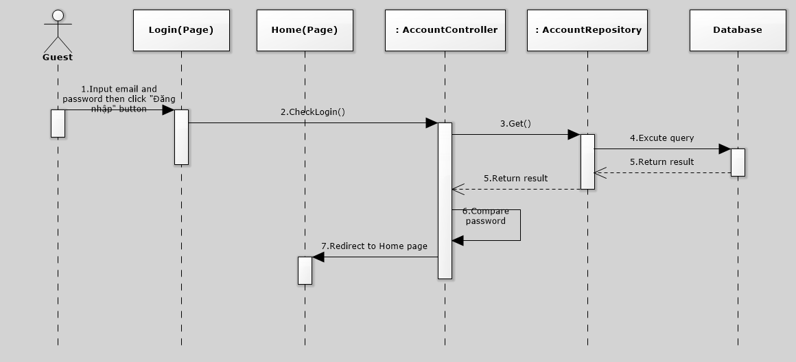

**Figure 4-30: Login Sequence Diagram**

#### <User> Create Order

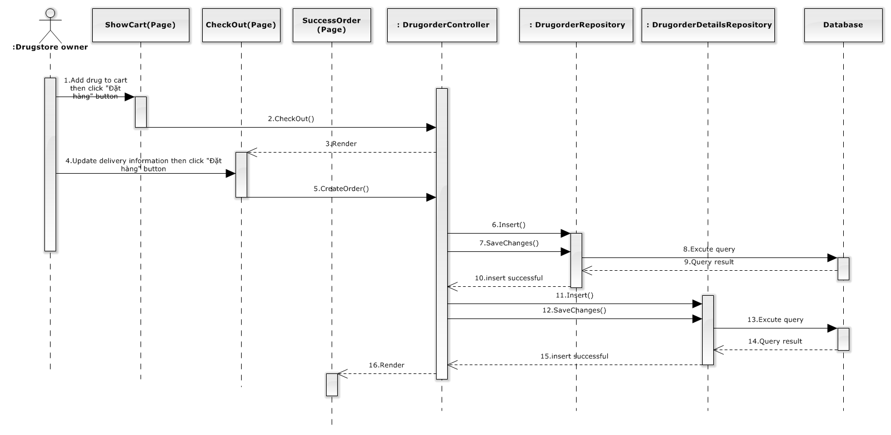

**Figure 4-31: Create Order Sequence Diagram**

#### <User> View Order history

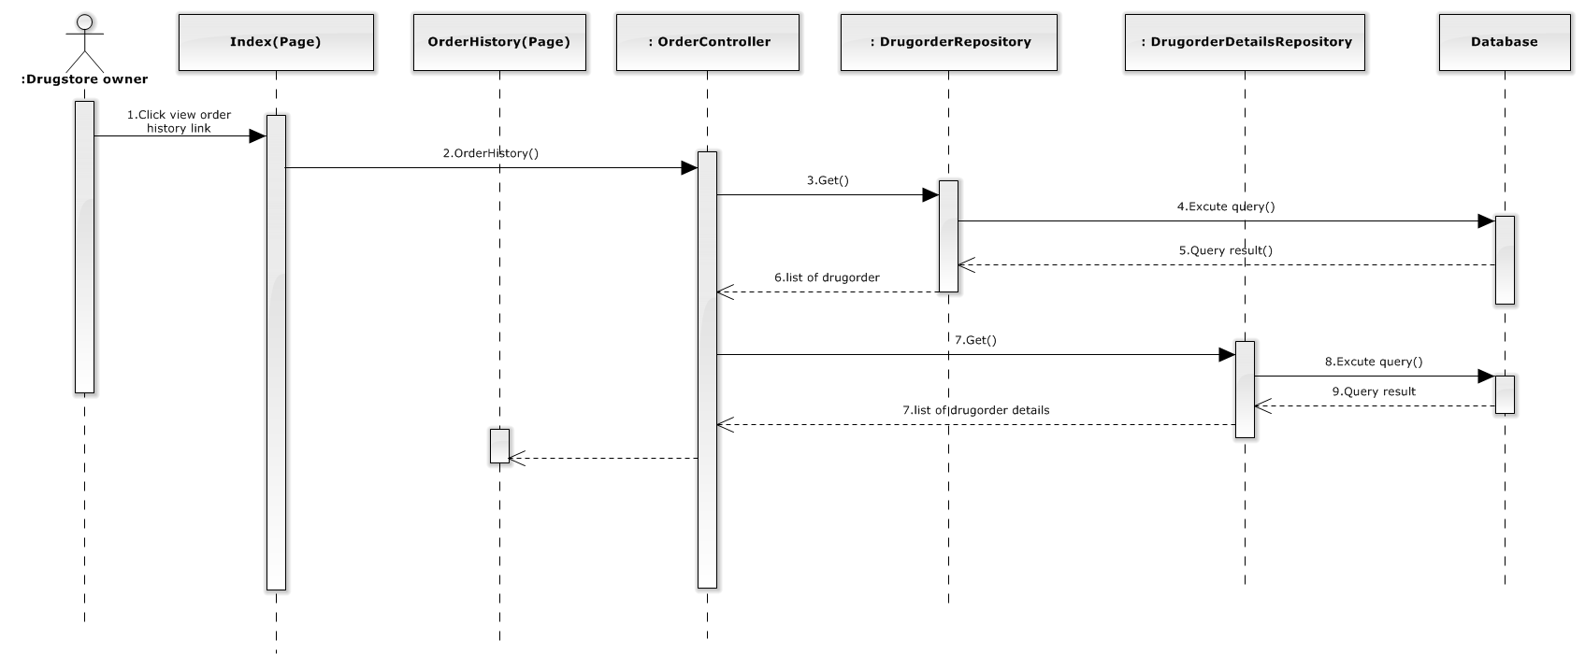

**Figure 4-32: View Order History Sequence Diagram**

#### <Staff> Approve Order

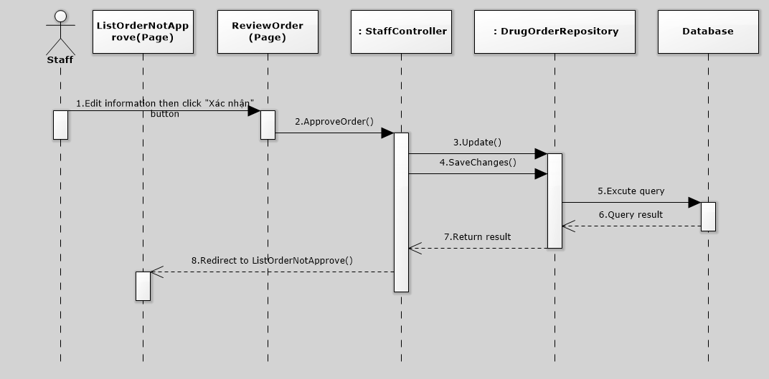

**Figure 4-33: Approve Order Sequence Diagram**

#### <Staff> Assign Salesman

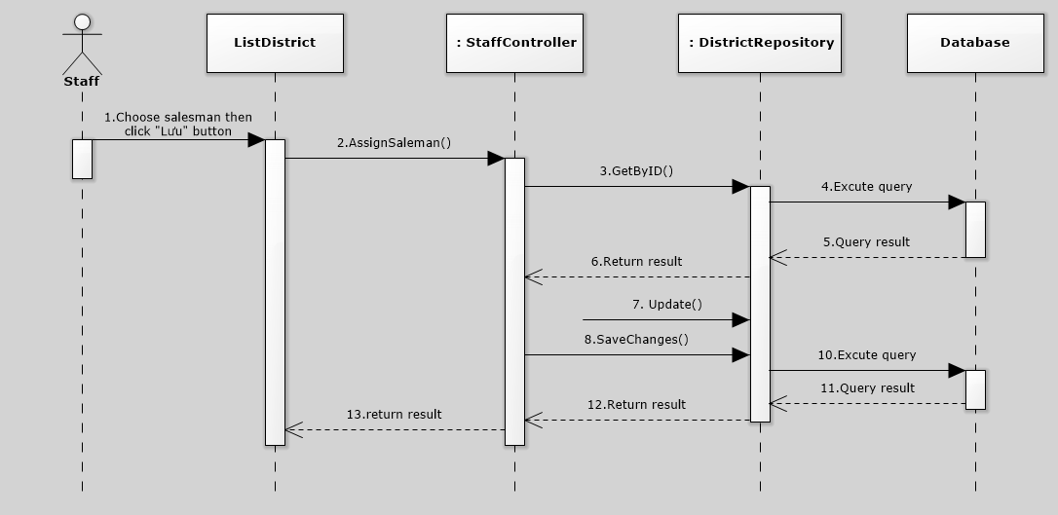

**Figure 4-34: Assign Salesman Sequence Diagram**

#### <Staff> Create Delivery Schedule

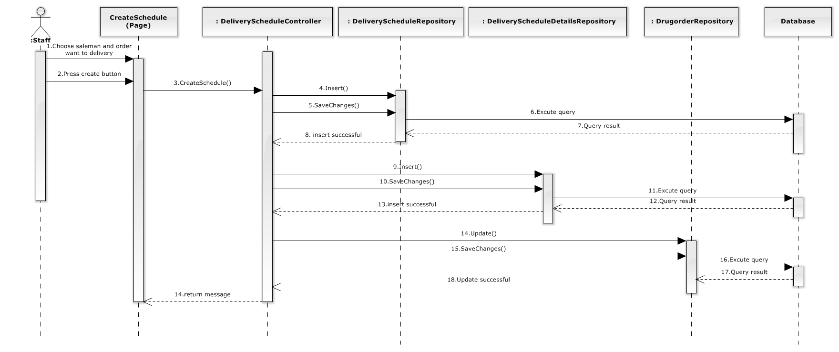

**Figure 4-35: Create Delivery Schedule Diagram**

#### <Staff> Delete Delivery Schedule

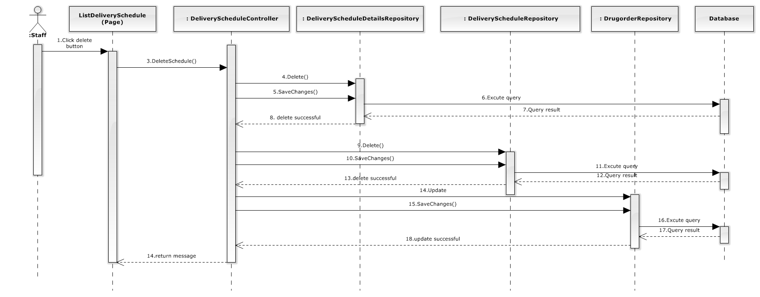

**Figure 4-36: Delete Delivery Schedule Sequence Diagram**

#### <Staff> Add Drug

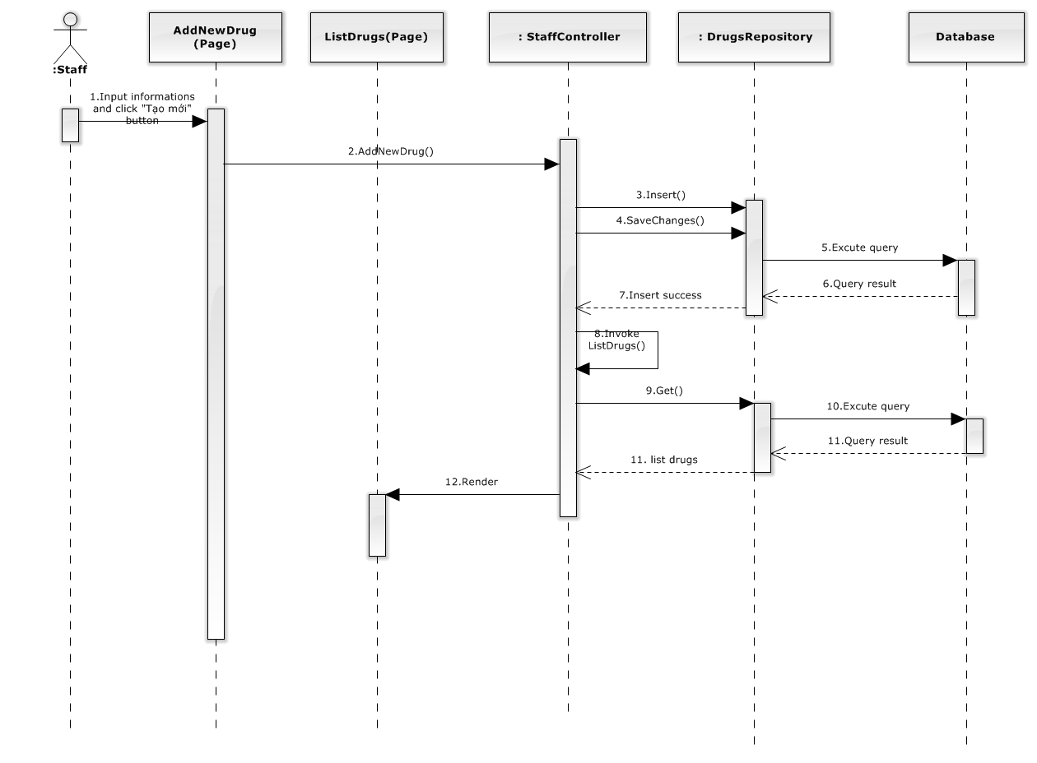

**Figure 4-37: Add Drug Sequence Diagram**

#### <Staff> Edit Drug

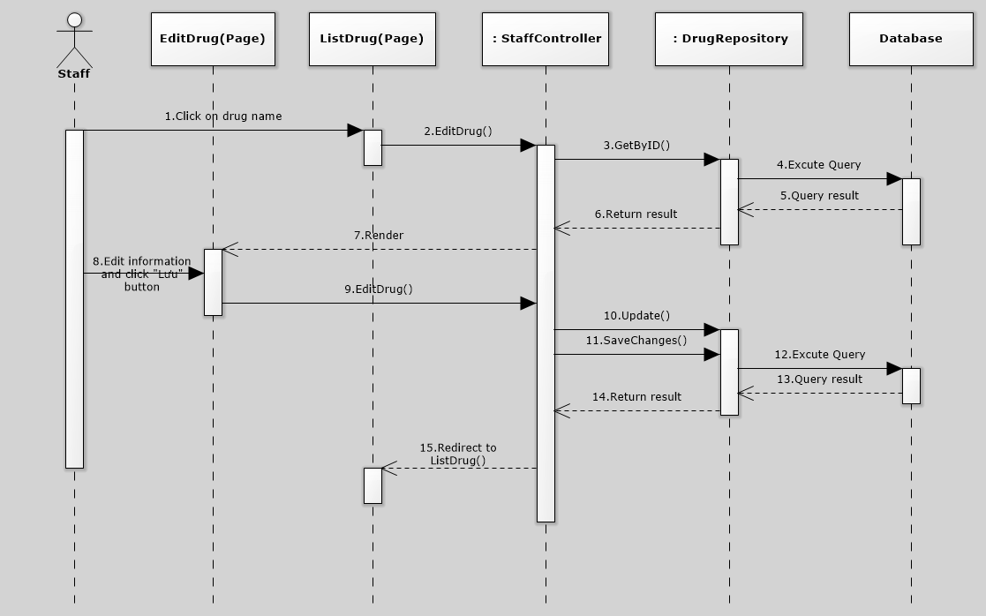

**Figure 4-38: Delete Drug Sequence Diagram**

#### <Staff> Delete Drug

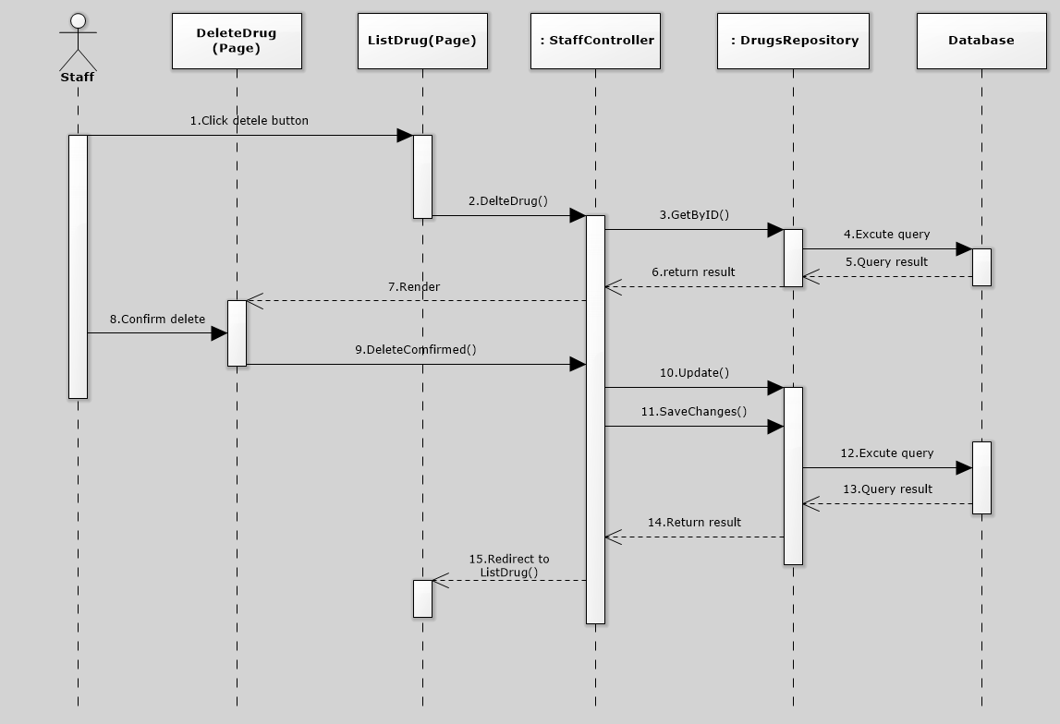

**Figure 4-39: Delete Drug Sequence Diagram**

#### <Staff> Create Category

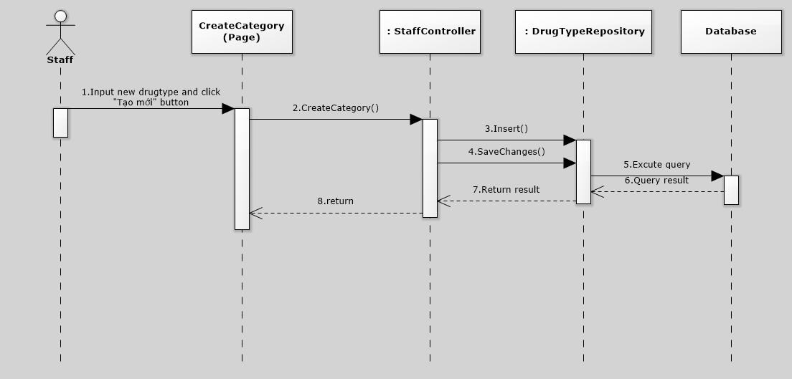

**Figure 4-40: Create Category Sequence Diagram**

#### <Staff> Edit Category

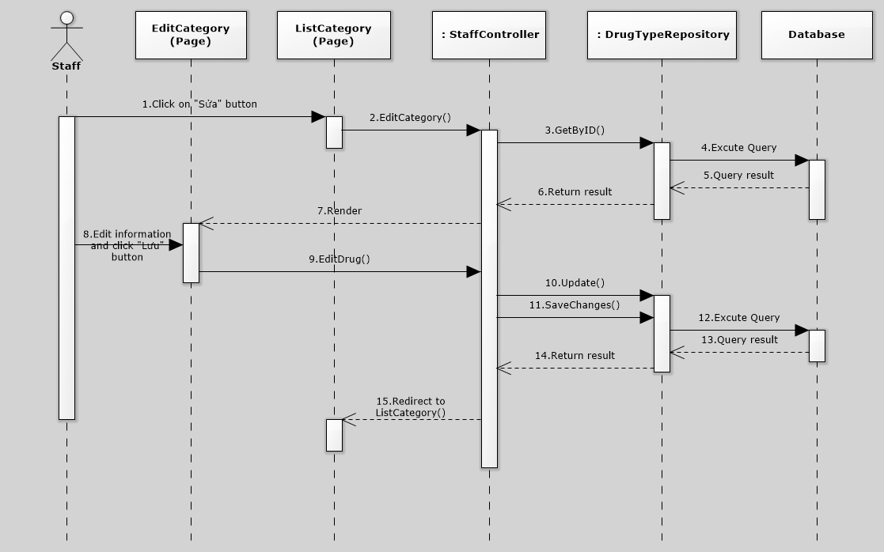

**Figure 4-41: Edit Category Sequence Diagram**

#### <Staff> Delete Category

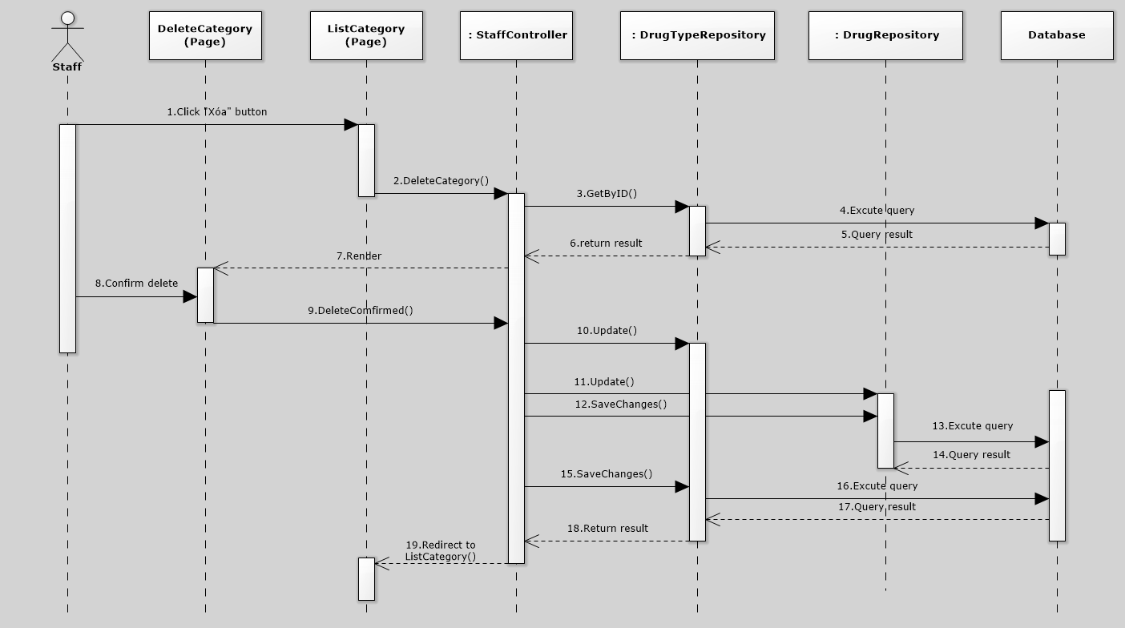

**Figure 4-42: Delete Category Sequence Diagram**

#### <Admin> Create Staff

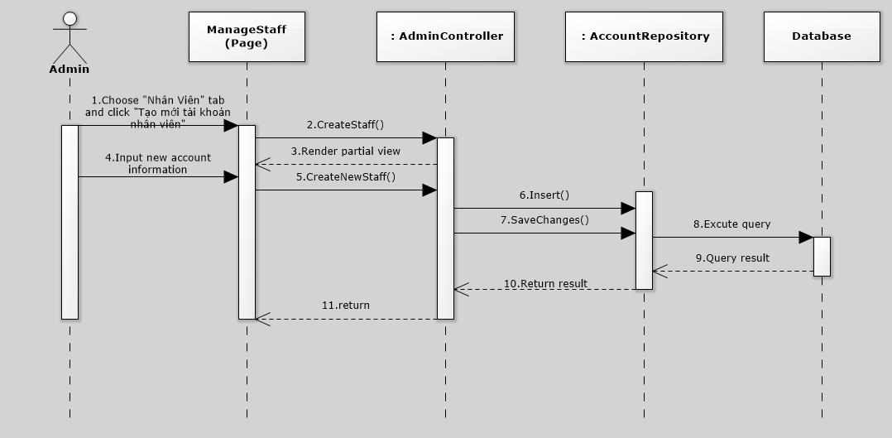

**Figure 4-43: Create Staff Sequence Diagram**

#### <Admin> Create Salesman

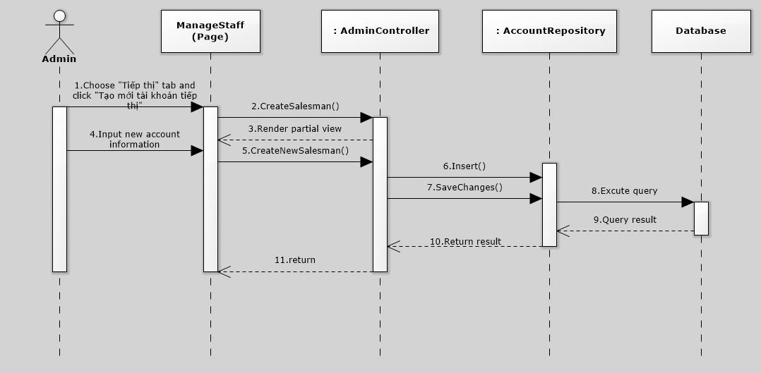

**Figure 4-44: Create Salesman Sequence Diagram**

#### <Admin> Create Deliveryman

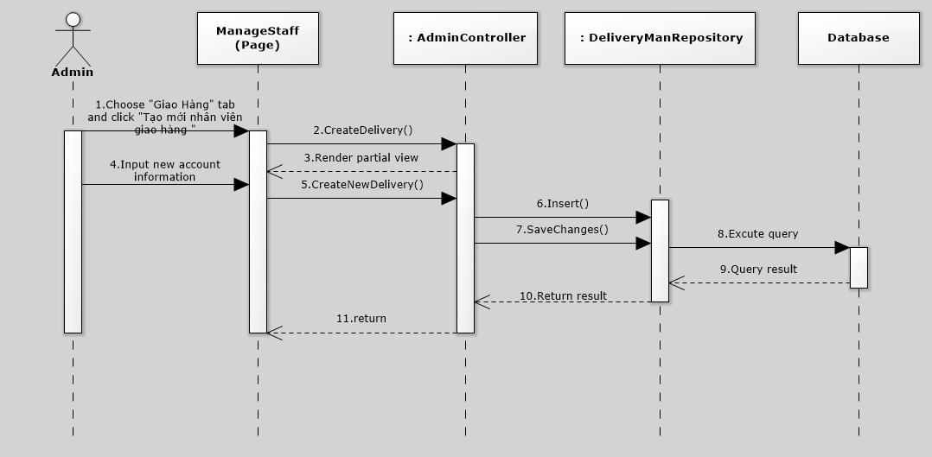

**Figure 4-45: Create Deliveryman Sequence Diagram**

#### <Admin> Deactivate Account

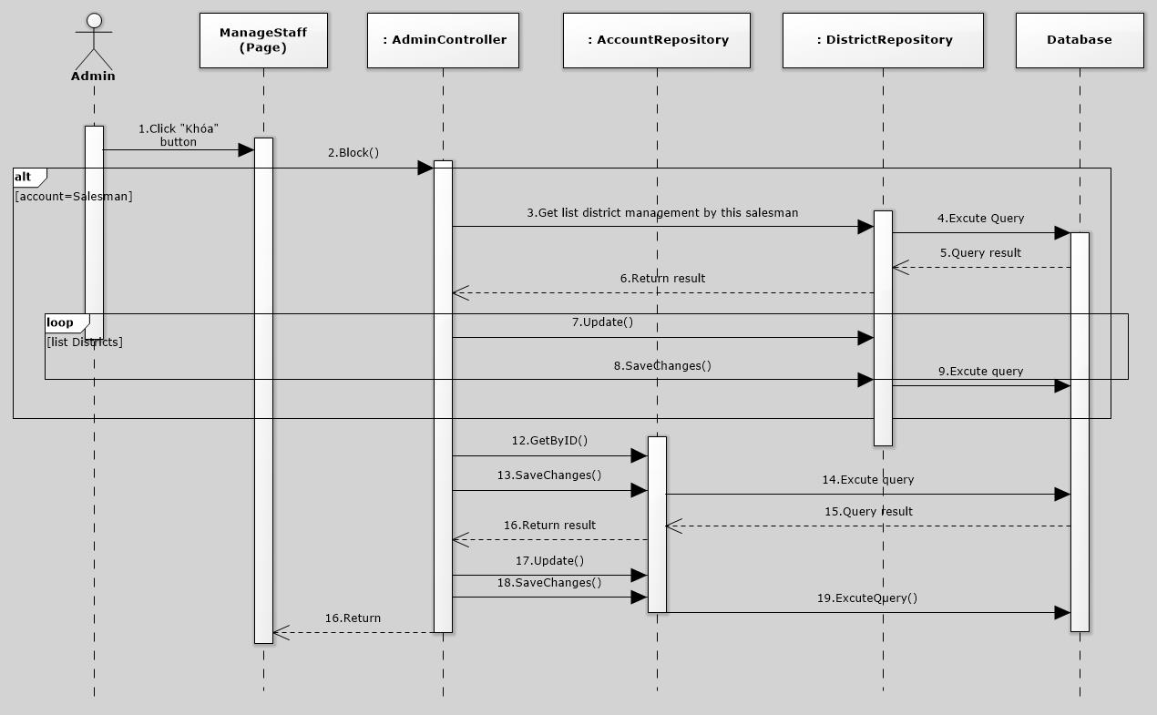

**Figure 4-46: Deactivate Account Sequence Diagram**

#### <Admin> Activate Account

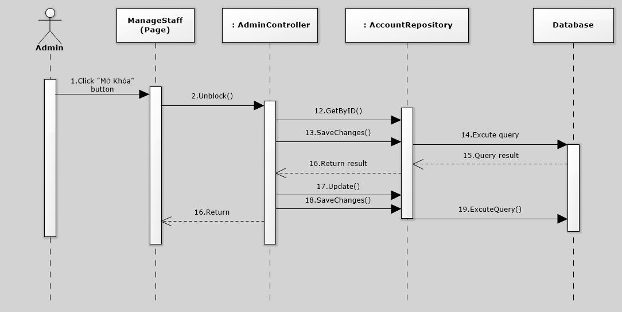

**Figure 4-47: Activate Account Diagram**

## Database Design

### Physical Database Design



**Figure 4-19: Physical Database Design**

#### Account

|  |  |  |  |  |  |
| --- | --- | --- | --- | --- | --- |
| Column Name | Type | Allow Null | Default Value | P/F Key | Description |
| AccountID | int |  | Auto generated | PK | Uniquely identifies of the account |
| Password | nvarchar(50) |  | - |  | Password of user |
| Username | nvarchat(50) |  | - |  | Username of user |
| RoleID | int |  | - | FK | Role of user in the system: Drugstore, Admin, Salesman, Staff. |
| ProfileID | int |  | - | FK | Profile Id of user |
| IsPending | bit |  | - |  | Status of user |
| IsActive | bit |  | - |  | User Deactivated or not |

Unique: AccountID

Foreign key: RoleID, ProfileID

#### AccountProfile

|  |  |  |  |  |  |
| --- | --- | --- | --- | --- | --- |
| Column Name | Type | Allow Null | Default Value | P/F Key | Description |
| ProfileID | int |  | Auto generated | PK | Uniquely identifies of the profile |
| Fullname | nvachar(50) |  | - |  | Fullname of user register to the system |
| Phone | nvarchar(50) |  | - |  | Phone of user registered to the system |
| Email | nvarchar(50) |  | - |  | Email of user registered to the system |
| Address | nvarchar(250) |  | - |  | Address of user registered to the system |
| Coordinate | nvarchat(500) |  | - |  | Coordinate of address |

Unique: N/A

Foreign Key: N/A

#### DeliveryMan

|  |  |  |  |  |  |
| --- | --- | --- | --- | --- | --- |
| Column Name | Type | Allow Null | Default Value | P/F Key | Description |
| DeliveryManID | int |  | Auto generated | PK | Uniquely identifies of the DeliveryMan |
| Fullname | nvarchar(50) |  | - |  | Fullname of DeliveryMan |
| Phone | nvarchar(50) |  | - |  | Phone of DeliveryMan |
| Email | nvarchar(50) |  | - |  | Email of DeliveryMan |

Unique: DeliveryManID

Foreign Key: N/A

#### DeliverySchedule

|  |  |  |  |  |  |
| --- | --- | --- | --- | --- | --- |
| Column Name | Type | Allow Null | Default Value | P/F Key | Description |
| DeliveryScheduleID | int |  | Auto generated | PK | Uniquely identifies of the schedule |
| CreateDate | date |  | - |  | Date of create schedule |
| DueDate | date |  |  |  | Date of delivery product |
| DeliveryManID | int |  |  | FK | Delivery is assigned to delivery schedule |
| Status | int |  |  |  | Status of schedule |

Unique: DeliveryScheduleID

Foreign Key: DeliveryManID

#### DeliveryScheduleDetails

|  |  |  |  |  |  |
| --- | --- | --- | --- | --- | --- |
| Column Name | Type | Allow Null | Default Value | P/F Key | Description |
| DeliveryScheduleDetailsID | int |  | Auto generated | PK | Uniquely identifies a schedule details |
| DeliveryScheduleID | int |  | - | FK | Delivery details belong to delivery schedule |
| DrungOrderID | int |  |  | FK | Order belong to delivery schedule |

Unique: DeliveryScheduleDetailsID

Foreign Key: DeliveryScheduleID, DrugOrderID

#### DiscountRate

|  |  |  |  |  |  |
| --- | --- | --- | --- | --- | --- |
| Column Name | Type | Allow Null | Default Value | P/F Key | Description |
| DrugstoreTypeID | int |  | - | FK | Type of Drugstore has different discount rate |
| DrugID | int |  | - | FK | Drug has price discount |
| Discount | float |  | - |  | Price discount of Drug |

Unique: N/A

Foreign Key: DrugID, DrugstoreTypeID

#### DrugOrder

|  |  |  |  |  |  |
| --- | --- | --- | --- | --- | --- |
| Column Name | Type | Allow Null | Default Value | P/F Key | Description |
| DrugOrderID | int |  | Auto generated | PK | Uniquely identifies the drug order |
| DrugstoreID | int |  |  | FK | Drugstore order delivery |
| Note | nvarchar(50) |  |  |  | Some more information for order |
| TotalPrice | float |  |  |  | Total price of order |
| DateOrder | datetime |  |  |  | Date that user order |
| IsActive | bit |  |  |  |  |
| Status | int |  |  |  | Status of order |

Unique: DrugOrderID

Foreign Key DrugstoreID

#### DrugOrderDetail

|  |  |  |  |  |  |
| --- | --- | --- | --- | --- | --- |
| Column Name | Type | Allow Null | Default Value | P/F Key | Description |
| DrugOrderDetailsID | int |  | Auto generated | PK | Uniquely identifies the Drug order details |
| DrugOrderID | int |  |  | FK | Details is belong to Drug order |
| DrugID | int |  |  | FK | All of Drug that user order |
| UnitID | int |  |  | FK | Type of drug (box, package) |
| Quantity | int |  |  |  | Quantity of Drug |

Unique: DrugOrderDetailID

Foreign Key: DrugOrderID, DrugID, UnitID

#### Drugstore

|  |  |  |  |  |  |
| --- | --- | --- | --- | --- | --- |
| Column Name | Type | Allow Null | Default Value | P/F Key | Description |
| DrugstoreID | int |  | Auto generated | PK | Uniquely identities an Drugstore |
| DrugstoreName | nvarchar(100) |  |  |  | Name of Drugstore |
| Address | nvarchar(100) |  |  |  | Address of Drugstore |
| Coordinate | nvarchar(100) |  |  |  | Address location of Drugstore |
| OwnerID | int |  |  | FK | The account owner of drugstore |
| DistrictID | int |  |  | FK | District which Drugstore belong to |
| DrugstoreTypeID | int |  |  | FK | Type of Drugstore |
| IsActive | bit |  |  |  | Check active drugstore |
| Debt | float |  |  |  | Debt of Drugstore |

Unique: DrugstoreID

Foreign key: OwnerID, DistrictID, DrugstoreTypeID

#### DrugstoreType

|  |  |  |  |  |  |
| --- | --- | --- | --- | --- | --- |
| Column Name | Type | Allow Null | Default Value | P/F Key | Description |
| DrugstoreTypeID | int |  | Auto generated | PK | Uniquely identifies the drugstore type |
| DrugstoreTypeName | nvarchar(50) |  |  | FK | Name of Drugstor Type |

Unique: DrugTypeID

Foreign Key: N/A

#### Drugtype

|  |  |  |  |  |  |
| --- | --- | --- | --- | --- | --- |
| Column Name | Type | Allow Null | Default Value | P/F Key | Description |
| DrugTypeID | int |  | Auto generated | PK | Uniquely identifies the drug type |
| DrugTypeName | nvarchar(50) |  |  | FK | Name of drug type |

Unique: DrugTypeID

Foreign Key: N/A

#### Payment

|  |  |  |  |  |  |
| --- | --- | --- | --- | --- | --- |
| Column Name | Type | Allow Null | Default Value | P/F Key | Description |
| PaymentID | int |  | Auto Generated | PK | Uniquely identifies the payment |
| DrugstoreID | int |  |  | FK | Payment belong to this drugstore |
| PaymentType | bit |  |  |  | Check drugstore paid or loan |
| Amount | float |  |  |  | Amount of payment |
| Balance | float |  |  |  | Price after paid or loan |
| Date | datetime |  |  |  | Date of payment |

Unique: PaymentID

Foreign Key: DrugstoreID

#### UnitPrice

|  |  |  |  |  |  |
| --- | --- | --- | --- | --- | --- |
| Column Name | Type | Allow Null | Default Value | P/F Key | Description |
| DrugID | int |  | - | PK | The ID of Drug |
| UnitID | int |  | - | PK | The ID of Unit |
| UnitPrice | float |  |  |  | Price of Unit |

Unique: DrugID, UnitID

Foreign Key: N/A

#### Role

|  |  |  |  |  |  |
| --- | --- | --- | --- | --- | --- |
| Column Name | Type | Allow Null | Default Value | P/F Key | Description |
| RoleID | int |  | Auto generated | PK | Uniquely identifies the role |
| RoleName | int |  | - |  | The name of role (Admin, Drugstore, Staff, Salesman) |

Unique: N/A

Foreign Key: N/A

#### Unit

|  |  |  |  |  |  |
| --- | --- | --- | --- | --- | --- |
| Column Name | Type | Allow Null | Default Value | P/F Key | Description |
| UnitID | int |  | Auto generated | PK | Uniquely identifies the unit |
| UnitName | int |  | - |  | Name of Unit |

Unique UnitID

Foreign Key: N/A

#### City

|  |  |  |  |  |  |
| --- | --- | --- | --- | --- | --- |
| Column Name | Type | Allow Null | Default Value | P/F Key | Description |
| CityID | int |  | Auto generated | PK | Uniquely identifies the unit |
| CityName | string |  | - |  | Name of City |

Unique: CityID

Foreign Key: N/A

#### District

|  |  |  |  |  |  |
| --- | --- | --- | --- | --- | --- |
| Column Name | Type | Allow Null | Default Value | P/F Key | Description |
| DistrictID | int |  | Auto generated | PK | Uniquely identifies the Unit |
| DistrictName | string |  | - |  | Name of District |
| CityID | int |  | - |  | ID of city belong to |
| SalesmanID | int |  | - |  | ID of account managed |

## Algorithms

### Nearest Neighbor Algorithms

#### Definition

The **nearest neighbour algorithm** was one of the first [algorithms](http://en.wikipedia.org/wiki/Algorithm) used to determine a solution to the [travelling salesman problem](http://en.wikipedia.org/wiki/Travelling_salesman_problem). In it, the salesman starts at a random city and repeatedly visits the nearest city until all have been visited. It quickly yields a short tour, but usually not the optimal one.

Reference: <http://en.wikipedia.org/wiki/Nearest_neighbour_algorithm>

#### Flowchart

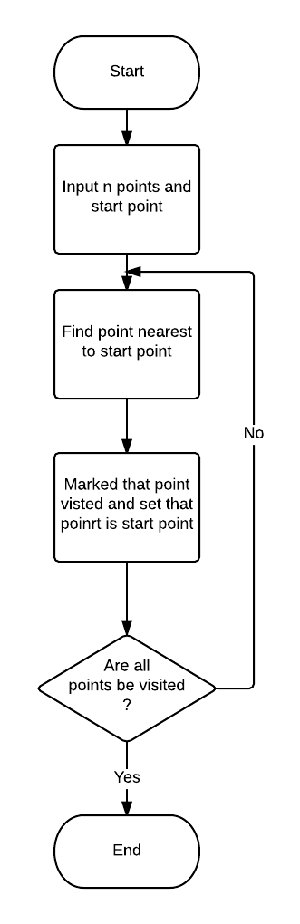

**Figure 4-20: Nearest Neighbor Algorithms Flowchart**



## Introduction

### System Overview

* This document describes plan and methods used in testing stage, an important step for grading the quality of product before packaging it.
* Testing group would plan, manage and execute the process of testing. Testers must execute and pass all test cases and technical details of system features.
* The testing group is also the coding group of Distribution Management System of pharmaceutial.

### Test Approach

The testing of project include unit test system test and acceptance test levels. It is hoped that there will be as less problem as possible in project.

* Unit testing will be done by team member and will be approved by team leader.
* System testing will be performed by all member of team. It will check all main-flow of the system to discover error or bugs that can’t be found on unit testing level.
* Acceptance testing will be performed by all members of team.

## Test Plan

### Scope of testing

The scope of testing in the project include:

* **Stages of testing**: the team has responsibility to conduct Unite testing, Integration testing and System testing
* **Types of testing**: The test team use functional test, white-box test and user interface testing
* **Range of testing**: Team performs testing all functions defined in the SRS based on the approved version. Test cases of each function are defined in the Test cases document that will be tested to determine if they meet the requirements and intermediate result will also be checked according to the SRS.

### Requirement for testing

#### Test items

|  |  |  |
| --- | --- | --- |
| ID | Group of function | Function |
| UC0001 | Account Control | Register |
| UC0002 | Login |
| UC0003 | Logout |
| UC0004 | Change Password |
| UC0005 | Manage Order | Create Order |
| UC0006 | Cancel Order |
| UC0007 | View Order Detail |
| UC0008 | View Order History |
| UC0009 | Approve Order |
| UC0010 | Change status Order |
| UC0011 | Manage Drug Store | Approve Drug Store |
| UC0012 | Verify kind of Drug Store |
| UC0013 | Manage Drug | Add Drug |
| UC0014 | Edit Drug |
| UC0015 | Delete Drug |
| UC0016 | View all Drug |
| UC0017 | Search Drug |
| UC0018 | View Drug detail |
| UC0019 | Manage Category | Create Category |
| UC0020 | Edit Category |
| UC0021 | Delete Category |
| UC0022 | Manage Schedule | Create Schedule |
| UC0023 | Update Schedule Status |
| UC0024 | Manage Salesman | Assign Sales man to Group |
| UC0025 | Manage Account | Create Account |
| UC0026 | Deactivate Account |
| UC0027 | Activate Account |

**Table 5-1: Test Items List**

#### Acceptance Test Criteria

* Test coverage on system test: >= 97%
* Test successful coverage: >= 97%

Number of test cases failed: less than 3% of total test cases.

#### Constraints

* There are only 2 testers and tester don’t have experience in testing
* Time of testing is short
* Have more environments should be tested: Window XP, Window 8… and more browsers: Firefox 30, Internet Exploder 10 and Google Chrome 40… But Test team can not cover all

#### Risk list

* Performance test: Cannot test the case which too many users connect to website at the same time.
* Not enough time to write enough test cases, execute test or re-test for fixed bug.
* Tester can be ill during the testing phase.

### Test Strategy

#### Test policy

* “Test without good faith”
* “Find bugs as soon as possible and always make sure they have been fixed”
* “No outstanding high severity faults”
* “Ensuring the product covers key features and attributes requirements”
* “Each primary function has at least one test case”
* “Focus on main function”
* “If any test fails we need to test again”
* “Using valid and invalid data”

#### Test Model

Using V-Model to implement testing process.

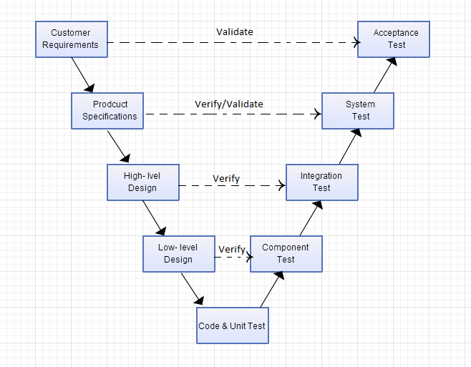

**Figure 5-1: V-Model Testing Process**

Testing progress is divided to 5 phases include: Unit test, Component test, Integration test, System test and Acceptance test

* Unit test:
  + Unit testing is used to verify a single minimal unit of source code. The purpose of unit testing is to isolate the smallest testable parts of DMS and verify that they function properly in isolation.
  + Unit testing is the first level of testing and is perform prior to component testing.
  + Unit testing will be done by developer.
* Component test:
  + Component testing is used to validate a combined many minimal units of source code.
  + Component testing is performed after unit testing and before integration testing
  + Component testing will be done by tester.
* Integration test:
  + Integration testing is a level of the software testing process where individual units or component are combined and tested as a group.
  + The purpose is to expose faults in the interaction between integrated units.
  + Integration testing is performed after component testing.
  + Integration testing will be done by tester.
  + There are two methods of doing integration testing: Bottom-up Integration testing and Top Down Integration testing:

|  |  |
| --- | --- |
| No | Integration Testing Method |
| 1 | Bottom-up integration  This testing begins with unit testing, followed by test of progressively higher-level combinations of units called modules. |
| 2 | Top-Down integration  This testing, the highest-level modules are tested first and progressively lower-level modules are tested after that. |

**Table 5-2:** Integration test

* System test:
  + System Testing is a level of the software testing process where a complete, integrated system is tested.
  + The purpose is to evaluate the system’s compliance with the specified requirements.
  + System testing is performed after integration testing.
  + System testing will be done by tester.
* Acceptance test:
  + Acceptance testing is performed after system testing.
  + Acceptance testing will be performed by the test leader and team leader.
  + The acceptance test will be done for a period of 1 weeks after completion of the system test process.

#### Type of Testing

##### Functional Testing

* Functional testing is a type of software testing whereby the system is tested against the functional requirements/specifications.
* Functions are tested by feeding them input and examining the output. Functional testing ensure that the requirements are properly satisfied by the website. This type of testing is not concerned with how processing occurs, but rather, with the results of processing.
* During functional testing, [Black Box Testing](http://softwaretestingfundamentals.com/black-box-testing/) technique is used in which the internal logic of the system being tested is not known to the tester.

|  |  |
| --- | --- |
| **Test Objective:** | The type of this test is to ensure proper target-of-test functionality, including user interaction, all function defined in specification document implemented correctly. |
| **Technique:** | Executing each use case, use-case flow, or function, using valid and invalid data, to verify the following:  - The expected results occur when valid data is used.  - The appropriate error or warning messages are displayed when invalid data is used.  - Each business rule is properly applied. |
| **Completion Criteria:** | - All planned tests have been executed.  - All identified defects have been addressed and closed. |
| **Special Considerations:** | Testing may be stopped when  Time runs out  A certain number of defects found  Test coverage > 97%  Stop when testing becomes unproductive |

**Figure 5-3: Function Testing**

##### User Interface Testing

GUI testing is the process of ensuring proper functionality of the GUI for a given web and making sure it conforms to its written specifications.

GUI testing evaluates design elements such as layout, colors, [fonts](http://whatis.techtarget.com/definition/font), font sizes, labels, text boxes, text formatting, captions, buttons, lists, icons, links, content and more.

|  |  |
| --- | --- |
| **Test Objective:** | Verify the following:  - Navigation through the target-of-test properly reflects business functions and requirements, including window-to-window, field-to-field, and use of access methods (tab keys, mouse movements, accelerator keys)  - Window objects and characteristics, such as menus, size, position, state, and focus conform to standards. |
| **Technique:** | Create or modify tests for each window to verify proper navigation and object states for each application window and objects. |
| **Completion Criteria:** | Each window successfully verified to remain consistent with benchmark version or within acceptable standard |
| **Special Considerations:** | Not all properties for custom and third party objects can be accessed. |

**Table 5-4: GUI Testing**

#### Test stage

Clearly state the stage in which the test will be executed. Identified below are the stages in which common test are executed

| **Type of Tests** | **Stage of Test** | | | |
| --- | --- | --- | --- | --- |
| **Unit** | **Component** | **Integration** | **System** |
| Function Testing | X | X | X | X |
| User Interface Testing |  | X | X |  |

**Table 5-5: Test stage**

#### Tools

|  |  |  |  |
| --- | --- | --- | --- |
| Purpose | Tool | Vendor/In-house | Version |
| Access to website | Firefox |  |  |
| Keep tracking defects | MS Word |  | Office 2010 & 2013 |
| Test Plan | MS Word |  | Office 2010 & 2013 |
| Test Case, Test Report | MS Excel |  | Office 2010 & 2013 |

**Table 5-6: Tools**

#### Resources

This table shows the staffing assumptions for the project.

|  |  |  |
| --- | --- | --- |
| **Worker/Doer** | **Role** | **Specific Responsibilities/Comments** |
| Tạ Đức Tùng | Test Leader | Manage Test Resource and assign test tasks.  Create and review Test Plan.  Create and review Test Case.  Execute test.  Create and review Test Report |
| VietNT | Tester | Create and review Test Case.  Execute test.  Create Test view points |

**Table 5-7: Human resource**

#### Schedule

Duration of all testing is from 27 October to 9 December.

Duration of create test plan, test case and checklist are from 20 October to 3 November.

## Test Cases

### Account Control

#### Register

|  |  |  |  |  |  |  |  |
| --- | --- | --- | --- | --- | --- | --- | --- |
| ID | Test Case Description | Preconditions | Test Case Procedure | Expected Output | Result | Test Date | Note |
| Resgister | | | | | | | |
| Steps  1. User Click on “Đăng kí” link on [Home] page. | | | | | | | |
| GF_14 | Test Register Success |  | 1. Go to register page 2. Enter "aaa@gmail.com" in "Email" text field Enter "aaa" in all remaining text field Select "Hà Nội" in "Thành phố" drop-down list Select "Quận Ba Đình" in "Quận" drop-down list then Click "Đăng kí" button | 1. Show Register Page 2. Show notice "Chúc mừng bạn đã đăng kí thành công ... " | Pass | 03/11/2015 |  |

#### Login

|  |  |  |  |  |  |  |  |
| --- | --- | --- | --- | --- | --- | --- | --- |
| ID | Test Case Description | Pre-conditions | Test Case Procedure | Expected Output | Result | Test Date | Note |
| Login | | | | | | | |
| Steps  1. Go to Index page  2. Click on “Login” button | | | | | | | |
| GF_04 | Test Login |  | 1. Click "Đăng Nhập" on header 2. Enter "admin" to username box, "123456" to the password box then Click "Đăng nhập" button | 1. Show Login screen 2. Display Administrator home page | Pass | 03/11/2014 |  |

#### Logout

|  |  |  |  |  |  |  |  |
| --- | --- | --- | --- | --- | --- | --- | --- |
| ID | Test Case Description | Preconditions | Test Case Procedure | Expected Output | Result | Test Date | Note |
| Logout | | | | | | | |
| Steps  1. User have login into system.  2. Click “Đăng xuất” in Control panel. | | | | | | | |
| AUF_01 | Test Logout | User have login | 1. Login account succesful  2. Logout account:  -Click on user account in right of the top  -Click [Đăng xuất] button | 1. [User] page will be shown  2. Logout success and go back to website Login page | Pass | 03/11/2014 |  |

#### Forgot Password

**Reference to:** <https://www.github.com/sangnvus/2015FALLIS02/blob/master/WIP/Documents/TestCase/DMS_TestCase_v1.3.xlsx>

#### Change Password

**Reference to:** <https://www.github.com/sangnvus/2015FALLIS02/blob/master/WIP/Documents/TestCase/DMS_TestCase_v1.3.xlsx>

### Manage Order

#### Create Order

**Reference to:** <https://www.github.com/sangnvus/2015FALLIS02/blob/master/WIP/Documents/TestCase/DMS_TestCase_v1.3.xlsx>

#### Cancel Order

**Reference to:** <https://www.github.com/sangnvus/2015FALLIS02/blob/master/WIP/Documents/TestCase/DMS_TestCase_v1.3.xlsx>

#### Create Schedule

**Reference to:** <https://www.github.com/sangnvus/2015FALLIS02/blob/master/WIP/Documents/TestCase/DMS_TestCase_v1.3.xlsx>

#### View Order Detail

**Reference to:** <https://www.github.com/sangnvus/2015FALLIS02/blob/master/WIP/Documents/TestCase/DMS_TestCase_v1.3.xlsx>

#### View All Order

**Reference to:** <https://www.github.com/sangnvus/2015FALLIS02/blob/master/WIP/Documents/TestCase/DMS_TestCase_v1.3.xlsx>

#### Approve Order

**Reference to:** <https://www.github.com/sangnvus/2015FALLIS02/blob/master/WIP/Documents/TestCase/DMS_TestCase_v1.3.xlsx>

#### View Order history

**Reference to:** <https://www.github.com/sangnvus/2015FALLIS02/blob/master/WIP/Documents/TestCase/DMS_TestCase_v1.3.xlsx>

### Mange Drug Store

#### Mange Drugstore

**Reference to:** <https://www.github.com/sangnvus/2015FALLIS02/blob/master/WIP/Documents/TestCase/DMS_TestCase_v1.3.xlsx>

#### Verify kind of Drugstore

**Reference to:** <https://www.github.com/sangnvus/2015FALLIS02/blob/master/WIP/Documents/TestCase/DMS_TestCase_v1.3.xlsx>

### Manage Drug

#### Add Drug

**Reference to:** <https://www.github.com/sangnvus/2015FALLIS02/blob/master/WIP/Documents/TestCase/DMS_TestCase_v1.3.xlsx>

#### Delete Drug

**Reference to:** <https://www.github.com/sangnvus/2015FALLIS02/blob/master/WIP/Documents/TestCase/DMS_TestCase_v1.3.xlsx>

#### Edit Drug

**Reference to:** <https://www.github.com/sangnvus/2015FALLIS02/blob/master/WIP/Documents/TestCase/DMS_TestCase_v1.3.xlsx>

### Manage Category

#### Create Category

**Reference to:** <https://www.github.com/sangnvus/2015FALLIS02/blob/master/WIP/Documents/TestCase/DMS_TestCase_v1.3.xlsx>

#### Edit Category

**Reference to:** <https://www.github.com/sangnvus/2015FALLIS02/blob/master/WIP/Documents/TestCase/DMS_TestCase_v1.3.xlsx>

#### Delete Category

**Reference to:** <https://www.github.com/sangnvus/2015FALLIS02/blob/master/WIP/Documents/TestCase/DMS_TestCase_v1.3.xlsx>

### Manage Schedule

#### Create Schedule

**Reference to:** <https://www.github.com/sangnvus/2015FALLIS02/blob/master/WIP/Documents/TestCase/DMS_TestCase_v1.3.xlsx>

#### Update Schedule

**Reference to:** <https://www.github.com/sangnvus/2015FALLIS02/blob/master/WIP/Documents/TestCase/DMS_TestCase_v1.3.xlsx>

### Manage Salesman

#### Assign Salesman to Group

**Reference to:** <https://www.github.com/sangnvus/2015FALLIS02/blob/master/WIP/Documents/TestCase/DMS_TestCase_v1.3.xlsx>

### Manage Account

#### Create Account

**Reference to:** <https://www.github.com/sangnvus/2015FALLIS02/blob/master/WIP/Documents/TestCase/DMS_TestCase_v1.3.xlsx>

#### Deactivate Account

**Reference to:** <https://www.github.com/sangnvus/2015FALLIS02/blob/master/WIP/Documents/TestCase/DMS_TestCase_v1.3.xlsx>

#### Activate Account

**Reference to:** <https://www.github.com/sangnvus/2015FALLIS02/blob/master/WIP/Documents/TestCase/DMS_TestCase_v1.3.xlsx>

## Checklists

### Checklist of Validation

|  |  |  |  |  |
| --- | --- | --- | --- | --- |
| # | Question | Yes | No | N/A |
| 1 | Does a failure of validation on every field cause a sensible user error symbol? |  |  | x |
| 2 | Is the user required to fix entries which have failed validation tests? |  |  | x |
| 3 | Have any fields got multiple validation rules and if so are all rules being applied? |  |  | x |
| 4 | If the user enters an invalid value and clicks on the insert button is the invalid entry identified and highlighted correctly with an error symbol? |  |  | x |
| 5 | Is validation consistently applied at screen level unless specifically required at field level? |  |  | x |
| 6 | For all numeric fields check whether negative numbers can and should be able to be entered. |  |  | x |
| 7 | For all numeric fields check the minimum and maximum values and also some mid-range values allowable? |  |  | x |
| 8 | For all character/alphanumeric fields check the field to ensure that there is a character limit specified and that this limit is exactly correct for the specified database size? |  |  | x |
| 9 | Do all mandatory fields require user input? |  |  |  |
| 10 | If any of the database columns do not allow null values then the corresponding screen fields must be mandatory. (If any field which initially was mandatory has become optional then check whether null values are allowed in this field.) |  |  | x |

### Checklist of User Interface

|  |  |  |  |  |
| --- | --- | --- | --- | --- |
| # | Question | Yes | No | N/A |
| USABILITY | | | | |
| 1 | Are the entire field prompts spelt correctly? |  |  | x |
| 2 | Are fonts too large or too small to read? |  | x |  |
| 3 | Are names in command button & option box names are not abbreviations. |  | x |  |
| 4 | Assure that option boxes, option buttons, and command buttons are logically grouped together in clearly demarcated areas "Group Box" |  |  | x |
| 5 | Can the typical user run the system without frustration? |  |  | x |
| 6 | Does the site have a consistent, clearly recognizable "look-&-feel"? |  |  | x |
| 7 | Is all terminology understandable for all of the site’s intended users? |  |  | x |
| USER INTERFACE TESTING-COLOR | | | | |
| 1 | Are hyperlink colors standard? | x |  |  |
| 2 | Are the field prompts the correct color? | x |  |  |
| 3 | Are the field backgrounds the correct color? | x |  |  |
| 4 | Are the screen and field colors adjusted correctly for non-editable mode? | x |  |  |
| 5 | Does the site use (approximately) standard link colors? | x |  |  |
| 6 | Are all the buttons are in standard format and size? | x |  |  |
| 7 | Is the general screen background the correct color? | x |  |  |
| 8 | Is the page background (color) distraction free? |  |  | x |
| USER INTERFACE TESTING-CONTENT | | | | |
| 1 | All fonts to be the same | x |  |  |
| 2 | Are all the screen prompts specified in the correct screen font? | x |  |  |
| 3 | Is all text properly aligned? | x |  |  |
| 4 | Is the text in all fields specified in the correct screen font? | x |  |  |
| 5 | Is all the headings left aligned? | x |  |  |
| 6 | Does the first letter of the second word appear in lowercase? | x |  |  |

### Checklist for Document

|  |  |  |  |  |
| --- | --- | --- | --- | --- |
| # | Question | Yes | No | N/A |
| TABLES AND FIGURES | | | | |
| 1 | Does every table column, including the stub column, have a heading? |  | x |  |
| 2 | Are references cited both in text and in the reference list? | x |  |  |
| 3 | Is lettering in a figure no smaller than 12 points and no larger than 14 points? | x |  |  |
| 4 | Are all figures and tables mentioned in the text and numbered in the order in which they are mentioned? | x |  |  |
| REFERENCES | | | | |
| 1 | Are references cited both in text and in the reference list? | x |  |  |
| 2 | Do the text citations and reference list entries agree both in spelling and in date? |  |  | x |
| 3 | Are journal titles in the reference list spelled out fully? | x |  |  |
| 4 | Are the references (both in the parenthetical text citations and in the reference list) ordered alphabetically by the authors’ surnames? | x |  |  |
| 5 | Are inclusive page numbers for all articles or chapters in books provided in the reference list? | x |  |  |
| 6 | Are references to studies included in your meta-analysis preceded by an asterisk? |  |  | x |
| FORMAT | | | | |
| 1 | Have you checked the journal’s website for instructions to authors regarding specific formatting requirements for submission? | x |  |  |
| 2 | Is the entire manuscript—including quotations, references, author note, content footnotes, and figure captions—double-spaced? Is the manuscript neatly prepared? | x |  |  |
| 3 | Are the margins at least 1 in. (2.54 cm)? | x |  |  |
| 4 | Are the title pages, abstracts, references, appendices, content footnotes, tables, and figures on separate pages (with only one table or figure per page)? Are the figure captions on the same page as the figures? Are manuscript elements ordered in sequence, with the text pages between the abstract and the references? | x |  |  |
| PARAGRAPHS AND HEADINGS | | | | |
| 1 | Is each paragraph longer than a single sentence but not longer than one manuscript page? | x |  |  |
| 2 | Do the levels of headings accurately reflect the organization of the paper? | x |  |  |
| 3 | Do all headings of the same level appear in the same format? | x |  |  |

## Test logs

### Defect Logs

|  |  |  |  |  |  |  |  |
| --- | --- | --- | --- | --- | --- | --- | --- |
| **No** | **Module name** | **Defect** | **Priority** | **Status** | **Assign to** | **Fix on** | **Retest on** |
| 1 | Register | Cannot Show District after choose City | High | Complete | Tạ Đức Tùng | 3/11/2015 | 20/11/2015 |
| 2 | Search Drug | When input wrong name, the result still be shown. | High | Complete | Tạ Đức Tùng | 3/11/2015 | 20/11/2015 |
| 3 | Create Order | Not Validation minus values | High | Complete | Tạ Đức Tùng | 3/11/2015 | 22/11/2015 |
| 4 | Edit Drug | Edit with blank field, Error message aren‘t be shown. | High | Complete | Tạ Đức Tùng | 3/11/2015 | 23/11/2015 |
| 5 | Create Order | No limit quantity maximum. | High | Complete | Tạ Đức Tùng | 3/11/2015 | 29/11/2015 |

### Test Report

|  |  |  |  |
| --- | --- | --- | --- |
| **Project Name** | Distribution Management System in Pharmaceutical. | **Creator** | Tạ Đức Tùng |
| **Project Code** | DMS | **Reviewer/Approver** | SangNV |
| **Document Code** | DMS_TestReport | **Issue Date** | December  5th 2015 |

|  |  |  |  |  |  |  |  |  |  |  |  |  |
| --- | --- | --- | --- | --- | --- | --- | --- | --- | --- | --- | --- | --- |
|  | **Function** | **Test Case** | | | | | | | **Checklist** | | |  |
| **No** | **Pass** | **Fail** | | **Untested** | | | **N/A** | **Pass** | **Fail** | **N/A** | **Total** |
|  | **Web Module** | | | | | | | | | | | |
|  | Login | 9 | 0 | | 0 | | | 0 | 27 | 0 | 4 | 37 |
|  | Logout | 1 | 0 | | 0 | | | 0 | 3 | 0 | 9 | 32 |
|  | Change password | 8 | 0 | | 0 | | | 0 | 21 | 0 | 2 | 38 |
|  | Forgot Password | 1 | 0 | | 0 | | | 0 | 25 | 1 | 0 | 50 |
|  | Create Order | 4 | 0 | | 0 | | | 0 | 31 | 0 | 0 | 35 |
|  | Cancel Order | 2 | 0 | | 0 | | | 0 | 31 | 0 | 0 | 35 |
|  | View Order Detail | 2 | 0 | | 0 | | | 0 | 24 | 0 | 7 | 33 |
|  | View All Order | 2 | 0 | | 0 | | | 0 | 27 | 0 | 4 | 33 |
|  | Search Drug | 8 | 0 | | 0 | | | 0 | 25 | 1 | 6 | 32 |
|  | View Order history | 7 | 0 | | 0 | | | 0 | 31 | 0 | 1 | 56 |
|  | View Payment history | 1 | 0 | | 0 | | | 0 | 27 | 0 | 4 | 32 |
|  | Set Discount rate | 1 | 0 | | 0 | | | 0 | 25 | 1 | 6 | 32 |
|  | Approve Order | 4 | 0 | | 0 | | | 0 | 31 | 0 | 0 | 35 |
|  | Add Drug | 5 | 0 | | 0 | | | 0 | 25 | 0 | 6 | 32 |
|  | Edit Drug | 5 | 0 | | 0 | | | 0 | 25 | 0 | 6 | 32 |
|  | Delete Drug | 7 | 0 | | 0 | | | 0 | 31 | 0 | 0 | 38 |
|  | Search Drug | 5 | 1 | | 0 | | | 0 | 31 | 1 | 0 | 38 |
|  | Create Category | 5 | 0 | | 0 | | | 0 | 24 | 0 | 7 | 33 |
|  | Edit Category | 5 | 0 | | 0 | | | 0 | 25 | 0 | 4 | 32 |
|  | Delete Category | 1 | 0 | | 0 | | | 0 | 25 | 0 | 3 | 32 |
|  | Assign Salesman | 5 | 0 | | 0 | | | 0 | 31 | 1 | 0 | 36 |
|  | Create Schedule | 2 | 0 | | 0 | | | 0 | 24 | 0 | 2 | 33 |
|  | Update Schedule Status | 2 | 1 | | 0 | | | 0 | 25 | 1 | 2 | 33 |
|  | Create Account | 5 | 0 | | 0 | | | 0 | 25 | 0 | 2 | 32 |
|  | Activate Account | 1 | 0 | | 0 | | | 0 | 25 | 0 | 2 | 32 |
|  | Deactivate Account | 5 | 0 | | 0 | | | 0 | 31 | 0 | 0 | 36 |
|  | Verify Drugstore | 5 | 0 | | 0 | | | 0 | 24 | 0 | 1 | 33 |
|  | Total | 294 | 5 | | 0 | | | 0 | 1029 | 8 | 66 | 1402 |
|  | **Test coverage** |  | |  | |  | 100% | | | | | |
|  | **Test successful coverage** |  | |  | |  | 100% | | | | | |



## Software User’s Manual

### Installation Guide

#### Prerequisites

Before we install the application and throw it into operation, the preconditions about the environment and tools specified below must be satisfied.

Firstly, system requirements for the DMSapplication to run on top of are specified below:

* Personal computers for the minimum configuration: 2 Gb of RAM, 50Gb of hard disk, Core 2 Duo 2.0 Ghz;
* Microsoft Windows 7 or higher.
* At least 100MB for the application resources and another 100MB for data storage.
* Secondly, these tools must be installed in advance and run without errors:
* IIS Express 7.0 or higher
* SQL Server 2008 or higher,
* .NET Framework 4.5,
* WebDeploy 3.5

#### Installation Procedures

**Step 1: Prepare the deployment package**

First, you need to publish you application and you’ll get folder to add to IIS

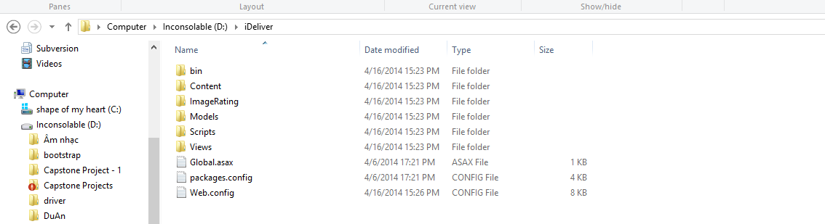

**Figure 6-1: DMS Web Application Release Folder**

**Step 2. Create Database**

Open file “DMS.sql” in “Document” folder of deployment package by Microsoft SQL Server Management Studio (MSSQL).

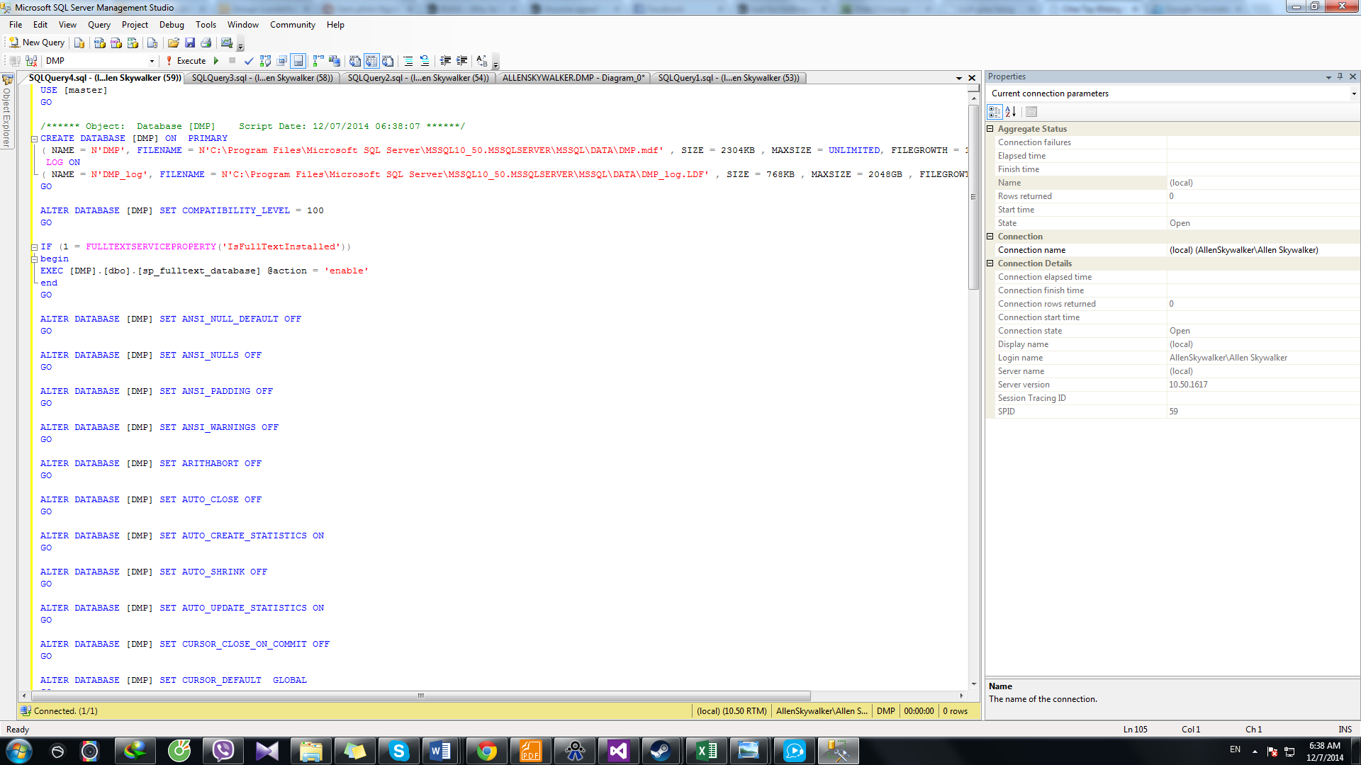

**Figure 6-2: Create DMS Database using SQL Query**

**Step 3: Install Application**

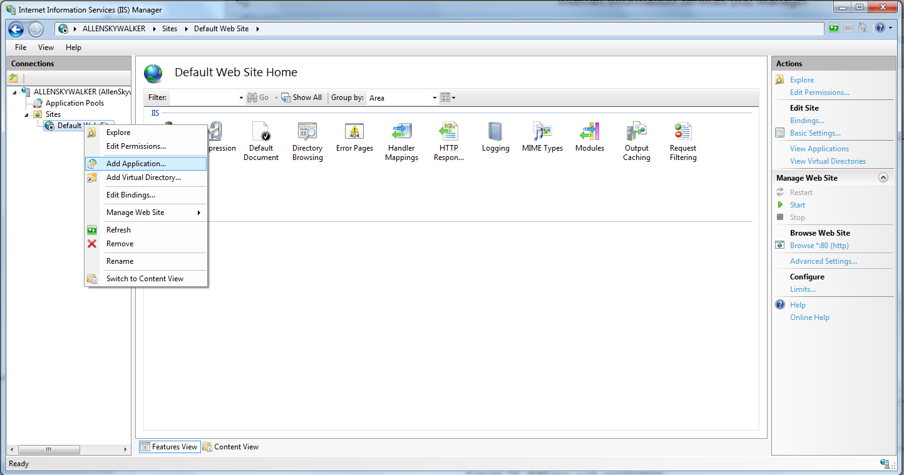

**Figure 6-3: Add New Web Application**

Expand the Sites folder and right-click on Default Web Site. Select “Add Application…” to open Add Application window. In “Add Application” window, fill the field “Alias” with name of Website.

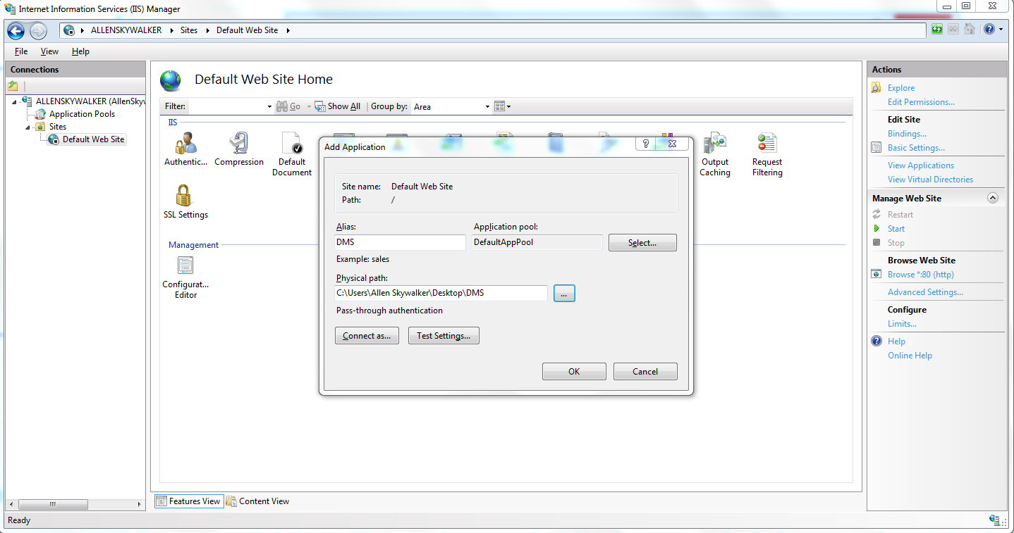

**Figure 6-4: Add New Web Application**

Click “…” button to Browse to the folder that contains deployment package. Select “Website” folder in the “DMS” folder, in “Application” folder and click OK.

Verify that the DMS Website has been added to “Default Website” of IIS Express by right-click the Website’s name, choosing “Manage Application” and then “Browse”.

**Step 4: Configure Database connection string**

Folder of the deployment package, find and open the file Web.config using Notepad or any other text editor.

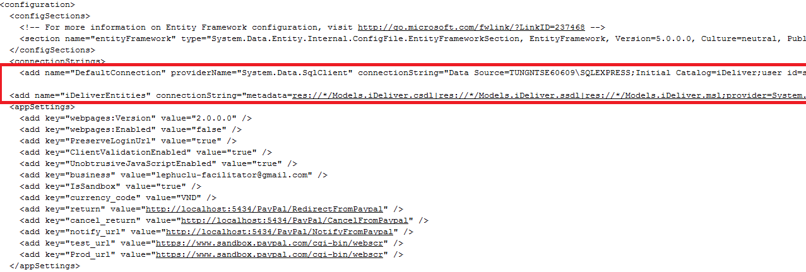

**Figure 6-5: Configure Database connection string**

In the connectionString tag, change the Data Source of the connection strings to the SQPServer instance where you installed the dataset. Also, update the password to access the SQLServer instance in the connection strings.

**Now go to** [**http://localhost/aspnet_client/DMS**](http://localhost/aspnet_client/DMS) **and enjoy the website.**

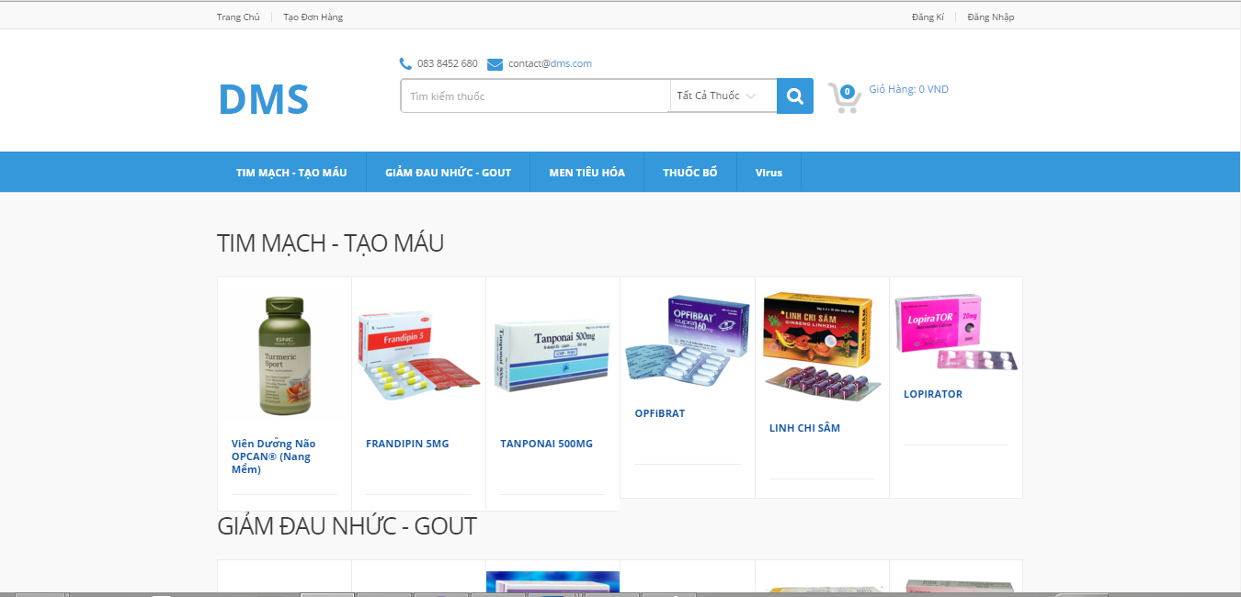

**Figure 6-6: DMS System Home Screen**

### User’s Guide

#### Guide for Drug Store

##### Log in

This function allows a user with a registered account to log in to the DMSsystem.

 Figure 10. Login screen

|  |  |
| --- | --- |
| Step | Instruction |
| 1. | Click the “Đăng nhập” button on the menu bar of the “Trang chủ” page. |
| 2. | Fill the registered account in the “Tên đăng nhập” field |
| 3. | Fill the password in the “Mật khẩu” field |
| 4. | Click the “Đăng nhập” button to log in to the system. You will be redirected to the page you are viewing |

##### Register

This function allows the user to register a new account with Customer role in the DMSsystem.



Figure 11. Register screen

|  |  |
| --- | --- |
| Step | Instruction |
| 1. | Fill in the fields “Email”, “Mật khẩu”, “Tên đầy đủ” “Số Điện thoại”, “Tên nhà thuốc”, “Địa chỉ nhà thuốc”, “Thành phố”, “Quận” with your information.  Your input will be validated as you type. Please make sure that all the values that you provide are validated. |
| 2. | Click the button “Đăng ký” to proceed to register your account with Customer role. |

##### Forgot Password

 Figure 12. Login screen

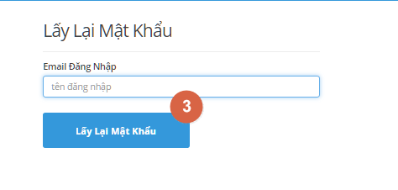

Figure 13. Forgot Password screen

|  |  |
| --- | --- |
| Step | Instruction |
| 1. | Click “Đăng nhập” link on top right of the page |
| 2. | Click “Quên mật khẩu” link to go to Forgot Password page |
| 3 | Enter your email address then click on “Lấy lại mật khẩu” button |

#### Guide for Authorized User

##### Change Password



Figure 14. Change Password screen

|  |  |
| --- | --- |
| Step | Instruction |
| 1. | Click “Đăng nhập” link on top right of the page |
| 2. | Click “Quên mật khẩu” link to go to Forgot Password page |
| 3 | Enter your email address then click on “Lấy lại mật khẩu” button |

##### Logout



Figure 15. Logout screen

|  |  |
| --- | --- |
| Step | Instruction |
| 1. | Hover mouse to username on top right of the page |
| 2. | Click “Đăng xuất” |

#### Guide for Drugstore

##### Create Order



Figure 16. Cart screen

|  |  |
| --- | --- |
| Step | Instruction |
| 1. | Click cart icon to go to Cart screen |
| 2. | Input name of drug which want to order |
| 3. | Choose unit of drug |
| 4. | Choose quantity of drug |
| 5. | Click the button “Checkout” to proceed to make order |

##### View Order History



Figure 18. Order History screen

|  |  |
| --- | --- |
| Step | Instruction |
| 1. | On Home Page. |
| 2. | Click “Lịch sử đơn hàng” link to see order history |

##### View Payment History



Figure 19. Payment History screen

|  |  |
| --- | --- |
| Step | Instruction |
| 1. | On Home Page. |
| 2. | Click “Lịch sử thanh toán” link to see order history |

##### Cancel Order



Figure 20. Cancel Order screen

|  |  |
| --- | --- |
| Step | Instruction |
| 1. | Click “Lịch sử đơn hàng” link |
| 2. | Click “Hủy đơn hàng” link cancel Order |

#### Guide for Staff

##### Add Drug



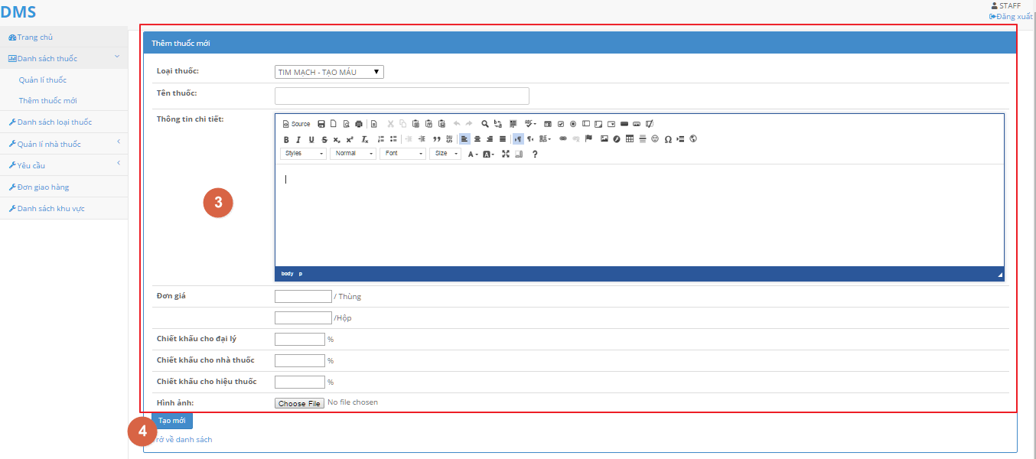

Figure 21. Add drugs screen

|  |  |
| --- | --- |
| Step | Instruction |
| 1. | Click “Danh sách thuốc” then click on “Quản lí thuốc” link |
| 2. | Click “Tạo mới” button |
| 3. | Fill Information about the drug |
| 4. | Click the “Tạo mới” button to add new Drug |

##### Edit Drug





Figure 21. Add drugs screen

|  |  |
| --- | --- |
| Step | Instruction |
| 1. | Click “Danh sách thuốc” then click on “Quản lí thuốc” link |
| 2. | Click “Tạo mới” button |
| 3. | Fill Information about the drug |
| 4. | Click the “Tạo mới” button to add new Drug |

##### Delete Drug



Figure 24. List drugs screen

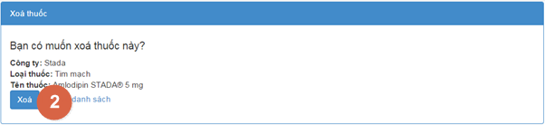

Figure 25. Delete drug screen

|  |  |
| --- | --- |
| Step | Instruction |
| 1. | Go to Drug list screen, then click “Xóa” button |
| 2. | Click “Xóa” button |

##### Create Category



Figure 26. List Category screen



Figure 27. Add new Category screen

|  |  |
| --- | --- |
| Step | Instruction |
| 1. | Click on “Danh sách loại thuốc” |
| 2. | Click “Tạo mới” button |
| 3. | Fill in new category then click “Tạo mới” button |

##### Delete Category



Figure 28. List Category screen

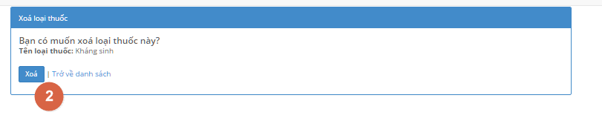

Figure 29. Delete Category screen

|  |  |
| --- | --- |
| Step | Instruction |
| 1. | Click on “Xóa” button |
| 2. | Click on “Xóa” button to delete selected Category |

##### Edit Category



Figure 30. List Category screen



Figure 31. Edit Category screen

|  |  |
| --- | --- |
| Step | Instruction |
| 1. | Click on “Xóa” button |
| 2. | Edit Category name then click “Lưu” button |

##### Approve Order



Figure 32. List Order screen

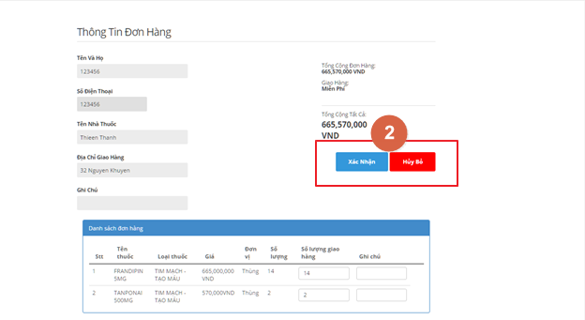

Figure 33. Approve Order screen

|  |  |
| --- | --- |
| Step | Instruction |
| 1. | Logged in a Staff account, system will show all not yet approve Order |
| 2 | Click “ Xem chi tiết” button, System will show detail of the selected Order |
| 3 | Click “Xác nhận” to approve Order, system will show the screen on step 1  Click “Hủy Bỏ” to cancel Order |

##### Assign Salesman



Figure 34. Assign Salesman screen

|  |  |
| --- | --- |
| Step | Instruction |
| 1. | On Staff account Homepage, click “Danh sách khu vực” |
| 2 | Choose city by click on “Thành phố” drop-down list  Choose salesman by click on “Nhân viên quản lí” drop-down list |
| 3 | Click “Lưu” button to save changes |

##### Create Delivery Schedule



Figure 35. List Delivery Schedule screen

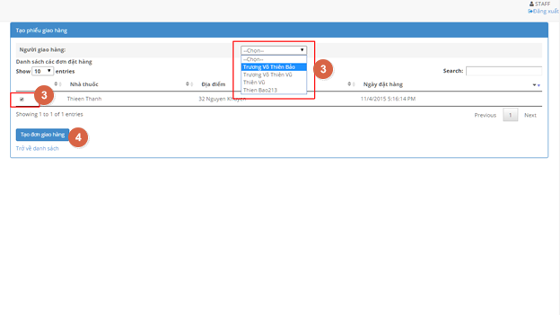

Figure 36. Create Delivery Schedule screen

|  |  |
| --- | --- |
| Step | Instruction |
| 1. | On Staff account Homepage, click “Đơn giao hàng” |
| 2 | Click “ Tạo mới” button, System will show all approved Order |
| 3 | Select the Checkbox next to the Order you want to make a delivery schedule  Select Delivery man from the drop-down list |
| 4 | Click “Tạo đơn giao hàng” |

##### Update Delivery Schedule

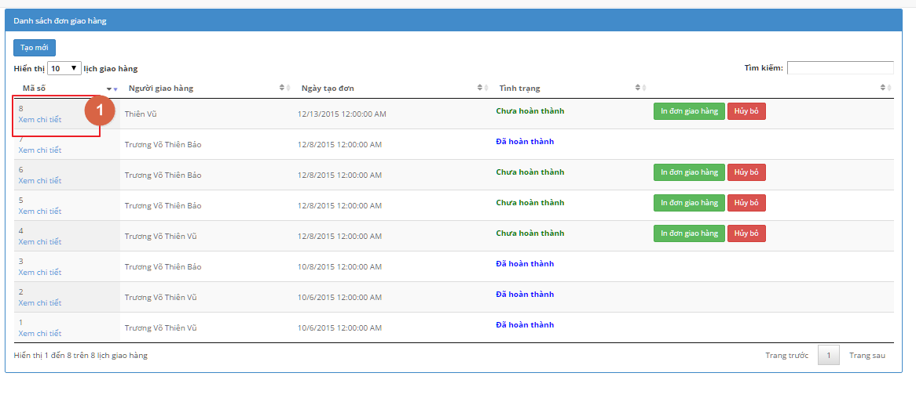

Figure 37. List Delivery Schedule screen



Figure 38. Update Delivery Schedule Status screen

|  |  |
| --- | --- |
| Step | Instruction |
| 1. | On Delivery List Page, Click “Xem chi tiết” link |
| 2 | Click “Hoàn tất” or “Hủy bỏ” to update status ò the delivery |

#### Guide for Salesman

##### Create Order for Drugstore



Figure 39. List Drugstore screen

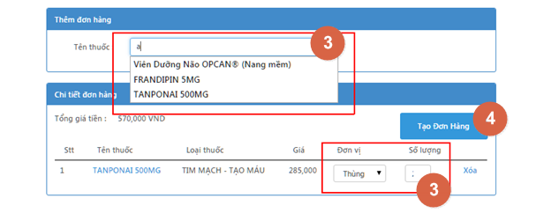

Figure 40. Add Drug screen

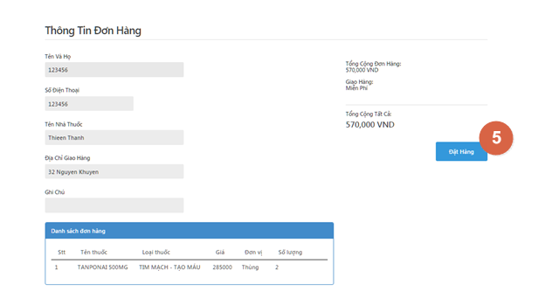

Figure 41. Create Order screen

|  |  |
| --- | --- |
| Step | Instruction |
| 1. | After logged in with salesman account, on Salesman account Homepage, click “Nhà thuốc”, then “Danh sách nhà thuốc quản lí” |
| 2 | Click “ Tạo đơn hàng” button , system will show Create Order screen |
| 3 | Enter Drug name in the “Tên thuốc” box to search, then select with mouse  Specified quantity in “Đơn vị” and “Số lượng”  Click “Xóa” to delete selected drug |
| 4 | Click “Tạo đơn hàng”, system will show Order detail screen |
| 5 | Click “Đặt hàng” to complete Order |

##### Verify Drugstore Account



Figure 42. List unverify Drugstore screen

|  |  |
| --- | --- |
| Step | Instruction |
| 1. | After logged in with salesman account, on Salesman account Homepage, click “Nhà thuốc”, then “Các nhà thuốc cần xác nhận”, system will list all not yet verified account. |
| 2 | Specify scale of the store by choose from “Loại nhà thuốc” drop-down list. |
| 3 | Click “Xác nhận” to verify the store  Click “Hủy bỏ” to denied created account |

##### View Order



Figure 44. Order Detail screen

|  |  |
| --- | --- |
| Step | Instruction |
| 1. | Go to View order page, then click on “Xem chi tiết” link |

##### View Order Detail



Figure 44. Order Detail screen

|  |  |
| --- | --- |
| Step | Instruction |
| 1. | Go to View order page, then click on “Xem chi tiết” link |

#### Guide for Administrator

##### Manage Staff Account

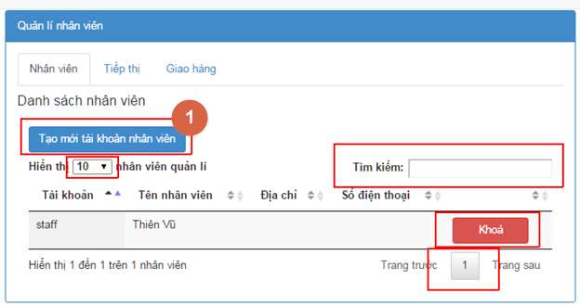

Figure 47. Manage Staff screen

* Create new staff account

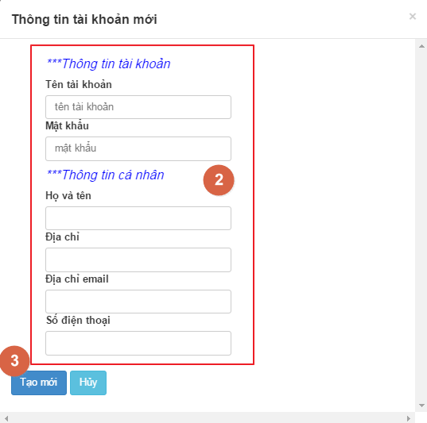

Figure 48. Add staff screen

|  |  |
| --- | --- |
| Step | Instruction |
| 1. | Click on “Tạo mới tài khoản nhân viên”, system show Create new staff screen |
| 2 | Fill in the information |
| 3 | Click [Tạo mới] to create new Staff account  Click [Hủy] to return to Staff account management page |

* Search account

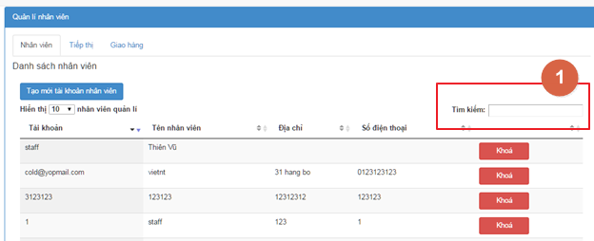

Figure 49. Seach Staff screen

|  |  |
| --- | --- |
| Step | Instruction |
| 1. | Type in the text box to search for staff account |

* Lock account

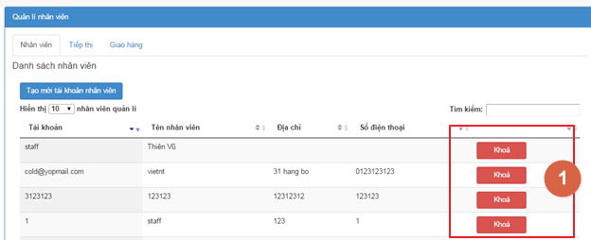

Figure 50. Lock Staff screen

|  |  |
| --- | --- |
| Step | Instruction |
| 1. | Click “Khóa” to lock account |

##### Manage Salesman Account

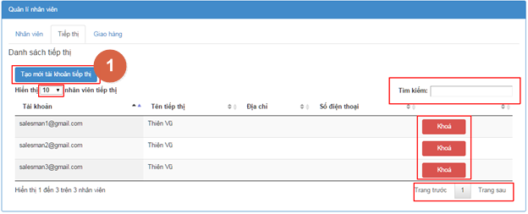

Figure 51. Manage Salesman screen

* Create new Salesman account



Figure 52. Add Salesman screen

|  |  |
| --- | --- |
| Step | Instruction |
| 1. | Click on “Tạo mới tài khoản tiếp thị”, system show Create Salesman screen |
| 2 | Fill in the information |
| 3 | Click [Tạo mới] to create new Salesman account  Click [Hủy] to return to Salesman account management page |

* Search account

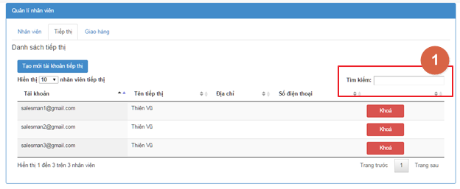

Figure 53. Search Salesman screen

|  |  |
| --- | --- |
| Step | Instruction |
| 1. | Type in the text box to search for Salesman account |

* Lock account

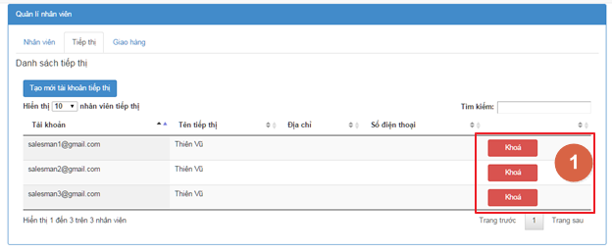

Figure 54. Lock Salesman screen

|  |  |
| --- | --- |
| Step | Instruction |
| 1. | Click “Khóa” to lock account |

##### Manage Deliveryman Account

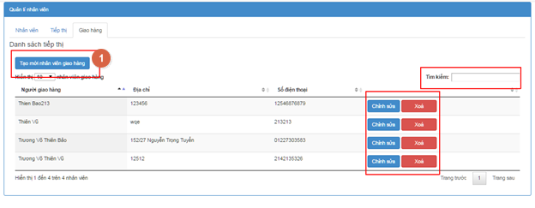

Figure 55. Manage Delivery Man screen

* Create new Delivery man information

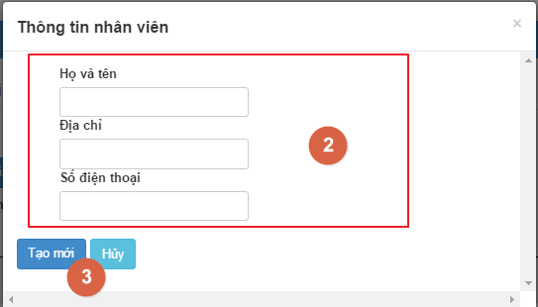

Figure 56. Add New Delivery Man screen

|  |  |
| --- | --- |
| Step | Instruction |
| 1. | Click on “Tạo mới tài khoản tiếp thị”, system show Create new Delivery man screen |
| 2 | Fill in the information |
| 3 | Click [Tạo mới] to create new Delivery man account  Click [Hủy] to return to Delivery man account management page |

* Search information

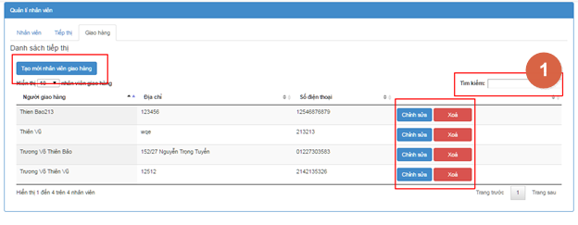

Figure 57. Search Delivery Man screen

|  |  |
| --- | --- |
| Step | Instruction |
| 1. | Type in the text box to search for Delivery man account |

* Delete Delivery Man information

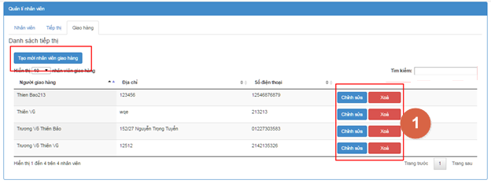

Figure 58. Delete Delivery Man screen

|  |  |
| --- | --- |
| Step | Instruction |
| 1. | Click “Khóa” to lock account |

* Edit delivery man information

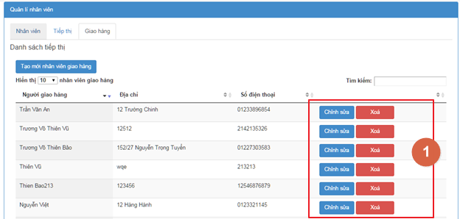

Figure 59. List Delivery Man screen

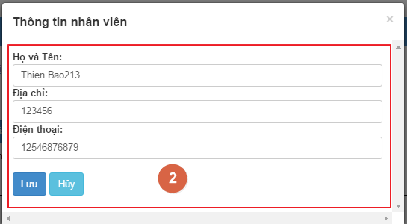

Figure 60. Edit Delivery Man screen

|  |  |
| --- | --- |
| Step | Instruction |
| 1. | Click “Chỉnh sửa” |
| 2 | Edit Information then  Click “Lưu” to Save changes  Click “Hủy” to return to Delivery man account management page |

##### Manage Drugstore Account



Figure 61. List Drugstore screen

|  |  |
| --- | --- |
| Step | Instruction |
| 1. | On Administrator homepage, Click on “Quản lí khách hàng”, then click “Tài khoản khách hàng” |
| 2. | Type in the text box “Tìm kiếm” to search for account |
| 3. | Click “Khóa” to lock account |

## Appendix

### Reference

<http://en.wikipedia.org/wiki/Model-view-controller>

<http://www.visual-paradigm.com/product/vpuml/tutorials/>

<http://www.packtpub.com/mastering-ninject-for-dependency-injection/book>

<http://en.wikipedia.org/wiki/Waterfall_model>

<http://www.asp.net/mvc/tutorials/mvc-4>

<http://msdn.microsoft.com/en-us/library/vstudio/ff926074.aspx>

<http://www.csharpfriends.com/articles/getarticle.aspx?articleid=336>

<http://www.uml-diagrams.org/>

<http://en.wikipedia.org/wiki/Database_design>